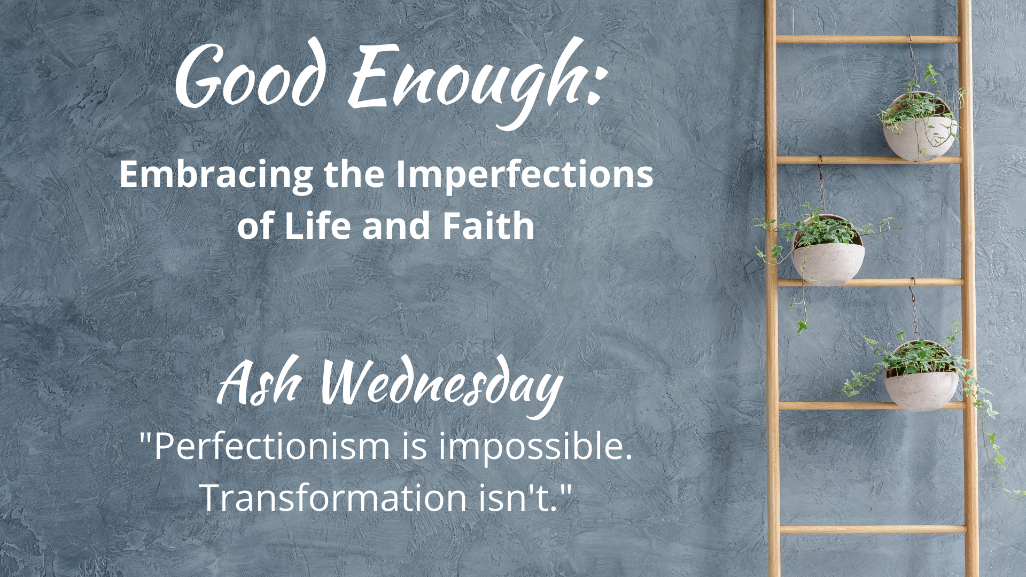

WE GATHER

Music for Gathering

Welcome

Threshold
[accompaniment begins under the Leader’s words]

Leader: Ash Wednesday marks the beginning of the Lent season, a time when we aspire to make some room for deeper introspection and practices that will draw us into the love and assurance of faith. But sometimes faith can feel not as assured as we hoped for. We can feel “less than,” perceiving that others seem to be able to be “more faithful” in their practices and beliefs. This Lent, rather than change for “the best,” we’ll seek to gain momentum one day at a time, “to reach for a faith that is never perfect, but good enough.”

[sung by a soloist or ensemble]
“Good Enough”

What in our lives do we dream about for tomorrow, void of sorrow?
Time spent regretting decisions of our yesterdays, mistakes we made?
Sometimes we get what we get,
life disappoints us and yet,
God is still here and somehow, this faith is good enough.

Calling on God

Leader: Let us pray together:

Holy One, Merciful God,
make yourself known to us.
Be present with us in this often troubled journey of life.
Create in us hearts that are open to transformation.
Give us the patience of practice in this Lent season–
ordering our days with time enough for you.
Amen.

Opening Hymn/Song
“Be Thou My Vision”
Chalice 595; ELW 793; GTG 450; NCH 451; UMH 451; VU 642; W&R 502
or
Contemporary Arrangement HERE

Honest Questions, Compassionate Response

Leader: Jesus used the word “hypocrite” to describe those who put on airs in public to make people believe that they were holy, that their religious practice was… well… perfect. But their hearts were actually not in the practice, rather in the rewards that public approval could bring them–which is here today, often gone tomorrow. Sometimes it is life itself that robs us of the shiny, perfect life that we had planned for ourselves. A diagnosis. A broken heart. A lost opportunity. What places in your life and faith could you begin to loose from the chains of perfectionism? Let us take a moment of silent reflection…

Silent Reflection

Leader: Hear this compassionate word from the prophet Isaiah: “Is not this the fast that I choose: to loose the bonds of injustice, to undo the thongs of the yoke, to let the oppressed go free, and to break every yoke?… Then your light shall break forth like the dawn, and your healing shall spring up quickly.”

Know that already, God is offering us
freedom from the bonds of perfectionism,
inviting us to break the yoke of what “should be”
so that we might discover what “might be” when we
honor the small steps that are actually possible, in this moment, for this one day.

And know, that despite our sometimes faltering steps,
in the name of Jesus Christ, you are being forgiven, even now.
In the name of Jesus Christ, you are forgiven.
Glory to God! Amen.

The Peace

[invite people to pass the peace in the manner to which you are accustomed, remembering to include the folx at home if you are live-streaming or recording]

WE PROCLAIM

First Reading
[selection from lectionary; chosen by preacher]

The Word in Music
[choral anthem; ensemble piece; or use during the imposition of ashes below]
“Dust I Am”
Listen HERE
Order HERE
or
“Come as You Are”
by The Many

Gospel Reading
Matthew 6:1-6, 16-21

Beware of practicing your piety before others in order to be seen by them; for then you have no reward from your Father in heaven.

So whenever you give alms, do not sound a trumpet before you, as the hypocrites do in the synagogues and in the streets, so that they may be praised by others. Truly I tell you, they have received their reward. But when you give alms, do not let your left hand know what your right hand is doing, so that your alms may be done in secret; and your Father who sees in secret will reward you.

And whenever you pray, do not be like the hypocrites; for they love to stand and pray in the synagogues and at the street corners, so that they may be seen by others. Truly I tell you, they have received their reward. But whenever you pray, go into your room and shut the door and pray to your Father who is in secret; and your Father who sees in secret will reward you.

And whenever you fast, do not look dismal, like the hypocrites, for they disfigure their faces so as to show others that they are fasting. Truly I tell you, they have received their reward. But when you fast, put oil on your head and wash your face, so that your fasting may be seen not by others but by your Father who is in secret; and your Father who sees in secret will reward you.

Do not store up for yourselves treasures on earth, where moth and rust consume and where thieves break in and steal; but store up for yourselves treasures in heaven, where neither moth nor rust consumes and where thieves do not break in and steal. For where your treasure is, there your heart will be also.

A Word of God that is still speaking,
Thanks be to God.

Thoughts about an Imperfect Life and Faith
“Perfectionism is impossible. Transformation isn’t.”

[see Sermon Fodder document for prompts]

Ritual of Ashes and Turning Ladders into Gardens

[sung by choir/ensemble]
Though all along our daily pilgrim race
our treasures small and very few may be,
our souls are blest with God’s unending grace,
and that is enough, enough for me.
Oh, that’s enough for me,
God’s truth has set me free;
the love of Christ has sanctified my soul,
and that is enough for me.

[accompaniment slows to a meditative feel
and continues under the following leader words]

Leader: Our ritual of receiving ashes will be accompanied this year by placing the small treasures of sprouts and shoots of plants that were planted by the children on a transformed and repurposed ladder-garden. This image will remind us each week to spend time tending the things that are beautiful and growing already in our midst rather than constantly climbing and reaching for more–for those things we think we are “supposed” to achieve or have in our lives.

We are reminded in the Ritual of Ashes that we are part of the dust and debris of this earth. Just as things of creation grow but also die in the cycle of life, so too our lives have times of growth and times of decay and death. Placing the sign of the cross on our foreheads with ashes is a reminder of this difficult reality but also a reminder of the presence of God, the grace of Christ, and the power of the Spirit in all of it. Early Christians were anointed with the sign of the cross on their foreheads at their baptism. This “sign and seal,” as it is called, is a way to remember that we are marked and held as God’s own, through all of the transformations and transitions we face.

You are invited to [instructions for coming to receive ashes and place seedlings on the visual ladder installation]…

Music for Ashes and Flowers
You could move the anthem suggestion above to this moment.

Closing Hymn/Song
“Sing Out! We’re Made of Common Dust”
Text by Carolyn Winfrey Gillette
Tune: CANONBURY 8.8.8.8 ("Lord, Speak to Me, That I May Speak")

A Blessing Before a Fast

[adapt these words if you spent time in the sermon talking about the book of devotions and small group/individual opportunities–
simply move these words into the sermon if you choose–or use them here]

Leader: Our Lent series, “Good Enough,” is based on a book of devotions by the same name by Kate Bowler and Jessica Richie. Kate Bowler is a seminary professor whose research about the history of the prosperity gospel and self-help movements in the US laid the groundwork for her latest NY Times bestselling books about dealing with the pressure to “live your best life now” when life throws you curveballs that make constant upward achievement very difficult… like the cancer she has dealt with over the last few years. In the Good Enough book of devotions, she and Jessica Richie offer wonderfully graceful invitations to seek alternatives to the pressure of perfectionism. We hope that you will make reading these daily devotions part of your Lent practice and join one of our small groups for debriefing and deepening your experience through conversation with others.

As Kate and Jessica say in their book, “a fast is giving up something—anything—to make more room for God. It might be a break from social media or Netflix, caffeine, unkind words, alcohol, or holding a grudge. If you are someone who has a complicated relationship with restricting food, skip that for now. Try something else instead. Remember, this isn’t about punishing yourself or a thinly veiled version of a diet. Share your intention with a friend to reinforce your commitment, but do your fast in secret—just between you and God. Try it out for a week, and then reassess.”

And so, each worship experience will end with a blessing from the book. Here is “A Blessing Before a Fast.”

Blessed are you, ready to open yourself to a new joy, a doorway that until now has been hidden. In this culture of acquisition and gain, blessed are you desiring fresh ears to hear what might be a bit too loud. Who take the next step to turn it down a notch and make more space for God. Who discipline yourself, with time, intention, and hope, anticipating God to show up in your discomfort. Trusting that when we need God, God promises to be there.
God, give me courage, give me strength, give me hunger for you. Let this set time of less be a chance for more of you. Let this fast be an entrance into the discernment I desire, the divine presence I’m longing for, and the hope to will what You will, oh God, to be who You’ve called me to be.”

Benediction

And now, may the God who loves all of creation, especially the imperfect bits,
and Jesus, our companion along this crooked path called life,
and the Holy Spirit, who loves to improvise in surprising ways,
go with you, dwell among you, and give you joy. Amen.

Choral Reprise
[sung slowly, in harmony]
God is still here and somehow, this faith is good enough.

Postlude
Worship Notes:

All liturgy and leader parts Marcia McFee © www.worshipdesignstudio.com/goodenough. Used and adapted with permission.

“Good Enough” theme song by Marsha Charles, Marcia McFee, Chuck Bell. Used with permission of Worship Design Studio.

“A Blessing Before a Fast” from Good Enough: 40’ish Devotionals for a Life of Imperfection by Kate Bowler and Jessica Richie. Used with permission. Purchase the book at https://katebowler.com/books/good-enough.

Music licenses: [insert your church’s licenses for congregational and choral music]

