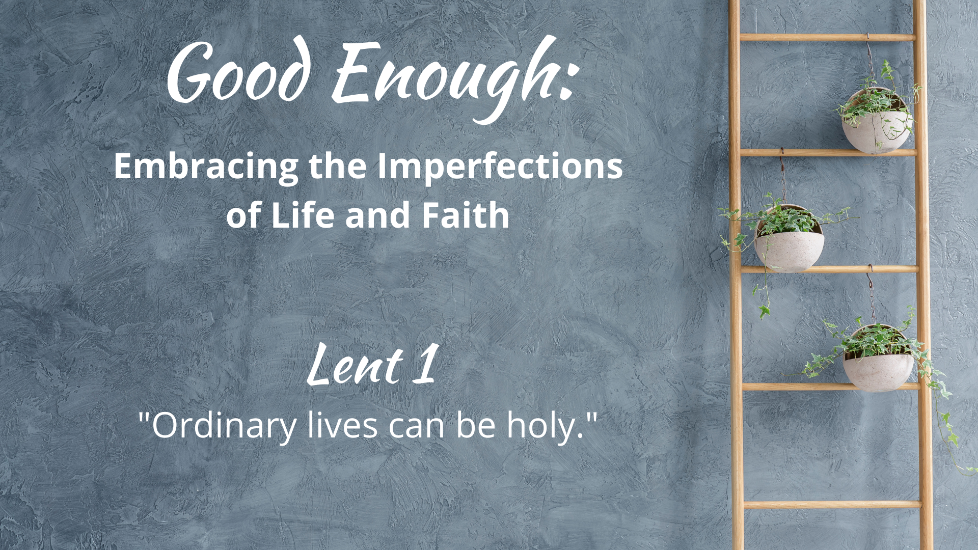

WE GATHER

Music for Gathering

Welcome
[invite children present to go to the back to help with the procession at the beginning of your welcome, giving them time to get back there and organized]

Threshold
[accompaniment begins under the Leader’s words]

Leader: The liturgical season of Lent developed over the centuries as a time of deepened reflection. Originally a period of preparation for baptisms on Easter Eve, it later became a time for all Christians to take stock of their lives and examine how the connection to their faith was progressing–or not–and to recommit to a life of goodness. This year we will indeed open up and take stock. But rather than feel guilty (a popular Lenten pastime) about what we haven’t accomplished in our lives and faith, we will spend some time questioning how our culture’s obsession with achievement and perfection actually keeps us from the true depths of life and faith. This Lent, we’ll take some time to turn ladder-climbing into garden-tending, nurturing our souls and embracing our holy, “good enough,” lives.

“Good Enough”
[sung by a soloist; children bring garden items forward (see Children’s Time scripts for suggestions for each week) to place on the ladder-garden]

What in our lives do we dream about for tomorrow, void of sorrow?
Time spent regretting decisions of our yesterdays, mistakes we made?
Sometimes we get what we get,
life disappoints us and yet,
God is still here and somehow, this faith is good enough. [repeat]
Calling on God
Based on Psalm 91

Leader: Let us pray together:

Holy One, Our Refuge and Shelter,
we call out to you,
sometimes in praise, sometimes in distress–as life goes.
Whether we perceive it or not, you are there.
Open us this day to your presence
in the smile of a friend, in the call of a bird–
in the simple and good enough moments that fill our days.
Amen.

The Children Lead Us

[See Children’s Time scripts]

Opening Hymn/Song
“Our Lord, You Were Sent”
Text by Carolyn Winfrey Gillette
Tune: FOUNDATION 11.11.11.11 (“How Firm a Foundation”)

Honest Questions, Compassionate Response

Leader: We find ourselves hungry for many things that we believe will bring us satisfaction. In today’s Gospel, the devil lays a bet that Jesus will jump at the chance for glory, fame, and the quick fix. Who wouldn’t? But Jesus keeps up the pithy one-liners long enough that the Tempster just has to slink away. What are the temptations that catch your ear, singing out promises that your life should be more special than it is? What if ordinary life is already holy–as is? Let us take a moment of silent reflection…

Silent Reflection

Leader: Hear this compassionate word from the Letter to the Romans: “The word is near you, on your lips and in your heart… Everyone who calls on the name of the Lord shall be saved.”

Know that already, God is offering us freedom from
the temptations of the “not enough-ness” of our time,
inviting us to love and revere the seeming ordinariness of the day-to-day
so that we might recognize its true beauty.

And know, that despite our sometimes faltering steps,
in the name of Jesus Christ, you are being forgiven, even now.
In the name of Jesus Christ, you are forgiven.
Glory to God! Amen.

The Peace

[invite people to pass the peace in the manner to which you are accustomed, remembering to include the folx at home if you are live-streaming or recording]

WE PROCLAIM

First Reading
[selection from lectionary; chosen by preacher]

The Word in Music
[choral anthem; ensemble piece]
“When Jesus Walked the Wilderness”
or
“Lovely, Needy People”
by The Many

Gospel Reading
Luke 4: 1-13

Jesus, full of the Holy Spirit, returned from the Jordan and was led by the Spirit in the wilderness, where for forty days he was tempted by the devil. He ate nothing at all during those days, and when they were over, he was famished. The devil said to him, “If you are the Son of God, command this stone to become a loaf of bread.” Jesus answered him, “It is written, ‘One does not live by bread alone.’”

Then the devil led him up and showed him in an instant all the kingdoms of the world. And the devil said to him, “To you I will give their glory and all this authority; for it has been given over to me, and I give it to anyone I please. If you, then, will worship me, it will all be yours.” Jesus answered him, “It is written, ‘Worship the Lord your God, and serve only him.’”

Then the devil took him to Jerusalem, and placed him on the pinnacle of the temple, saying to him, “If you are the Son of God, throw yourself down from here, for it is written, ‘He will command his angels concerning you, to protect you,’ and ‘On their hands they will bear you up, so that you will not dash your foot against a stone.’”Jesus answered him, “It is said, ‘Do not put the Lord your God to the test.’” When the devil had finished every test, he departed from him until an opportune time.

A Word of God that is still speaking,
Thanks be to God.

Thoughts about an Imperfect Life and Faith
“Ordinary lives can be holy.”

[see Sermon Fodder document for prompts]

Prayers of the People

[sung]
Though all along our daily pilgrim race
our treasures small and very few may be,
our souls are blest with God’s unending grace,
and that is enough, enough for me.
Oh, that’s enough for me,
God’s truth has set me free;
the love of Christ has sanctified my soul,
and that is enough for me.

[accompaniment slows to a meditative feel
and continues under the following leader words]

Leader: Our prayer song in this Lent season is written by an evangelist who wrote in the 19th century, Daniel S. Warner. A newspaper publisher and outspoken believer in sanctification (the movement toward perfection), he nonetheless penned this hymn drawing on First Timothy 6, a text that reminds us not to slip from the desire to see one’s family well-fed and clothed to seeing them more well-fed and clothed than others. Embracing a good enough life means also embracing the need for the ordinariness of all lives to be good enough–cared for enough, sheltered and fed enough, loved enough. As long as this is not true in this world, we will pray and work for justice. And so Warner’s first verse is followed by an adapted new second verse turning our attention to the needs of the world.

[sung]
When food and raiment are not ever sure,
and simple fare is hard to get for some,
we work to share our goods with one and all,
and that is enough, enough for me.
Oh, that’s enough for me,
God’s truth has set me free;
a love like Christ’s is meant for ev’ry soul,
and that is enough for me.

[prayers of the people continue as you are accustomed]

Offering
[in the manner to which you are accustomed, insert offertory music if needed]

Doxology
Old 100th

Praise God from whom all blessings flow,
Praise Jesus Christ, our burdens know,
Praise Spirit through whom our hearts grow,
Praise Three-in-One, from here below.

Prayer after Offering

Generous God,
in light of your extravagant blessings–
no matter what the state of the world or our imperfect lives–
we offer our gifts and ourselves,
and know that you transform what we plant
into the produce of love.
Amen.

[Communion - insert on weeks that your church practices this ritual; see adaptable liturgy in separate Communion document]

Closing Hymn/Song
“Open My Eyes, That I May See”
Chalice 586; GTG 451; UMH 454; VU 371; W&R 480
or
Contemporary arrangement HERE

A Blessing for a Joyfully Mediocre Journey

“Blessed are you who realize there is simply not enough–time, money, resources.
Blessed are you who are tired of pretending that raw effort is the secret to perfection.
It’s not. And you know that now.
Blessed are you who need a gentle reminder that even now, even today,
God is here, and somehow, that is good enough.”
Benediction

And now, may the God who loves all of creation, especially the ordinary parts,
and Jesus, our companion along this crooked path called life,
and the Holy Spirit, who loves to improvise in surprising ways,
go with you, dwell among you, and give you joy. Amen.

Choral Reprise
[sung slowly, in harmony]
God is still here and somehow, this faith is good enough.

Postlude

Worship Notes:

All liturgy and leader parts Marcia McFee © www.worshipdesignstudio.com/goodenough. Used and adapted with permission.

“Good Enough” theme song by Marsha Charles, Marcia McFee, Chuck Bell. Used with permission of Worship Design Studio.

“A Blessing for a Joyfully Mediocre Journey” from Good Enough: 40’ish Devotionals for a Life of Imperfection by Kate Bowler and Jessica Richie. Used with permission. Purchase the book at https://katebowler.com/books/good-enough.

Music licenses: [insert your church’s licenses for congregational and choral music]

