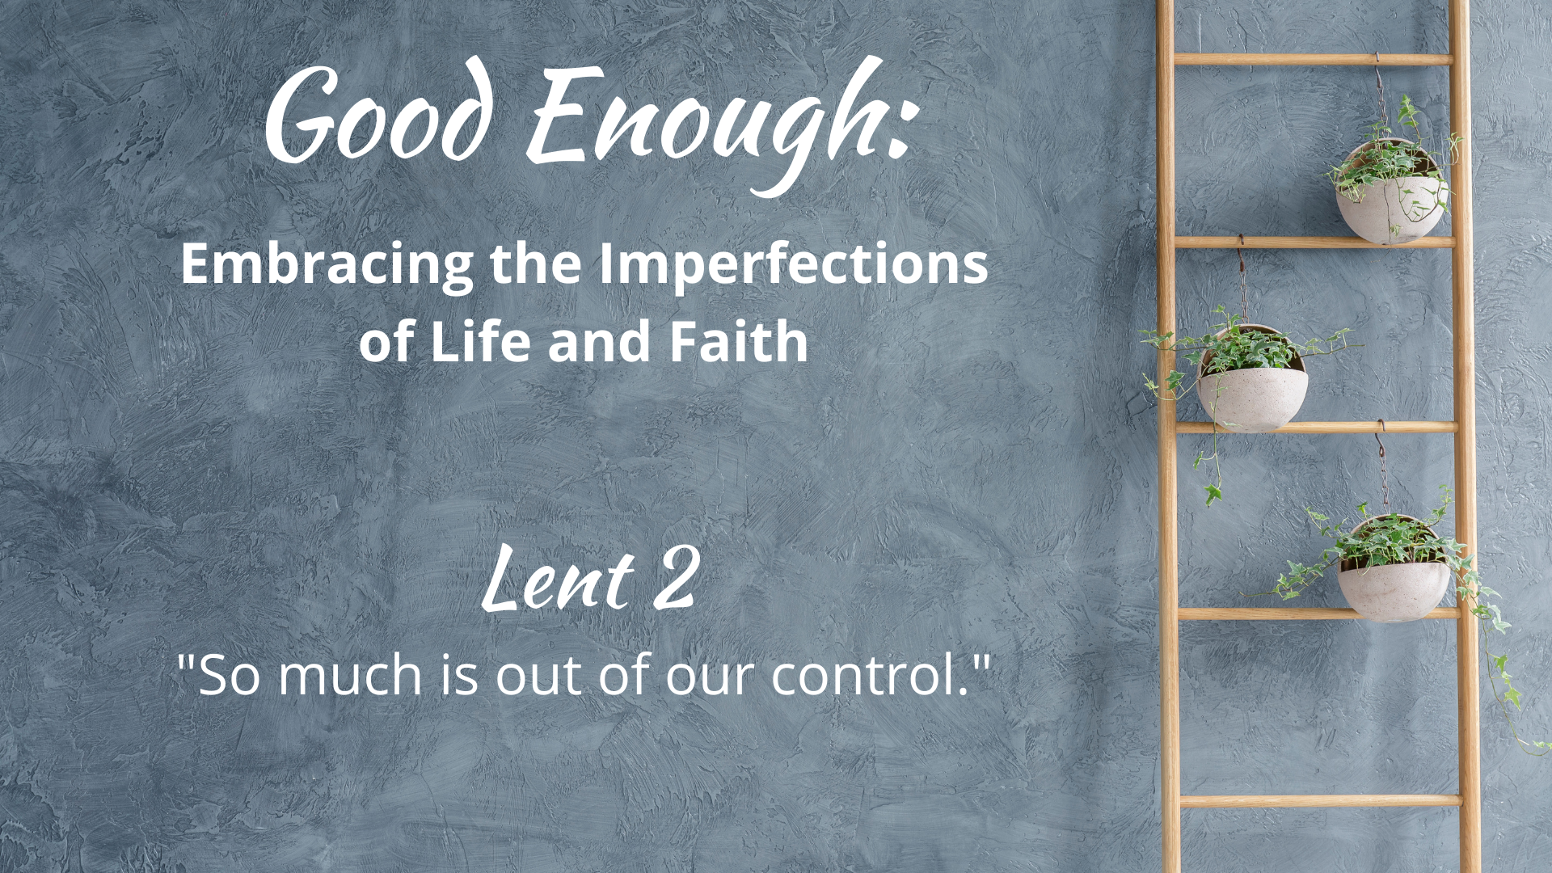

WE GATHER

Music for Gathering

Welcome
[invite children present to go to the back to help with the procession at the beginning of your welcome, giving them time to get back there and organized]

Threshold
[accompaniment begins under the Leader’s words]

Leader: We continue our movement through the Lent season this week with another kind of “letting go.” This week we lament that so much in life is out of our control. This is frustrating to us and so sometimes we have been tempted to believe the sayings that tell us if we just “think positively,” we can turn it all around. Yet our experience tells us that this doesn’t always work. Let us turn ladder-climbing toward the expectation of a perfect life into garden-tending, nurturing “what is” and embracing our holy, good enough, lives.

“Good Enough”
[sung by a soloist; children bring garden items forward (see Children’s Time scripts for suggestions for each week) to place on the ladder-garden]

What in our lives do we dream about for tomorrow, void of sorrow?
Time spent regretting decisions of our yesterdays, mistakes we made?
Sometimes we get what we get,
life disappoints us and yet,
God is still here and somehow, this faith is good enough.
[repeat with congregation]

Calling on God
Based on Psalm 27

Leader: Let us pray together:

Holy One, Our Light and Salvation,
we call out to you,
sometimes afraid of the adversaries in life.
Shelter us in days of trouble, lead us on level paths.
Open us this day to your grace and peace,
transform our frustrations
into simple and good enough moments that fill our days.
Amen.

The Children Lead Us

[See Children’s Time scripts]

Opening Hymn/Song
“Take Time to Be Holy”
Chalice 572; UMH 395; VU 672; W&R 483
or
“Lord, I Need You” Songselect #5925687

Honest Questions, Compassionate Response

Leader: Even Jesus got dang frustrated when folks didn’t behave as he would have liked. We probably aren’t receiving death threats from Herod as Jesus was, but our wellbeing could be threatened by the idea that if we just try hard enough, are nice enough, say just the right thing, life will always go our way. We run around in so many directions, trying to herd the chicks into some imagined semblance of perfect formation (have you ever tried to herd chicks?). What if we could let go of needing all things and all people to be “just so” and instead learn to dance with the unfolding of that which is not ours to control? Let us take a moment of silent reflection…

Silent Reflection

Leader: Hear this compassionate word from the Psalmist: “I believe that I shall see the goodness of the LORD in the land of the living. Wait for the LORD; be strong, and let your heart take courage; wait for the LORD!”

Know that already, God is offering us freedom from
feeling alone in fixing what feels oh so wrong with this world,
inviting us to let go of the need to be God,
so that we might recognize that God is with us, offering courage in difficulty.

And know, that despite our sometimes faltering steps,
in the name of Jesus Christ, you are being forgiven, even now.
In the name of Jesus Christ, you are forgiven.
Glory to God! Amen.

The Peace

[invite people to pass the peace in the manner to which you are accustomed, remembering to include the folx at home if you are live-streaming or recording]

WE PROCLAIM

First Reading
[selection from lectionary or contemporary reading; chosen by preacher]

The Word in Music
[choral anthem; ensemble piece]
“Gonna Lay My Burden Down”
or
“All You Ask”
by The Many

Gospel Reading
Luke 13: 31-35

At that very hour some Pharisees came and said to him, "Get away from here, for Herod wants to kill you."

He said to them, "Go and tell that fox for me, 'Listen, I am casting out demons and performing cures today and tomorrow, and on the third day I finish my work. Yet today, tomorrow, and the next day I must be on my way, because it is impossible for a prophet to be killed outside of Jerusalem.'

Jerusalem, Jerusalem, the city that kills the prophets and stones those who are sent to it! How often have I desired to gather your children together as a hen gathers her brood under her wings, and you were not willing! See, your house is left to you. And I tell you, you will not see me until the time comes when you say, 'Blessed is the one who comes in the name of the Lord.'"

A Word of God that is still speaking,
Thanks be to God.

Thoughts about an Imperfect Life and Faith
“So much is out of our control.”

[see Sermon Fodder document for prompts]

Prayers of the People

[sung]
Though all along our daily pilgrim race
our treasures small and very few may be,
our souls are blest with God’s unending grace,
and that is enough, enough for me.
Oh, that’s enough for me,
God’s truth has set me free;
the love of Christ has sanctified my soul,
and that is enough for me.

[accompaniment slows to a meditative feel
and continues under the following leader words]

Leader: Sanctification, or the process of being set apart or made holy, is a theological concept that has been greatly debated over time–are we made holy in a once-and-done kind of way or are we always simply moving in that direction based on our merits? It is as if once the debate is settled, then we can know what to do and control the outcome of goodness for ourselves. And yet, if we worry less about our own sanctification and more on treating the world, the planet, and all the creatures, especially those who are suffering, as holy and worthy of our love, then we will be acting on what we can control, sharing what we have with others.

[sung]
When food and raiment are not ever sure,
and simple fare is hard to get for some,
we work to share our goods with one and all,
and that is enough, enough for me.
Oh, that’s enough for me,
God’s truth has set me free;
a love like Christ’s is meant for ev’ry soul,
and that is enough for me.

[prayers of the people continue as you are accustomed]

Offering
[in the manner to which you are accustomed, insert offertory music if needed]

Doxology
Old 100th

Praise God from whom all blessings flow,
Praise Jesus Christ, our burdens know,
Praise Spirit through whom our hearts grow,
Praise Three-in-One, from here below.

Prayer after Offering

Generous God,
in light of your extravagant blessings–
no matter what the state of the world or our imperfect lives–
we offer our gifts and ourselves,
and know that you transform what we plant
into the produce of love.
Amen.

[Communion - insert on weeks that your church practices this ritual; see adaptable liturgy in separate Communion document]

Closing Hymn/Song
“Since the Lord is My Salvation”
Text by Carolyn Winfrey Gillette
Tune: NETTLETON 8.7.8.7 D ("Come, Thou Fount of Every Blessing”)

A Blessing for When You Realize Everyone is Struggling

“Blessed are you who see things clearly, where struggle is everyone’s normal.
You walk among the fellowship of the afflicted, a club no one wants to join.
And while this life isn’t shiny, it does come with superpowers.
Superpowers of ever-widening empathy and existential courage
that gets you back up after another fall
and a deepened awe at the beauty and love that can be found amid life’s rubble.
Like flowers that grow from the cracks in the sidewalk.
These virtues blossom in you. And thank God for you.

Blessed are all of us who struggle, for we are in good company,
and we’ll never walk alone.”

Benediction

And now, may the God who loves all of creation, especially when it’s painful,
and Jesus, our companion along this crooked path called life,
and the Holy Spirit, who loves to improvise in surprising ways,
go with you, dwell among you, and give you joy. Amen.

Choral Reprise
[sung slowly, in harmony]
God is still here and somehow, this faith is good enough.

Postlude

Worship Notes:

All liturgy and leader parts Marcia McFee © www.worshipdesignstudio.com/goodenough. Used and adapted with permission.

“Good Enough” theme song by Marsha Charles, Marcia McFee, Chuck Bell. Used with permission of Worship Design Studio.

“A Blessing for When You Realize Everyone is Struggling” from Good Enough: 40’ish Devotionals for a Life of Imperfection by Kate Bowler and Jessica Richie. Used with permission. Purchase the book at https://katebowler.com/books/good-enough.

Music licenses: [insert your church’s licenses for congregational and choral music]

