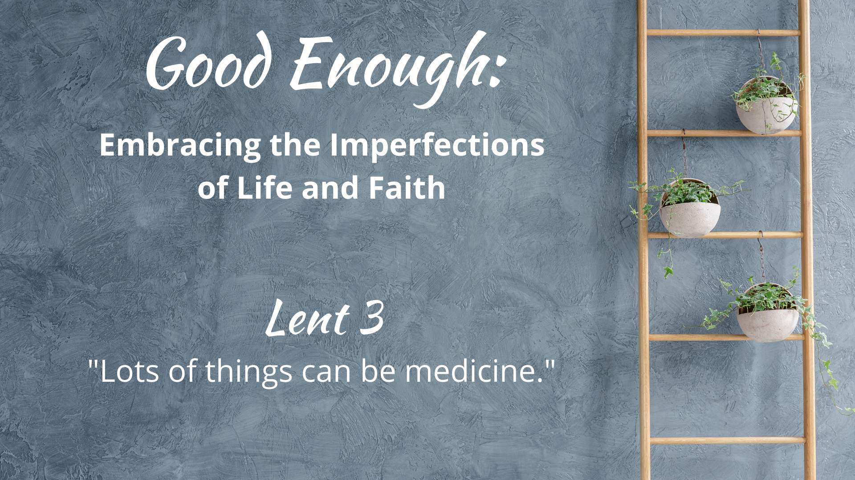

WE GATHER

Music for Gathering

Welcome
[invite children present to go to the back to help with the procession at the beginning of your welcome, giving them time to get back there and organized]

Threshold
[accompaniment begins under the Leader’s words]

Leader: As we continue our look at what it means to release oppressive expectations about perfection in our lives and in our faith, this week we turn to a harmful idea that the prescription for our fear of failure is to simply work harder. As the book Good Enough reminds us, “We might feel we are climbing an ‘endless staircase’ of achievement, for high grades or success…[in] caregiving, work, or social pressure.” This Lent, we are taking some time to stop climbing ladders and staircases, to tend our souls slowly and lovingly, tilling the soil and fertilizer, and embracing our holy, “good enough,” lives.

“Good Enough”
[sung by a soloist; children bring garden items forward (see Children’s Time scripts for suggestions for each week) to place on the ladder-garden]

What in our lives do we dream about for tomorrow, void of sorrow?
Time spent regretting decisions of our yesterdays, mistakes we made?
Sometimes we get what we get,
life disappoints us and yet,
God is still here and somehow, this faith is good enough.
[repeat with congregation]

Calling on God
Based on Psalm 63

Leader: Let us pray together:

Holy One, Our Balm, Our Feast
we lift our hands and call your name,
in need of healing–thirsting and hungry.
Your steadfast love is better than life.
Open us this day to your nourishment
in the songs of the land, in the beauty of the sky–
in the simple and good enough moments that fill our days.
Amen.

The Children Lead Us

[See Children’s Time scripts]

Opening Hymn/Song
“The Gifts of God are Free”
Text by Carolyn Winfrey Gillette
Tune: ST. THOMAS 6.6.8.6 ("I Love Thy Kingdom, Lord")

Honest Questions, Compassionate Response

Leader: In our Gospel scripture today, we will hear about the unproductive fig tree. Oh, the shame of being unproductive! Cut it down! Make room for a more dedicated and hard-working fig tree! Who among us is living up to our fullest potential? The productivity experts these days can diagnose what’s wrong and sell us the antidote in 3 amazing sessions for a low-low price that is guaranteed to turn our lives around. But the gardener offers an alternative medicine–nurture it slowly, letting it soak in the manure all around until it can get the good stuff out of it. Lying fallow and getting fertilized with laughter and tears at the crappy stuff of life can help heal what ails us. Is this not sometimes productive enough? What productivity expectations are holding you captive? Let us take a moment of silent reflection…

Silent Reflection

Leader: Hear this compassionate word from Isaiah: “Everyone who thirsts, come to the waters; and you that have no money, come, buy and eat! Come, buy wine and milk without money and without price.”

Know that already, God is offering us love enough
no matter how much we attain or achieve.
We are invited to release oppressive expectations of ourselves and others
so that we might recognize true worth afforded to all.

And know, that despite our sometimes faltering steps,
in the name of Jesus Christ, you are being forgiven, even now.
In the name of Jesus Christ, you are forgiven.
Glory to God! Amen.

The Peace

[invite people to pass the peace in the manner to which you are accustomed, remembering to include the folx at home if you are live-streaming or recording]

WE PROCLAIM

First Reading
[selection from lectionary; chosen by preacher]

The Word in Music
[choral anthem; ensemble piece]
“God of the Sparrow”
or
“Take Comfort”
by The Many

Gospel Reading
Luke 13: 1-9

At that very time there were some present who told him about the Galileans whose blood Pilate had mingled with their sacrifices. He asked them, "Do you think that because these Galileans suffered in this way they were worse sinners than all other Galileans? No, I tell you; but unless you repent, you will all perish as they did.

Or those eighteen who were killed when the tower of Siloam fell on them—do you think that they were worse offenders than all the others living in Jerusalem? No, I tell you; but unless you repent, you will all perish just as they did."

Then he told this parable: "A man had a fig tree planted in his vineyard; and he came looking for fruit on it and found none. So he said to the gardener, 'See here! For three years I have come looking for fruit on this fig tree, and still I find none. Cut it down! Why should it be wasting the soil?'

He replied, 'Sir, let it alone for one more year, until I dig around it and put manure on it. If it bears fruit next year, well and good; but if not, you can cut it down.’"
.

A Word of God that is still speaking,
Thanks be to God.

Thoughts about an Imperfect Life and Faith
“Lots of things can be medicine.”

[see Sermon Fodder document for prompts]

Prayers of the People

[sung]
Though all along our daily pilgrim race
our treasures small and very few may be,
our souls are blest with God’s unending grace,
and that is enough, enough for me.
Oh, that’s enough for me,
God’s truth has set me free;
the love of Christ has sanctified my soul,
and that is enough for me.

[accompaniment slows to a meditative feel
and continues under the following leader words]

Leader: Often our religious debates within Christianity have focused on what makes us “worthy” of salvation… is it faith alone or the work that we do to follow rules and answer God’s call? Many have wanted an easy answer, “just tell me what I have to do to enter the kin-dom of heaven!” This week we have affirmed that God’s love and grace come without price and making ourselves sick with overwork is not the answer to what ails us. And yet, God does call us to work together to alleviate the suffering of others. Why? Not so we can buy the golden ticket to eternal life, but so that all might know a heaven of help right here on earth.

[sung]
When food and raiment are not ever sure,
and simple fare is hard to get for some,
we work to share our goods with one and all,
and that is enough, enough for me.
Oh, that’s enough for me,
God’s truth has set me free;
a love like Christ’s is meant for ev’ry soul,
and that is enough for me.

[prayers of the people continue as you are accustomed]

Offering
[in the manner to which you are accustomed, insert offertory music if needed]

Doxology
Old 100th

Praise God from whom all blessings flow,
Praise Jesus Christ, our burdens know,
Praise Spirit through whom our hearts grow,
Praise Three-in-One, from here below.

Prayer after Offering

Generous God,
in light of your extravagant blessings–
no matter what the state of the world or our imperfect lives–
we offer our gifts and ourselves,
and know that you transform what we plant
into the produce of love.
Amen.

[Communion - insert on weeks that your church practices this ritual; see adaptable liturgy in separate Communion document]

Closing Hymn/Song
“O Love That Will Not Let Me Go”
Chalice 540; GTG 833; NCH 485; UMH 480; VU 658; W&R 446
or
Contemporary Arrangement (listen, see link to purchase in YouTube description) HERE

A Blessing for Slowing Down

“…blessed are we who stop—okay, maybe not stop entirely,
who are we kidding—but who slow down.
We who discover rest and new life and renewal
when we step off the treadmill (or at least turn it down).
We who remember that the world keeps spinning without us. And thank God for that. We who remember we are loved, loved, loved. Just being us."

Benediction

And now, may the God who loves all of creation, and you–without price,
and Jesus, our companion along this crooked path called life,
and the Holy Spirit, who loves to improvise in surprising ways,
go with you, dwell among you, and give you joy. Amen.

Choral Reprise
[sung slowly, in harmony]
God is still here and somehow, this faith is good enough.

Postlude

Worship Notes:

All liturgy and leader parts Marcia McFee © www.worshipdesignstudio.com/goodenough. Used and adapted with permission.

“Good Enough” theme song by Marsha Charles, Marcia McFee, Chuck Bell. Used with permission of Worship Design Studio.

“A Blessing for Slowing Down [excerpt]” from Good Enough: 40’ish Devotionals for a Life of Imperfection by Kate Bowler and Jessica Richie. Used with permission. Purchase the book at https://katebowler.com/books/good-enough.

Music licenses: [insert your church’s licenses for congregational and choral music]

