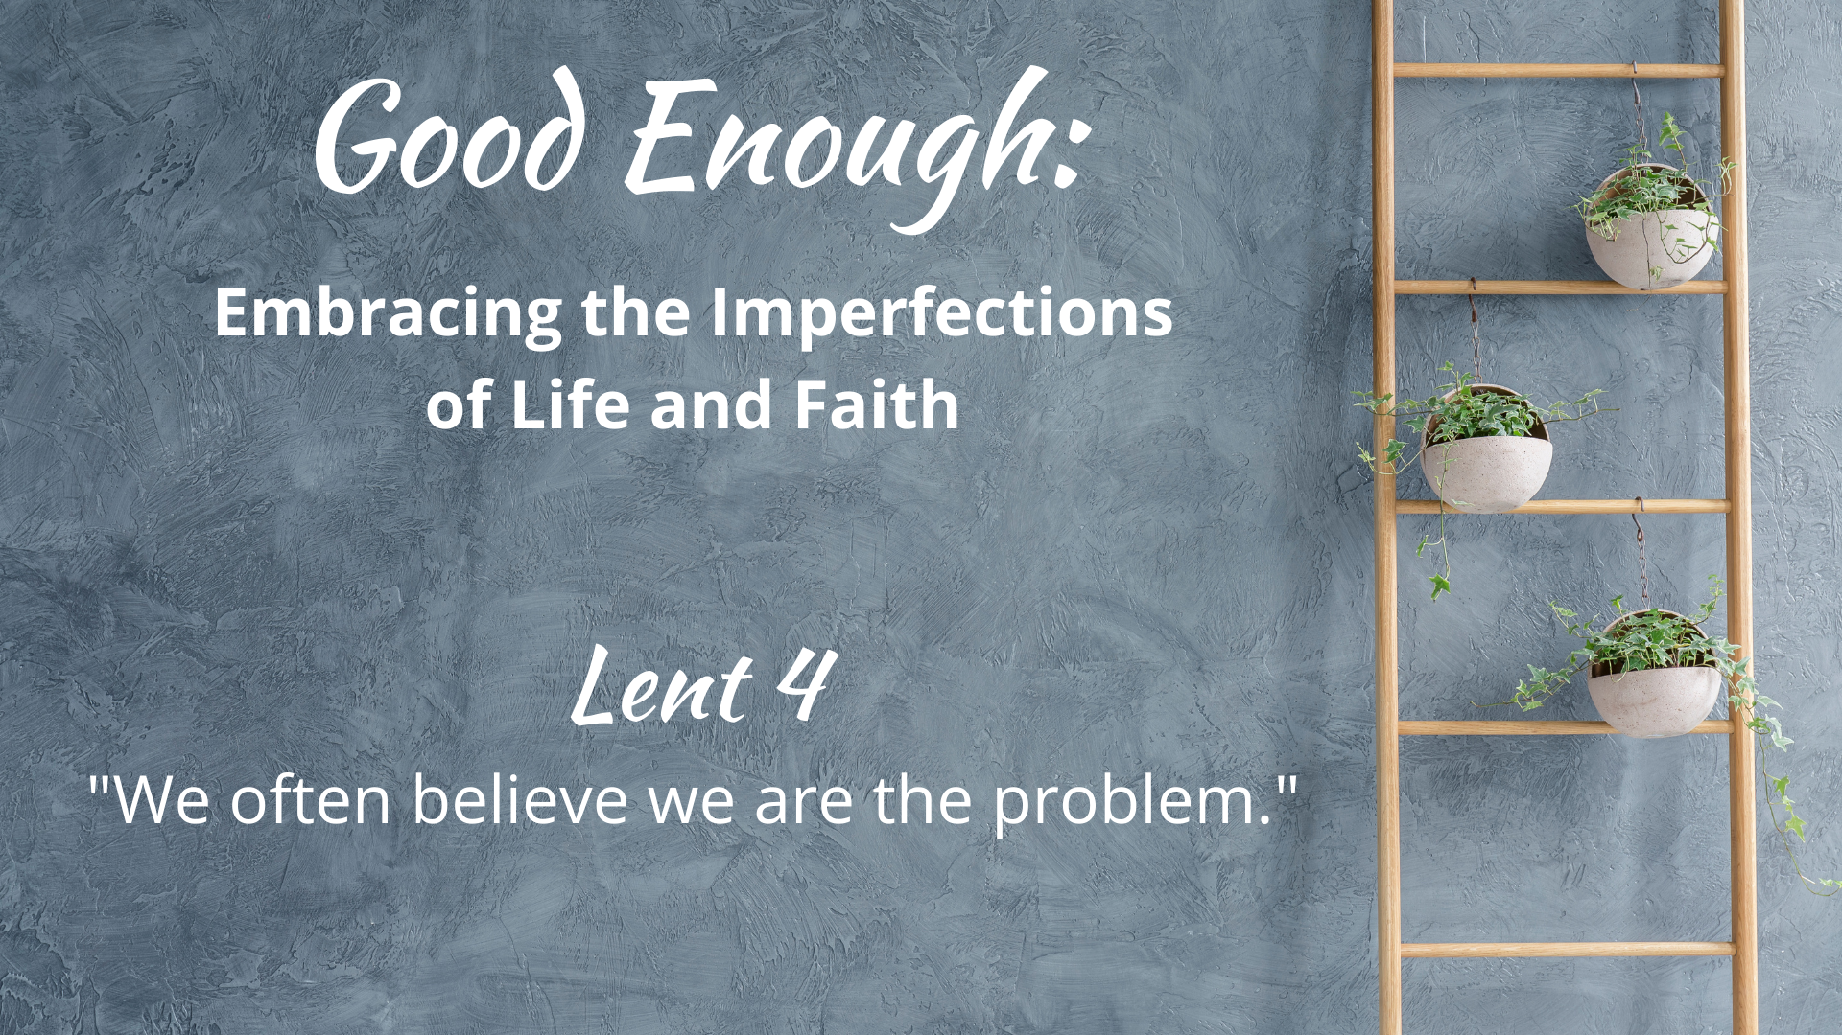

WE GATHER

Music for Gathering

Welcome
[invite children present to go to the back to help with the procession at the beginning of your welcome, giving them time to get back there and organized]

Threshold
[accompaniment begins under the Leader’s words]

Leader: Each week of this Lent season, we are focusing on ways that we can practice a counter-cultural theology that emphasizes the beauty and grace of the reality of life-right-now rather than waiting with increasing judgment to reach some vision of a perfected existence. Our ladder-climbing efforts sometimes end up taking us down a rung or two as things don’t work out just right. And so let us continue to turn ladders into gardens, nurturing our souls and embracing our holy, “good enough,” lives.

“Good Enough”
[sung by a soloist; children bring garden items forward (see Children’s Time scripts for suggestions for each week) to place on the ladder-garden]

What in our lives do we dream about for tomorrow, void of sorrow?
Time spent regretting decisions of our yesterdays, mistakes we made?
Sometimes we get what we get,
life disappoints us and yet,
God is still here and somehow, this faith is good enough.
[repeat with congregation]

Calling on God
Based on Psalm 32

Leader: Let us pray together:

Holy One, God of Forgiveness,
we call out to you and
and you surround us with deliverance.
You love us infinitely more than we love ourselves or others.
Open us this day to your counsel,
helping us be more merciful, more grace-filled,
so that we might rejoice in simple and good enough moments that fill our days.
Amen.

The Children Lead Us

[See Children’s Time scripts]

Opening Hymn/Song
“We’re Part of the Blessing”
Text by Carolyn Winfrey Gillette
Tune: ASH GROVE 6.6.11.6.6.11 D ("Let All Things Now Living”)

Honest Questions, Compassionate Response

Leader: Today we will hear how the Prodigal Son lives high on the hog and then famine strikes in the land of his dream vacation. And so he heads home, tail between his legs, expecting that he has lost it all. To his surprise, his extravagant failure is met with extravagant love and grace. We can be pretty hard on ourselves when things don’t go as planned. Guilt, shame, and fear of being seen as a failure can leave us wallowing in the pig pen. Our delusions of a perfectible life keep us disappointed in ourselves. Truth is, life is a big ole risk every single day and facing whatever each day holds is not only good enough, but worthy of love and grace. Do you find yourself being unrealistically hard on yourself? Let us take a moment of silent reflection…

Silent Reflection

Leader: Hear this compassionate word from the Second Letter to the Corinthians: “From now on, therefore, we regard no one from a human point of view; even though we once knew Christ from a human point of view, we know him no longer in that way. So if anyone is in Christ, there is a new creation: everything old has passed away; see, everything has become new!”

Know that already, God is offering us freedom from
the guilt and shame of our past failings and our present unrealistic expectations.
We are invited to rejoice that each day is a new beginning,
so that we might enjoy, and not dread, the life before us.

And know, that despite our sometimes faltering steps,
in the name of Jesus Christ, you are being forgiven, even now.
In the name of Jesus Christ, you are forgiven.
Glory to God! Amen.

The Peace

[invite people to pass the peace in the manner to which you are accustomed, remembering to include the folx at home if you are live-streaming or recording]

WE PROCLAIM

First Reading
[selection from lectionary; chosen by preacher]

The Word in Music
[choral anthem; ensemble piece]
“I Thought By Now”
(includes soloists and choir/ensemble…
can also work for contemporary worship)
or
“Only Grace”
by The Many

Gospel Reading
Luke 15: 1-3, 11b-32

Now all the tax collectors and sinners were coming near to listen to him. And the Pharisees and the scribes were grumbling and saying, “This fellow welcomes sinners and eats with them.” So he told them this parable:

“There was a man who had two sons. The younger of them said to his father, 'Father, give me the share of the property that will belong to me.' So he divided his property between them. A few days later the younger son gathered all he had and traveled to a distant country, and there he squandered his property in dissolute living.

“When he had spent everything, a severe famine took place throughout that country, and he began to be in need. So he went and hired himself out to one of the citizens of that country, who sent him to his fields to feed the pigs. He would gladly have filled himself with the pods that the pigs were eating; and no one gave him anything. But when he came to himself he said, 'How many of my father's hired hands have bread enough and to spare, but here I am dying of hunger! I will get up and go to my father, and I will say to him, “Father, I have sinned against heaven and before you; I am no longer worthy to be called your son; treat me like one of your hired hands.”’

“So he set off and went to his father. But while he was still far off, his father saw him and was filled with compassion; he ran and put his arms around him and kissed him. Then the son said to him, 'Father, I have sinned against heaven and before you; I am no longer worthy to be called your son.'

“But the father said to his slaves, 'Quickly, bring out a robe—the best one—and put it on him; put a ring on his finger and sandals on his feet. And get the fatted calf and kill it, and let us eat and celebrate; for this son of mine was dead and is alive again; he was lost and is found!' And they began to celebrate.

“Now his elder son was in the field; and when he came and approached the house, he heard music and dancing. He called one of the slaves and asked what was going on. He replied, 'Your brother has come, and your father has killed the fatted calf, because he has got him back safe and sound.’ Then he became angry and refused to go in. His father came out and began to plead with him. But he answered his father, 'Listen! For all these years I have been working like a slave for you, and I have never disobeyed your command; yet you have never given me even a young goat so that I might celebrate with my friends. But when this son of yours came back, who has devoured your property with prostitutes, you killed the fatted calf for him!'

"Then the father said to him, 'Son, you are always with me, and all that is mine is yours. But we had to celebrate and rejoice, because this brother of yours was dead and has come to life; he was lost and has been found.’"

A Word of God that is still speaking,
Thanks be to God.

Thoughts about an Imperfect Life and Faith
“We often believe we are the problem.”

[see Sermon Fodder document for prompts]

Prayers of the People

[sung]
Though all along our daily pilgrim race
our treasures small and very few may be,
our souls are blest with God’s unending grace,
and that is enough, enough for me.
Oh, that’s enough for me,
God’s truth has set me free;
the love of Christ has sanctified my soul,
and that is enough for me.

[accompaniment slows to a meditative feel
and continues under the following leader words]

Leader: Blaming is a typical human behavior. We’ve talked about those times when we blame ourselves harshly, and we know we often turn the blame on others. A particular attitude of blaming happens in a culture that has identified “goodness” with “boot-strapping effort.” So many who are victims of systematized oppression are blamed for their own circumstances. They end up being deprived of just resolutions to the deprivation that results from unjust systems. As individuals, as a society, and as a church, we must work to eradicate this kind of blaming and its resulting layers of suffering.
[sung]
When food and raiment are not ever sure,
and simple fare is hard to get for some,
we work to share our goods with one and all,
and that is enough, enough for me.
Oh, that’s enough for me,
God’s truth has set me free;
a love like Christ’s is meant for ev’ry soul,
and that is enough for me.

[prayers of the people continue as you are accustomed]

Offering
[in the manner to which you are accustomed, insert offertory music if needed]

Doxology
Old 100th

Praise God from whom all blessings flow,
Praise Jesus Christ, our burdens know,
Praise Spirit through whom our hearts grow,
Praise Three-in-One, from here below.

Prayer after Offering

Generous God,
in light of your extravagant blessings–
no matter what the state of the world or our imperfect lives–
we offer our gifts and ourselves,
and know that you transform what we plant
into the produce of love.
Amen.

[Communion - insert on weeks that your church practices this ritual; see adaptable liturgy in separate Communion document]

Closing Hymn/Song
“This is a Day of New Beginnings”
Chalice 518; NCH 417; UMH 383; VT 565; W&R 355
or
“New Beginning” Songselect #7068781

A Blessing for Becoming Real

"Blessed are you who do not despise your realness.
It may hurt. You may not recognize yourself in the mirror.
But this is what we hoped for, right?
To live and love. To be loved.
To have our experiences show on our faces and in our cells.
It is the real life of Jesus in us, being made visible, as all our seams show.”

Benediction

And now, may the God who loves all of creation, especially the broken bits,
and Jesus, our companion along this crooked path called life,
and the Holy Spirit, who loves to improvise in surprising ways,
go with you, dwell among you, and give you joy. Amen.

Choral Reprise
[sung slowly, in harmony]
God is still here and somehow, this faith is good enough.

Postlude

Worship Notes:

All liturgy and leader parts Marcia McFee © www.worshipdesignstudio.com/goodenough. Used and adapted with permission.

“Good Enough” theme song by Marsha Charles, Marcia McFee, Chuck Bell. Used with permission of Worship Design Studio.

“A Blessing for Becoming Real [excerpt]” from Good Enough: 40’ish Devotionals for a Life of Imperfection by Kate Bowler and Jessica Richie. Used with permission. Purchase the book at https://katebowler.com/books/good-enough.

Music licenses: [insert your church’s licenses for congregational and choral music]

