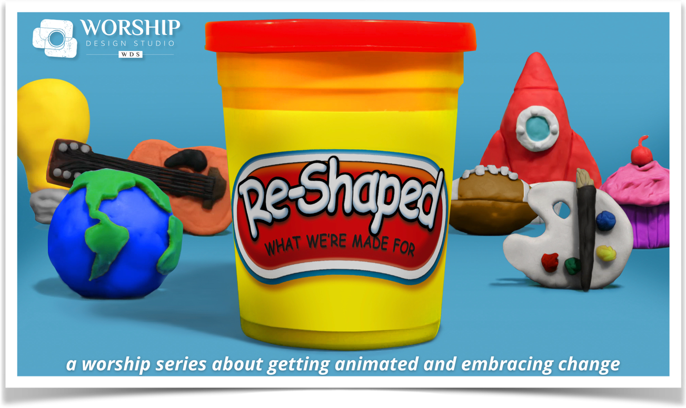
Story for All Ages
(Children’s + Time)

This worship series will hopefully get everyone nostalgic for those days of playing with Play-Doh or any kind of molding clay that changes shape. But children will no doubt be enthralled with the idea of having Play-Doh in the sanctuary and as part of the worship experience!

And the truth is that the time with children is often a time when adults as well as kids and youth get an “aha” about the theme for the day. So we are borrowing a phrase from our Unitarian Universalist friends in calling the time for children a “Story for All Ages.” The four iconic characters featured in children’s TV and movies and lifted up in these four weeks are great examples of stories that have captured our imagination and helped us learn and grow in readiness for change.

There are two things in this document: 1) a script for use in worship called “A Story for All Ages”; and 2) the “Play-Doh Contemplation” that can be used in a Sunday School, Religious Education, or home setting if families are worshiping at home.

And of course, let there be Play-Doh! Whatever shapes the children make, be sure to do a little photo shoot and consider using these photos in worship the next Sunday. Children will love seeing their creations on the big screen! And youth leaders, check out the Visuals and Media doc for links to stop-motion “how-to’s” that could be a really fun project before or throughout the series!

Have Fun!
Dr. Marcia McFee

Week 1
“We Were Made for This”

A Story for All Ages

Invite children of any age to join you. Invite them to stand in a circle rather than sit if you have room for children to do that. Since we will be making shapes with our bodies, it is better to have attention focused into the circle rather than shy children feeling like they are “on display” to the congregation. Be sure to acknowledge the children who may be watching a livestream at home or the recorded video afterwards. Leaving an opening in the circle near where the livestream camera is pointing is a great way to help them feel included (and be able to see your actions).

Good morning! Did you see all the Play-Doh in our worship space this morning?? That’s pretty unusual, isn’t it? Well, that’s what we are going to be talking about for a few weeks–change!

Sometimes we are going right along happily in our lives, and then something unusual happens that we aren’t used to. Something changes. We call it “out of the ordinary.” It is at that moment that knowing how to play and discover and have fun is really, really important. So we are going to help everyone remember that “we were made for this!” For play, for change, for adjusting to new things.

Look what I have here [show Gumby–either a real one or a picture].

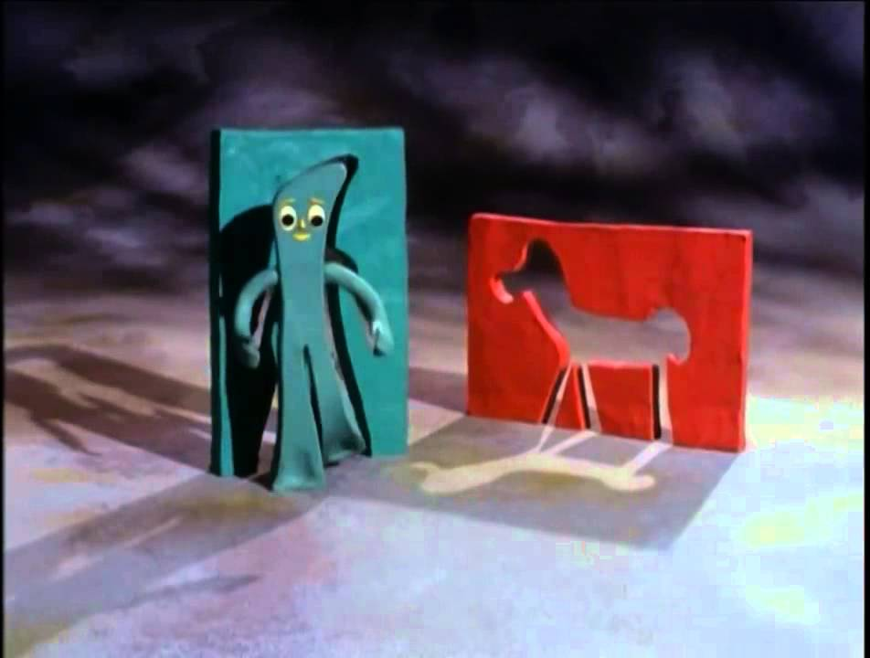
This is Gumby! He has been around since 1953! That means that a lot of grownups grew up with Gumby. Have YOU ever been introduced to Gumby?

Gumby is made up of a material that you can stretch and change. Gumby and his friend Poke (a clay horse) had their own TV show, and not only could they be changed into different positions in the show, they could go back into their clay ball form and change into anything!

[you could play the TV show opening video if you have projection technology]

Gumby has become a model for us to remember that we were made by God to be flexible. It helps us to grow and face anything that comes our way. That’s a pretty great talent God gave us!

So let’s “be Gumby” this morning. I’m going to make a shape out of Gumby and then we are going to “be Gumby” and make that shape.

[do this 3 or 4 times… if you don’t have an actual Gumby, here is a photo you could use on the screen or print out]

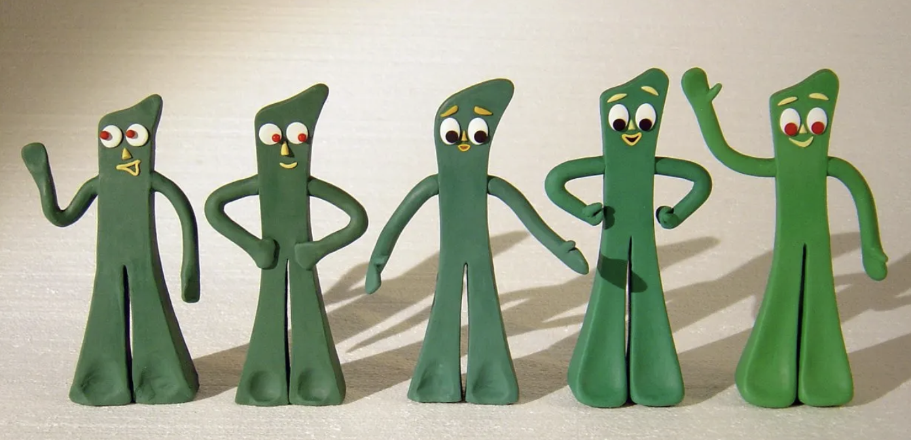

Great! I can see that you are all set and ready to be Gumby, to be flexible, whenever something unusual or out of the ordinary comes up. Let’s pray a repeat-after-me prayer poem:

I am a piece of God’s clay
I am a piece of God’s clay
And God invites us all to play
And God invites us all to play
When things are different we can say,
When things are different we can say,
“I can change, I’ll make a way!”
“I can change, I’ll make a way!”

Let’s pray: Dear God, thank you for making us ready for life’s changes by creating us to be flexible. We know you are with us always, helping us each and every day. Thank you! And all God’s children say, “Amen.” Amen.

Adapted Play-Doh Contemplation for Children

Leader: Let’s play with our Play-Doh! Let’s work on making anything you want!

[give children the chance to make something]

These are great! Tell me about them!

[give each child the chance to tell you about what they made]

Do you know what “change” means? [let them talk this out with you]

Yes, sometimes things are one way and then they become something else! That is “change.” [spend some time using some examples that the children will resonate with… moving, growing up, new year at school with new teacher, etc.]

So let’s make a change right now. I want you to think about how you could change what you made into something different! Will you do that? It doesn’t have to be a big change, just make your creation a little bit different somehow.

[allow time to do this… and if any child really doesn’t want to… that’s OK and a perfect opportunity to talk about how change is sometimes hard]

What did you make out of your original creation? [allow time for each child to tell you how they changed their creation]

Wow! That’s so great. Sometimes it can be really fun to discover how something can change and become something else. And even if we don’t want to at first, sometimes after the change happens, we find out it is even better! God made us with the ability to change and grow, just like your Play-Doh! It is a talent that we will use our whole lives. Great job!

Week 2:
“Inside Out”

A Story for All Ages

Invite children of any age to join you. Invite them to stand in a circle rather than sit if you have room for children to do that. Since we will be making shapes with our bodies, it is better to have attention focused into the circle rather than shy children feeling like they are “on display” to the congregation. Be sure to acknowledge the children who may be watching a livestream at home or the video afterwards. Leaving an opening in the circle near where the livestream camera is pointing is a great way to help them feel included (and be able to see your actions).

Good morning! Welcome to Week 2 of our worship series about change. I hope you are getting to have some fun with Play-Doh here at church and at perhaps even at home!

This week we are talking about how it FEELS to go through a change. I love the movie “Inside Out” because we get to meet a girl who lives in Minnesota–Riley is her name–and what happens inside her head when her family has to move to California. She has several characters who play her emotions, her feelings. Let me introduce them to you [use a photo either on the screen or on a paper]:

Here they are (see the images HERE):
Sadness is blue because they often feel blue.
Fear is pale purple because they often get scared.
Disgust is green because some things make them feel icky.
Anger is red because they get hot under the collar.





And Joy is yellow because they want to feel sunny and happy all the time!
I recognize all these characters. In fact, I think they are inside all of us, what do you think? Have you ever felt like these?

Let’s follow these pictures and let these characters come to life in us.

[Do a pantomime of making the body shapes and facial expressions of each character in the photos one at a time… invite the adults to do it with the children if you want… have fun with Joy’s upside-down position!]

What we learn in the story is that Riley needs each and every one of these emotions as she learns to deal with the change of moving from one city to another. Even though Joy would like for her to be happy all the time, Riley actually needs to allow all the feelings, including sadness, fear, disgust, and anger, to move through the difficult things and feel better about being in a new place and making new friends. Any change we go through–whether it is moving or changing grades and teachers or someone going away or even just getting older–will be filled with lots of emotions and that’s alright. Today we are hearing a Bible story that says that Jesus can help change us from the Inside Out and is always with us through every change.

This week when you play with your Play-Doh, maybe you can make different characters out of the different colors, just like the characters in the movie.

Let’s say our prayer poem. Repeat after me:

I am a piece of God’s clay
I am a piece of God’s clay
And God invites us all to play
And God invites us all to play
When things are different we can say,
When things are different we can say,
“I can change, I’ll make a way!”
“I can change, I’ll make a way!”

Let’s pray: Dear God, thank you for giving us so many ways to feel and work through the changes of life. We know you are with us always, helping us each and every day. Thank you! And all God’s children say, “Amen.” Amen.

Adapted Play-Doh Contemplation for Children

If you have a way of playing some scenes from the movie, here are a few good ones to choose from on YouTube, depending on your age groups:

Meet the Emotions
Introducing the Emotions
First Day at School
Joy Realizes Why Sadness is Important
A Compilation of “Best Scenes”

Leader: Do you have a story of when you felt joy or sadness or disgust or fear or anger?

[let children tell you some stories]

Let’s play with our Play-Doh! I want to invite you to make something that reminds you of the story you just told or another that you might remember. Anything you create is just fine… no, better than fine… it will be “just right.”

[give children the chance to make something and then invite them to share about it if they want]

Now let’s make one thing out of our individual creations! In the movie, all the emotions are very different but they help each other out. Let’s see what we can create together!

[take time to make a one creation out of all the separate pieces]
Week 3
“Everything Changes”

A Story for All Ages

Invite children of any age to join you. Invite them to stand in a circle rather than sit if you have room for children to do that. Since we will be making shapes with our bodies, it is better to have attention focused into the circle rather than shy children feeling like they are “on display” to the congregation. Be sure to acknowledge the children who may be watching a livestream at home or the recorded video afterwards. Leaving an opening in the circle near where the livestream camera is pointing is a great way to help them feel included (and be able to see your actions).

Good morning! I’m excited to see you today and talk about a very, very popular song that has become a favorite song of many people, many children AND grown-ups, in fact. What song from a Disney movie reached the top ten of Billboard’s Hot 100 singles list in 2014? Does anyone know? Here is a hint: it is sung in a very COLD movie! [let them guess… then pop up a picture on the screen or on a piece of paper]

Yes! In the movie Frozen, Elsa sings “Let it Go.” Today in our worship series about change, we are talking about how sometimes we have to let go in order to make room for something new–let go in order to change. That can be scary sometimes. In the movie Frozen, Elsa is a queen who has special powers to create ice and snow. But she is afraid of these powers, and so she hides far away so she won’t have to use them, and so she won’t hurt anyone by freezing them on the spot! But finally, with the help and love of her sister, Anna, she sees that she must use her powers for good to save the people of her home town.

Today in our scripture, Jesus says that we can’t always hold on to old ways and we can’t be afraid of letting go so that we can grow into something even more beautiful. If we stay the same way forever, it is like being frozen in time, like the frozen village in the movie. So I have an idea. When I say “Freeze!” let’s take a frozen position with our bodies. When I say “Let Go!” you can thaw out (like Olaf the Snowman when he is melting). Here we go… [do this a few times]

See how fun that was to change and change again? It’s OK to feel afraid, as we said last week, but God also gave us another big talent… letting go. Because change is part of life. Just like it is most fun to play again and again with Play-Doh rather than just make one thing and never change it, life can be wonderful even and especially because of the changes.

Let’s say our prayer poem. Repeat after me:

I am a piece of God’s clay
I am a piece of God’s clay
And God invites us all to play
And God invites us all to play
When things are different we can say,
When things are different we can say,
“I can change, I’ll make a way!”
“I can change, I’ll make a way!”

Let’s pray: Dear God, thank you for helping us let go of things that need to change. We know you are with us always, helping us each and every day. Thank you! And all God’s children say, “Amen.” Amen.

Adapted Play-Doh Contemplation for Children


If you have a way of playing a video from YouTube, here is a really fun Play-Doh animation with the characters from Frozen (the first 5 minutes):

Leader: Let’s play with our Play-Doh! What do you want to make?

[let the kids be inspired by the video and make whatever they want to… then…]

The scripture today is a story about Jesus telling people to let their lives be like seeds that are planted in the dark ground so they can burst open and grow up to be things like wheat and flowers and vegetables and whatever else they were created to be. Let’s make a garden out of our Play-Doh. Will you make some seeds that we can plant?

[give time to make small balls of Play-Doh… you might want to have a “garden” plot already made of Play-Doh so they can squish the balls… ahem, “plant” the seeds]

If you were a seed like the ones you just made, what would you want to sprout up to be? [Let the children share this… ] I love all those ideas! In order for that to happen, you would have to be planted as a seed, let go of being a seed, and sprout up to grow into something else… and that’s pretty much what we do all through our lives… we let go of being a child to become a teenager, and then let go of being a teenager to be an adult. Thank you for making these seeds. Let’s plant them in our Play-Doh garden and also make some that are already grown. [If you have time, let them make the “end result” with the Play-Doh].

Week 4
“Be En-Couraged”

A Story for All Ages

Invite children of any age to join you. Invite them to stand in a circle rather than sit if you have room for children to do that. Since we will be making shapes with our bodies, it is better to have attention focused into the circle rather than shy children feeling like they are “on display” to the congregation. Be sure to acknowledge the children who may be watching a livestream at home or the recorded video afterwards. Leaving an opening in the circle near where the livestream camera is pointing is a great way to help them feel included (and be able to see your actions).

Good morning! We’ve had so much fun with Play-Doh over the last three weeks, haven’t we? We have learned so much about how God created us to be malleable like clay, ready for anything that comes down the road. Speaking of road, there is another beloved character I’d like for us to talk about today. Does anyone watch Sesame Street? Who is red and furry on Sesame Street?

[let the children guess]

Yes! Elmo!


Show a photo… try THIS ONE of Elmo with Keven Clash

Elmo was born in 1983, created by a puppeteer named Kevin Clash. Kevin wanted to create a character that would be a red furry monster for Sesame Street… but you know what? Elmo the monster was so loved by kids he wasn’t a scary monster at all. Some babies even said “Elmo” before they learned to say “Mommy!”

Elmo became so loved that he made movies. One of Elmo’s movies was called Elmo in Grouchland. In the movie, he goes on a very long journey, and his friends sing him a song called “Take the First Step” to encourage him. One friend says, “I know exactly how you feel… you feel STUCK!” Do you ever feel like you are stuck in the mud and can’t get anywhere? Let’s pretend our feet are stuck and we are trying to walk but we can’t!

[Have some fun being stuck in the mud, pantomiming trying to get your feet out of a sticky mess]

Whew! It’s hard to walk when you’re stuck! So Elmo’s friends sing some encouragement to him [you can purchase the song on iTunes or just speak it]:

“Elmo get your chin up, things could be worse,
you could have your feet stuck down in the earth,
I don’t see no roots growing from your toes,
just furry little feet and they’re revvin’ revvin’ revvin’ to go!
Take that first step and soon you’ll see
just how brave your heart can be.
Look on up to the sky, take that first step and kiss your fears goodbye!”

And do you know what he does? He takes a step! [get them to take a step with you] And another! [take another one] And then he and all his friends start not only walking but dancing!

Oh, it is so much easier to deal with a change or a long journey to change when you have support and friends. Jesus encouraged Peter to take a big step out of a boat one time and then helped him when he got scared. Let’s say our repeat-after-me prayer poem.

I am a piece of God’s clay
I am a piece of God’s clay
And God invites us all to play
And God invites us all to play
When things are different we can say,
When things are different we can say,
“I can change, I’ll make a way!”
“I can change, I’ll make a way!”

Let’s pray: Dear God, thank you for helping us make a way, moving us from stuck in the mud to dancing our journey of change. We know you are with us always, helping us each and every day. Thank you! And all God’s children say, “Amen.” Amen.

Adapted Play-Doh Contemplation for Children

If you have a way of playing a video from YouTube, you can watch Elmo’s song HERE
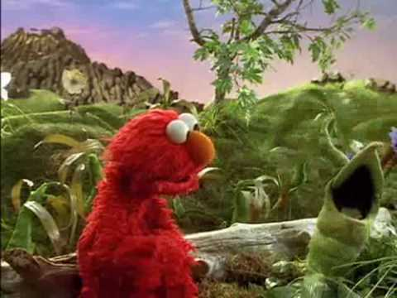
Leader: Let’s make this scene along the roadway of Elmo and his friends with our Play-Doh today! [Have some fun doing this]

Wow! Look at all these friends. Who are the people in your life that encourage you when you need it? [Spend some time talking about this, along with some other questions such as… ] What encouragement do you need today? Can we encourage each other? What words of encouragement can we remember to tell to other people?

If you want to, take a look at photos you’ve taken over the four weeks to remember the lessons learned through fun creativity about change.

