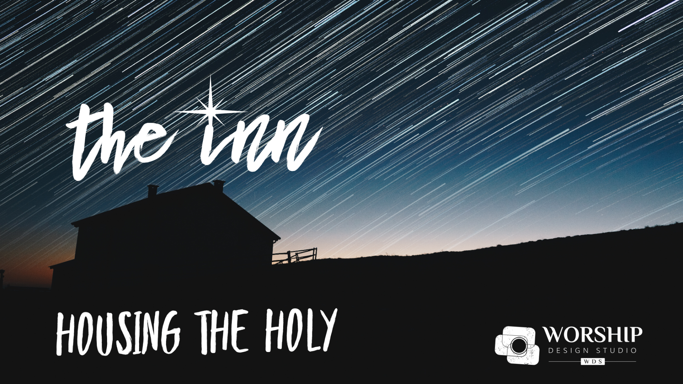
“The Inn”
Christmas Eve

Prelude

Greetings and Announcements

We Open the Door
(Threshold Moment)
“Hope Waits for Us at Advent”
Original song by Amanda Udis-Kessler, scores and recordings in downloads.

[music begins to underscore the following words]

Leader: All through the season of Advent as we prepared for Christmas, we’ve been exploring how we as a church can “make more room in the inn,” becoming more hospitable to the needs of our community. On this Christmas Eve, we declare that The Inn is open for the business of compassion with room enough for all! The long-awaited Messiah has been born and on him the light shines. We have only to open the doors of our lives and say “welcome.” Our Advent journey has led us to this moment when the light shining through the closed doors of life becomes an open door to new possibilities, new relationships. What a poignant moment for us this year as the light–the hope, peace, joy and love–multiplies from one illuminated heart and hand to another.
.
[soloist sings once without descant, perhaps slowly this night, with feeling;
if you are processing a light (see the Visual document for ideas),
it comes forward during the singing]
Love comes to us at Christmas.
Love comes to heal our souls.
Love brings an invitation
that our hearts might be made whole.
As we gather at the stable
in the darkness, glad and grateful
for the sacred in our midst,
for wonder and delight,
Christ is born in us this night.

Reader(s):

Tonight we offer the Lights of Hope, Peace, Joy, and Love
to illumine the Door of Welcome.
And we add the brightest light of all… the Light of the Newborn Jesus.
It shines bright like the star that rose over Bethlehem.
May this light also shine in our hearts, in our lives, and in our church.
May this light awaken us to possibilities and lead us to greater hospitality.
There IS room in this Inn, a House for the Holy.

[Repeat the theme song with the congregation, a tempo, with the descant as the Readers return to their seats]

Love comes to us at Christmas.
Love comes to heal our souls.
Love brings an invitation
that our hearts might be made whole.
As we gather at the stable
in the darkness, glad and grateful
for the sacred in our midst,
for wonder and delight,
Christ is born in us this night.

The Peace

The Light of Christ be with you!
And also with you!

As we rise in body or spirit for our opening hymn, I invite you to pass the peace of Christ with those around you (and the people worshiping at home)!

Opening Hymn/Song

“Joy to the World”
AAHH 197, Chalice 143, ELW 267, GTG 134, NCH 132, UMH 246, VT 240, VU 59, W&R 179

Children’s Time
See Children’s Time Document in downloads for scripts by Mark Burrows.

The Prophecy
Isaiah 9: 2-7 (NRSV)
[consider putting together an easy movement piece with people who walk simple patterns around the sanctuary holding encased candles in each hand (perhaps they come out of the “anchor image” barn door on the chancel and into the space)–turn lights down, have the reader read slowly, put some musical underscoring underneath and “voila!” you have a beautifully dramatized reading of this scripture]

The people who walked in darkness have seen a great light; those who lived in a land of deep darkness on them light has shined… [pause for music and movement for a bit] For a child has been born for us, a son given to us; authority rests upon his shoulders; and he is named Wonderful Counselor, Mighty God, Everlasting Father, Prince of Peace. His authority shall grow continually, and there shall be endless peace for the throne of David and his kingdom. He will establish and uphold it with justice and with righteousness from this time onward and forevermore. The zeal of the LORD of hosts will do this.

[add a hymn here if you want more congregational singing]

The Story
Luke 2: 1-7 (NRSV)

In those days a decree went out from Emperor Augustus that all the world should be registered. This was the first registration and was taken while Quirinius was governor of Syria. All went to their own towns to be registered. Joseph also went from the town of Nazareth in Galilee to Judea, to the city of David called Bethlehem, because he was descended from the house and family of David. He went to be registered with Mary, to whom he was engaged and who was expecting a child. While they were there, the time came for her to deliver her child. And she gave birth to her firstborn son and wrapped him in bands of cloth, and laid him in a manger, because there was no place for them in the inn.

Anthem
[or replace with congregational hymn or classic like “O Holy Night”]
“The Manger is Stranger”
[choral arrangement included in downloads; you may have sung this on Advent 1, making it an easy repeat for those choir members who are in town for Christmas Eve or even a scaled-down quartet of voices]
or
“Welcome to the Manger”
(for soloist/guitar - listen HERE)

Sermon
See downloads for Sermon Fodder document to get jumpstarted.

Prayers of the People
“Make of My Heart a Stable”
Original song by Amanda Udis-Kessler, scores and recordings in downloads.

[the refrain is played through once, then the people sing]

[Sung]
Make of my heart a stable,
a house for the holy,
a warm and sturdy place
for [hope] to live and grow.
[sparse musical underscoring may continue under the Leader’s words]

In this moment we open the doors of our hearts to honesty before God
about what we’ve done and left undone that created less hope in a hurting world.
Let us breathe out this regret… [pause to breathe out]
and breathe in the life-giving, for-giving Spirit of God… [pause to breathe in]
and out again with the Peace of Christ… [another breath out].

[Sung]
Make of my life a stable,
a house for the holy,
a warm and sturdy place
for [hope] to live and grow.
[sparse musical underscoring may continue under the Leader’s words]

In this moment we open the doors of our lives to the call of the Spirit,
inviting us to become more than we can ask or imagine.
Let us breathe out our fear… [pause to breathe out]
and breathe in the courage of the Spirit of God… [pause to breathe in]
and out again, with the Peace of Christ… [another breath out].

[Sung]
Make of our church a stable,
a house for the holy,
a warm and sturdy place
for [hope] to live and grow.
[music concludes]

In this moment we open the doors of this church, filling it with
the compassion of Christ for all those who are struggling.
We remember and pray for…

those who are suffering economic hardship, and insecurity in basic needs;
may abundance be shared.

… for those who are suffering mentally, finding it difficult to cope;
may paths open and hope return.

… for those who are suffering illness or injury;
may healing abound.

…. for those who are suffering loneliness and isolation;
may companionship and solace arrive.

… for those who are suffering discrimination, fear and violence;
may they know respect, respite, and safety.

May the Advent of Compassion be born in us,
reside within us,
move outward from us,
to meet the needs of the world,
making a house for the Holy that is each and every child of God.

We pray this in the name of Jesus, who taught us to pray:
[The Prayer of Jesus… don’t forget to print this prayer or have it on the screen for visitors who may not have it memorized (this is a good practice all the time, but especially on Christmas Eve)]

Communion Liturgy

[One of my favorite adaptations to sung responses for the Great Thanksgiving are ones created by my friend, Steve Garnaas-Holmes, using familiar Christmas tunes. The following liturgy is designed using those sung responses. As always, feel free to use something more familiar for your tradition. See Steve’s settings and download the musical parts HERE for your worship guide (I would NOT print all the words to the prayer below in your worship guide… only the music). Please note the citation at that link if you use/print Steve's music… and yes, he has given permission for livestreaming].
The Story Continues…
Luke 2: 8-20 (NRSV)

Leader (from the communion table): After Jesus was born, the visitors began to show up to his birthplace, spurred by the message of the angels. But what we know is that in the presence of Jesus there are no visitors, we are all family with a place reserved for each one of us… [continue with any other invitational language that is appropriate for your tradition]. And so, let us hear about those who gathered and join them in the presence of Jesus:

(Luke 2: 8-20) Nearby shepherds were living in the fields, guarding their sheep at night. The Lord’s angel stood before them, the Lord’s glory shone around them, and they were terrified. The angel said, “Don’t be afraid! Look! I bring good news to you—wonderful, joyous news for all people. Your savior is born today in David’s city. He is Christ the Lord. This is a sign for you: you will find a newborn baby wrapped snugly and lying in a manger.” Suddenly a great assembly of the heavenly forces was with the angel praising God. They said, “Glory to God in heaven, and on earth peace among those whom he favors.”

When the angels returned to heaven, the shepherds said to each other, “Let’s go right now to Bethlehem and see what’s happened. Let’s confirm what the Lord has revealed to us.” They went quickly and found Mary and Joseph, and the baby lying in the manger. [musical introduction for “Away in the Manger” tune could start here].

When they saw this, they reported what they had been told about this child. Everyone who heard it was amazed at what the shepherds told them. Mary committed these things to memory and considered them carefully. The shepherds returned home, glorifying and praising God for all they had heard and seen. Everything happened just as they had been told.
Sung Preface
(Tune: Away in a Manger, words below)

[sung]
The Lord be with you.
And also with you.
Lift up your hearts.
We lift them to God.
Now let us give thanks to the Lord our God.
How good it is to give thanks and praise!

[spoken]
We gather tonight at the Manger of Grace.
And it is right, and a good and joyful thing,
on this special night and always and everywhere,
to give thanks to you, creator of heaven and earth.

You, who breathed into us the same breath as the infant Jesus,
You, who crafted our every fiber just as you did your own Son,
You, who formed us in your own image–
that same newborn image of the One Who Walked Among Us,
Thanks and praise be to You!

Your intention was for every created thing to have a place,
to have vitality, to have sustenance in this world.
Join us to your purpose, offering hospitality and healing
to the suffering world.

And so,
with your people on earth
and all the company of heaven
we praise your name and join their unending hymn:

Sanctus
(Tune: Hark, the Herald Angels Sing, words below)

[sung]
Holy, holy, holy Lord,
God of power and might adored,
heaven and earth are shining bright
with the glory of your light.
Loud hosannas now we sing!
In the highest may they ring!
Blessed is the coming One, Christ, Emmanuel, your Son.
Glory in the highest! Holy God, your name be blessed!

[spoken]
Holy are you, and blessed is your Son Jesus Christ.
In the midst of a time of despair, oppression, division, and fear,
your gestation in the house of a holy womb–
through an unlikely midwife of salvific power–
brought Jesus, the Christ, into this world.

Into The Inn of simple means
came a life dedicated and anointed by the Spirit
to preach good news to the poor,
to proclaim release to the captives
and recovering of sight to the blind,
to set at liberty those who are oppressed,
and to announce that the time had come
when you would save your people.

A common birth for common people,
he healed the sick, fed the hungry,
and sat in houses at table with those who suffer,
and those who perpetuated suffering,
laying bare complicity and compassion.

His baptism, ministry, death, and resurrection
gave the blueprints for the building of church community,
and rejection of slavery to sin and death.
You made a new covenant with us
to be midwives, by water and the Spirit,
birthing more hope, more peace, more joy, more love in this world,
making more room in this house, at this table, for all.

When the Lord Jesus ascended,
he promised to be with us always,
in the power of your Word and Holy Spirit.

In another house, on another night–
the night in which he gave himself up for us–
he took bread, gave thanks to you, broke the bread,
gave it to his disciples, and said:
“Take, eat; this is my body which is given for you.
Do this in remembrance of me.”

When the supper was over, he took the cup,
gave thanks to you, gave it to his disciples, and said:

“Drink from this, all of you;
this is my blood of the new covenant,
poured out for you and for many
for the forgiveness of sins.
Do this, as often as you drink it,
in remembrance of me.”

And so,
in remembrance of your mighty acts in Jesus Christ,
we offer ourselves as a holy and living sacrifice,
in union with Christ’s offering for us,
as we proclaim the mystery of faith.

Memorial Acclamation
(Tune: We Three Kings, words below)

[sung]
Dying Christ destroyed our death.
Rising Christ restores our life.
Christ will come again in glory,
raising us all to life.
Oh, God of wonder, God of might,
God of love, our hearts delight:
feed us, guide us, walk beside us,
bless us with our gentle light.

[spoken]
Pour out your Holy Spirit on us gathered here,
and on these gifts of bread and wine.
Open our hearts in and through this act,
stripping away any excuse or fearful hesitation,
so that we will open our doors to the world
as the body of Christ, redeemed by his love.

By your Spirit make us one with Christ,
one with each other,
and one in ministry to all the world,
until Christ comes in final victory
and we feast at his heavenly banquet.

Through your Son Jesus Christ
with the Holy Spirit in your holy church,
all honor and glory is yours, almighty God,
now and forever.

Great Amen
(Tune: Infant Holy, Infant Lowly, words below)

[sung]
God our Mother, Christ our Brother, Spirit in these gifts you vow:
by your giving, in our living, we become your Body now.
Bread is broken, light revealing;
Word is spoken for our healing.
Make us all your Body now.
Amen, amen.
Breaking of the Bread and Lifting of the Cup
[Use your own words here in keeping with your tradition,
or do these actions deliberately in silence.]

Communion
[This is a good time to add more of the Christmas hymnody
that your congregation loves to sing on Christmas Eve]

Closing Carol
[Note: the following leader part is aspirational, hoping we will be post-pandemic enough to be in person, close together, and able to pass the light]

[the music begins to underscore as the candles begin to be lit in the congregation and lights are turned off, if they are not already]

Leader: Friends, this is the moment we’ve been waiting for. This is the moment we missed so much last year. Yes, we found ways to “pass the light” from one to another across the distance, knowing that nothing could extinguish the light of God in this world, knowing that Christ was with us and will always be. But oh, how good it is to be in this Holy House together. And for those who are watching online, we feel you, we know you are there, we are so glad that you join us in this moment with a candle lit at your own holy house. The Spirit makes it possible for us to be connected, as we found out last year. Let us sing this beloved song, Silent Night, that has been present through two centuries of ups and downs, steadfast in its message that the light still shines.

“Silent Night”
AAHH 211, Chalice 145, ELW 281, GTG 122, NCH 134, UMH 239, VT 244, VU 67, W&R 186

[After the last verse, continue the music softly as the leader moves toward the back door and says…]

Leader: I invite you to turn and face the doors of this church for the Benediction before extinguishing your light. As you turn, see the lighted faces of this gathered community and know that you belong in this family of love.

Benediction

As you go out into the world this night…

May God’s Door of Welcome
swing open in your heart and in your life.

May Christ’s humble first dwelling
remind you of the plenty you already know.

And may the Spirit lead you into
more possibility and hospitality that you can imagine,
making room in The Inn for all.

May it be so for you.
May it be so for us.
May it be so for this church.
Go in peace. Merry Christmas. Amen.

Postlude

