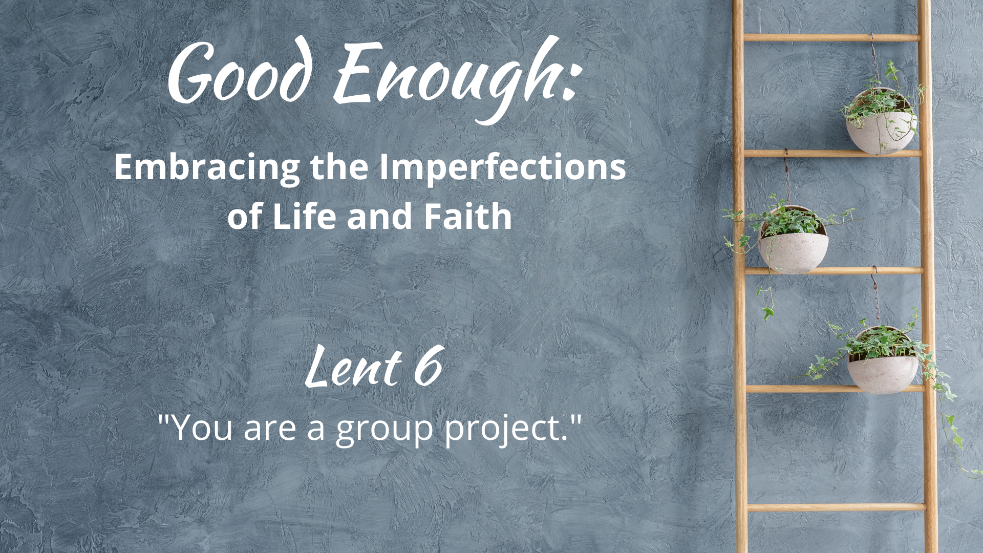

WE GATHER

Music for Gathering

Welcome
[invite children present to go to the back to help with the procession at the beginning of your welcome, giving them time to get back there and organized.]

Threshold
[accompaniment begins under the Leader’s words]

Leader: We stand at the precipice of Lent and Holy Week. This day moves from shouting and praising to a time of crying and lament. The drama of the story of Jesus’ last week reads like the book of our lives. Feeling hopeful one moment, we plummet the next as we deal with disappointment, danger, and grief. God’s incarnation on earth was not immune from this roller-coaster we call life. One thing we know, when the going gets rough, the last thing on our minds is climbing the ladder of self-improvement. We just want to survive, to be comforted, to have our pain known and embraced. And so we turn from the isolation of perfection and turn toward deep love. It is never too late to nurture the garden of relationships, for we are all a group project.

“Good Enough”
[sung by a soloist; children bring garden items forward (see Children’s Time scripts for suggestions for each week) to place on the ladder-garden]

What in our lives do we dream about for tomorrow, void of sorrow?
Time spent regretting decisions of our yesterdays, mistakes we made?
Sometimes we get what we get,
life disappoints us and yet,
God is still here and somehow, this faith is good enough. [repeat]

Calling on God
Based on Psalm 118

Leader: Let us pray together:

Holy One, God of Goodness,
we call out to you at the Gates of Righteousness,
sometimes in praise, sometimes in distress–sometimes both at once.
We long to be in your house in the presence of beloveds,
binding the festal procession with branches.
Open us this day to your love
in and through the webs of our relationships–
and in the simple and good enough moments that fill our days.
Amen.

The Children Lead Us

[See Children’s Time scripts]

Opening Hymn/Song
[you might want to do a couple of instrumental verses to allow for people to enjoy the parade before beginning to sing]
“Lord, What a Parade!”
Text by Carolyn Winfrey Gillette
Tune: LYONS 10.10.11.11 ("O Worship the King, All Glorious Above!”)

Honest Questions, Compassionate Response

Leader: Jesus orchestrated a low-budget parade into a city where he knew his days were numbered. “Get me a colt,” he said. Not a steed. Not a float. A young, green donkey (not the color, that’s horse-speak for not-ridden-alot-yet). And folks gathered and his friends started some liturgical shouting that ticked off the local priests. Life is hard and we all need friends and sometimes big, loud, praying that will not be messed with. We are created for interdependence. So all our hiding and pretending that we are “perfectly fine” all on our own just won’t work. Get on the donkey when you need to and let people lay down their cloaks for you and make some noise for you. ‘Cause you know you’ll do it for them too when the chips are down. What keeps you from connectedness with others? Let us take a moment of silent reflection…

Silent Reflection

Leader: Hear this compassionate word from the Letter to the Philippians: “Let the same mind be in you that was in Christ Jesus…”

Know that already, God is offering us freedom from isolation
as we are called into the kind of community Christ had in mind for all.
We are invited to the audacity of interdependence
so that we might recognize love in its giving and receiving.

And know, that despite our sometimes faltering steps,
in the name of Jesus Christ, you are being forgiven, even now.
In the name of Jesus Christ, you are forgiven.
Glory to God! Amen.

The Peace

[invite people to pass the peace in the manner to which you are accustomed, remembering to include the folx at home if you are live-streaming or recording]

WE PROCLAIM

First Reading
[selection from lectionary; chosen by preacher]

The Word in Music
[choral anthem; ensemble piece]
“Blessed is He”
(good for young voices and handbells)
or
“Tear Down the Walls”
by The Many

Gospel Reading
Luke 19: 28-40

After [Jesus] had said this, he went on ahead, going up to Jerusalem. When he had come near Bethphage and Bethany, at the place called the Mount of Olives, he sent two of the disciples, saying, “Go into the village ahead of you, and as you enter it you will find tied there a colt that has never been ridden. Untie it and bring it here. If anyone asks you, ‘Why are you untying it?’ just say this, ‘The Lord needs it.’”

So those who were sent departed and found it as he had told them. As they were untying the colt, its owners asked them, “Why are you untying the colt?” They said, “The Lord needs it.”

Then they brought it to Jesus; and after throwing their cloaks on the colt, they set Jesus on it. As he rode along, people kept spreading their cloaks on the road.

As he was now approaching the path down from the Mount of Olives, the whole multitude of the disciples began to praise God joyfully with a loud voice for all the deeds of power that they had seen, saying, “Blessed is the king who comes in the name of the Lord! Peace in heaven, and glory in the highest heaven!”

Some of the Pharisees in the crowd said to him, “Teacher, order your disciples to stop.” He answered, “I tell you, if these were silent, the stones would shout out.”

A Word of God that is still speaking,
Thanks be to God.

Thoughts about an Imperfect Life and Faith
“We are a group project.”

[see Sermon Fodder document for prompts]

Prayers of the People

[sung]
Though all along our daily pilgrim race
our treasures small and very few may be,
our souls are blest with God’s unending grace,
and that is enough, enough for me.
Oh, that’s enough for me,
God’s truth has set me free;
the love of Christ has sanctified my soul,
and that is enough for me.

[accompaniment slows to a meditative feel
and continues under the following leader words]

Leader: We are about to make a turn into Holy Week. As we do, we remember the suffering of that week is not simply located in the time and place of Jesus’ time. Suffering continues. Oppression is not eradicated. There are lonely, scared, hungry, homeless and despairing loved ones that are part of the “group project” that is humanity. And so we enter a time of prayer that parades of protest will turn one day to parades of joy.

[sung]
When food and raiment are not ever sure,
and simple fare is hard to get for some,
we work to share our goods with one and all,
and that is enough, enough for me.
Oh, that’s enough for me,
God’s truth has set me free;
a love like Christ’s is meant for ev’ry soul,
and that is enough for me.

[prayers of the people continue as you are accustomed]

Offering
[in the manner to which you are accustomed, insert offertory music if needed]

Doxology
Old 100th

Praise God from whom all blessings flow,
Praise Jesus Christ, our burdens know,
Praise Spirit through whom our hearts grow,
Praise Three-in-One, from here below.

Prayer after Offering

Generous God,
in light of your extravagant blessings–
no matter what the state of the world or our imperfect lives–
we offer our gifts and ourselves,
and know that you transform what we plant
into the produce of love.
Amen.

[Communion - insert on weeks that your church practices this ritual; see adaptable liturgy in separate Communion document]

Closing Hymn/Song
“Stand by Me”
Chalice 629; UMH 512; VT 595; W&R 495
or
“You Never Let Go” Songselect #4674166
A Blessing for When You Feel Lonely

“Blessed are we who cry out,
‘God, I need a friend to share the simple unaffected joys that come,
the troubles unbidden, those too heavy to sustain…’
Blessed are we, opening our hands in readiness,
to risk intimacy, to receive the gift of friendship, and give it in return.”

Benediction

And now, may the God who loves all of creation, especially the lonely bits,
and Jesus, our companion along this crooked path called life,
and the Holy Spirit, who loves to improvise in surprising ways,
go with you, dwell among you, and give you joy. Amen.

Choral Reprise
[sung slowly, in harmony]
God is still here and somehow, this faith is good enough.

Postlude

Worship Notes:

All liturgy and leader parts Marcia McFee © www.worshipdesignstudio.com/goodenough. Used and adapted with permission.

“Good Enough” theme song by Marsha Charles, Marcia McFee, Chuck Bell. Used with permission of Worship Design Studio.

“A Blessing for When You Feel Lonely” from Good Enough: 40’ish Devotionals for a Life of Imperfection by Kate Bowler and Jessica Richie. Used with permission. Purchase the book at https://katebowler.com/books/good-enough.

Music licenses: [insert your church’s licenses for congregational and choral music]

