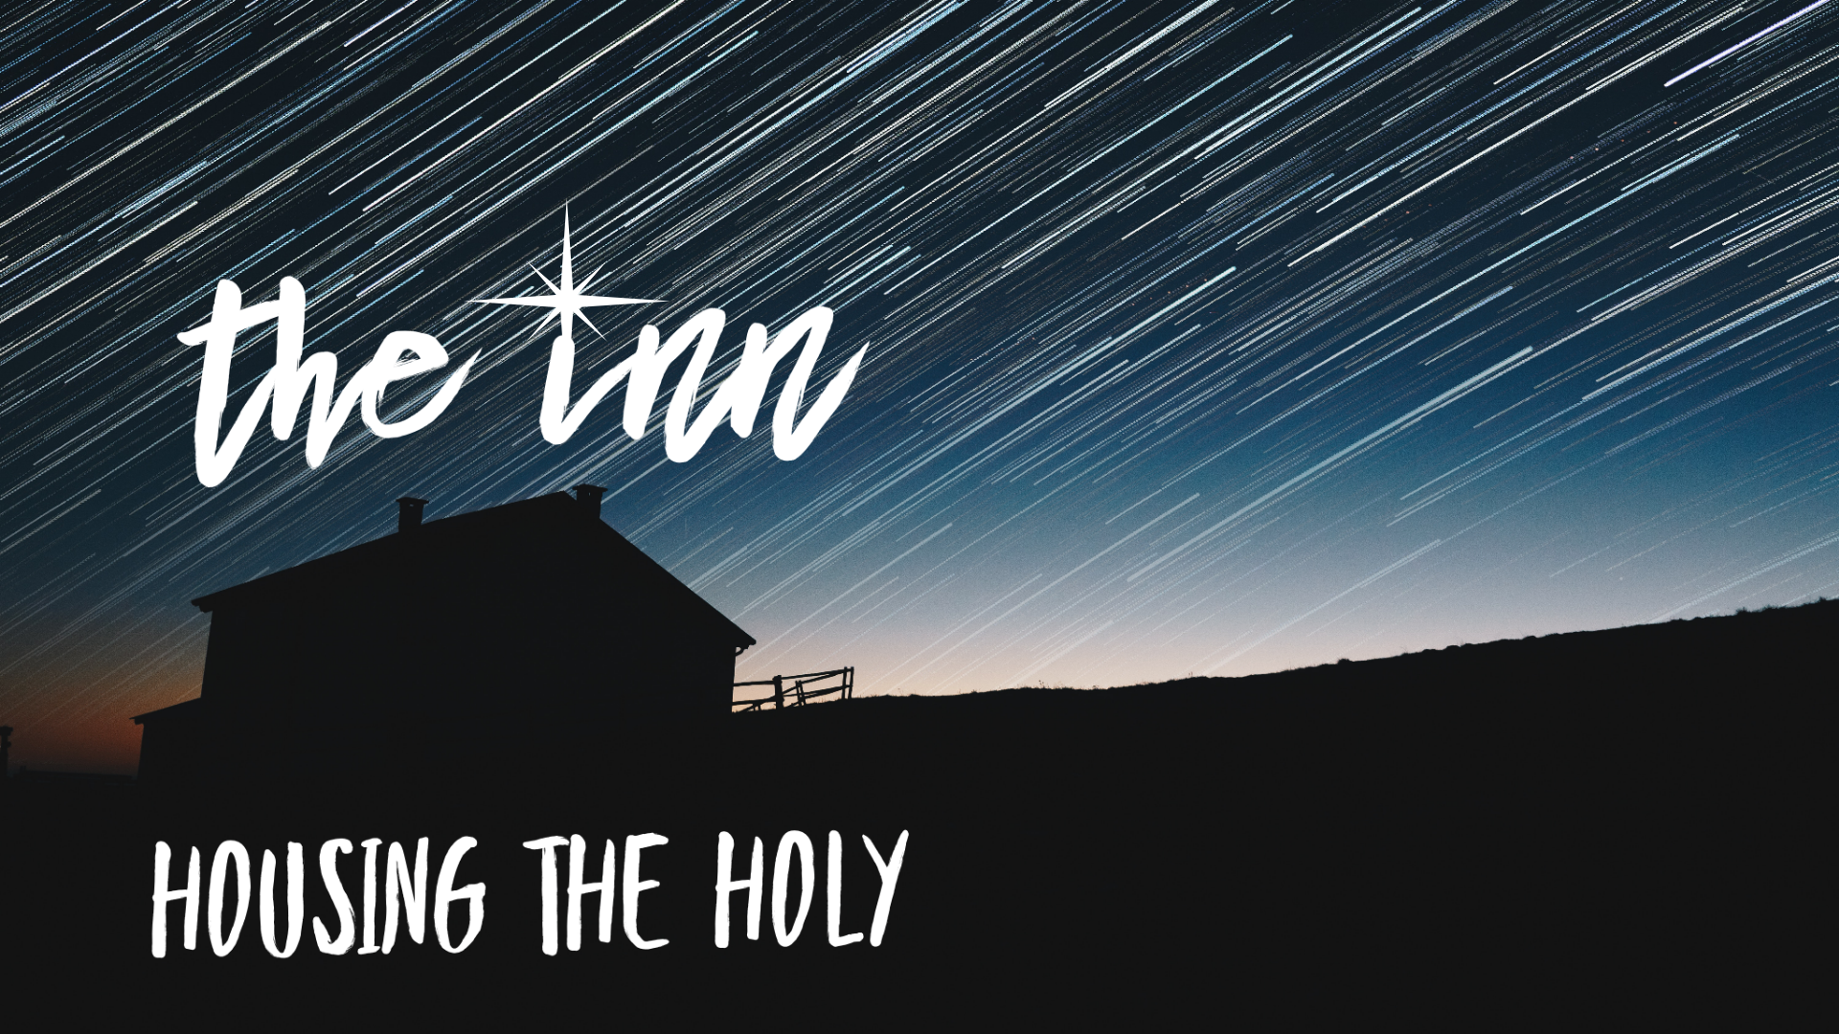


Did you ever consider that YOU are a “House for the Holy?”

That’s right. Your life–your very being–is a place where
hope, peace, joy, and love are housed.

At Christmas, we remember that Jesus was born into a simple stable
because there was no room in The Inn.
So no matter how simple you believe your self, or your home, or your life to be,
you are a containers for the Holy,
a place where Divine Light can shine into the dark corners of this world.

You have a part to play in this pageant we call “life” in this community.
You are sacred. You are worthy. You belong.

We hope this little booklet of weekly devotions will open the doors of your heart, mind, and soul, and offer you hope, peace, joy, and love.
You can use it on your own, you can share it with your family.
You can read it all at once or spread it out over weeks.

The doors of our church are open the next 5 weeks at the hours below.
Just come in and rest, get some peace, light a candle, or visit the meditation stations.
That’s it. Stewards will be present to be sure it is a safe space but you don’t have to talk to anyone if you prefer some solitude. There will be a place where you can let us know if you need anything. Prayers, food, assistance of any kind.
Our doors and our hearts are open. You are not alone.

First Church, corner of Main and 3rd St.
Open House hours: Thurs-Sat 4-7pm starting Dec 2

Things you could use at home to create your own sacred space:

Candles to make your own home-made Advent wreath

Decorate a door in your house by adding something to it over time through Christmas as a symbol of growing welcome and hospitality in your heart and in your house

A journal if you want to have more space to write and reflect

See the children’s devotional booklet for a fun way to include your whole family this year
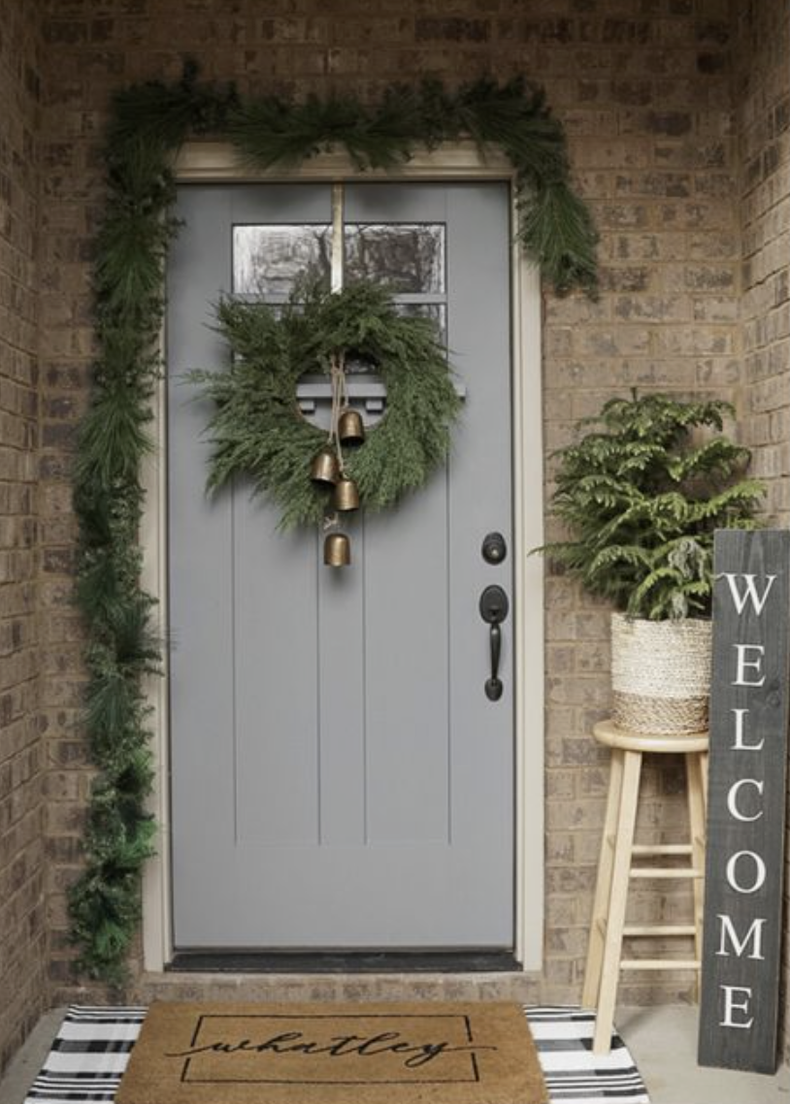




To find out more ways to connect during Advent/Christmas and get a digital copy of this devotional booklet, scan this QR code now or go to www.firstchurch.com/advent.

“Making Room”
First Week of Advent

Economic disparity runs rampant, locally and globally. As we enter the Advent season, how can our churches become houses where the Holy will be born anew–offering respite, sustenance and care, opening the doors ever wider to those seeking shelter from the onslaught of life? No one church can do it all, but each can do something. As we study the biblical prophets that call us to care for our neighbors and “make room in the inn,” the lonely and frightened spaces within us are filled with the light of Hope, Peace, Joy, and Love.

Read this out loud, and together if you are with others…

Hope waits for us at Advent
Hope waits for us to trust.
Hope waits for our commitment
to a land that’s kind and just.

In this time of preparation
for the work of co-creation,
for the birthing of a world
that heals the ones in pain.
Hope is born in us again!

Light a candle.

Today I offer the Light of Hope to illumine the Door of Welcome.
May this light shine in my heart, in my life, and in our community.
May Hope awaken me to possibilities and lead to greater hospitality.

There IS room in this Inn, a House for the Holy.
What could I/we do to offer hospitality and welcome
in the neighborhood this week?
Option with Children: If you are doing this with children,
you could do the activity for Week 1 here.

An Ancient Prayer
Psalm 25: 4-5

Make your ways known to me, Lord;
teach me your paths.
Lead me in your truth—teach it to me—
because you are the God who saves me.
I put my hope in you all day long.

A Poem
“An Open Space”
by John van de Laar

The calls are always there, God,
to be more, have more, do more,
Every corner of our lives
needs to be filled with something,
Every step, every word, every thought
must be pregnant with meaning and purpose,
We need to prevail, triumph,
win the race!
Except no one ever wins. Not really.
We run as fast as we can to stand still,
and so many get left behind,
broken, poor, depleted.

Perhaps, in this Advent waiting time,
we can learn to let go,
slow down,
open up;
Perhaps we can begin to clear away
some of the clutter,
and open up a space within us
for silence,
for stillness,
for hope,
for the Holy.
And maybe, just maybe,
as we create this open space
we will find more room in our lives
for generosity,
for laughter,
for connection,
for caring,
for love,

for life.
Space to write your thoughts about this poem:
Breath Prayer

Make of my heart a stable,
a house for the holy,
a warm and sturdy place
for hope to live and grow.

In this moment we open the doors of our hearts,
letting go of all we do not need.
Take a deep breath in…
and then breathe out regret…
and breathe in forgiveness…
and out again, inviting peace.

In this moment we open the doors of our hearts to the Spirit,
inviting us to become more than we can ask or imagine.
Take a deep breath in…
and then breathe out fear…
and breathe in courage…
and out again, inviting hope.


In this moment we open the doors of our hearts,
Feel free to write things in the margins–people you know or news you’ve heard–as a way of praying
filling it with compassion for all those who are struggling.
We remember and pray for…

… those who are suffering economic hardship, and insecurity in basic needs;
may abundance be shared.

… those who are suffering mentally, finding it difficult to cope;
may paths open and hope return.

… those who are suffering illness or injury;
may healing abound.

…. those who are suffering loneliness and isolation;
may companionship and solace arrive.

… those who are suffering discrimination, fear and violence;
may they know respect, respite, and safety.

May the Advent of Compassion be born in us,
reside within us,
move outward from us,
to meet the needs of the world,
making a house for the Holy that is each and every child of God.

A Blessing

May God’s Door of Welcome
swing open just a little bit more.

May Jesus’ humble first dwelling
remind you of the plenty you already know.

And may the Spirit lead you into
more possibility and hospitality that you can imagine,
making room in The Inn for all.

May it be so.

“A Place at the Table”
Second Week of Advent

Like the childhood game of “musical chairs,” we are convinced that there are not enough places at the table. And so we shrink the guest list just in case there is not enough, and we scramble to occupy the chairs first. And yet our sacred texts invite us to imagine and make real the gathering of all people to the table–this is what is right and good.

Read this out loud, and together if you are with others…

Peace waits for us at Advent
Peace waits for us to rest.
Peace waits for our acceptance
of the truth that we are blessed.

In this time of preparation
for the work of co-creation,
for the birthing of a world
of gentleness and play.
Peace is born in us each day!

Light two candles.

Today I offer the Light of Hope and Peace to illumine the Door of Welcome.
May this light shine in my heart, in my life, and in this community.
May Peace awaken us to possibilities and lead us to greater hospitality.

There IS room in this Inn, a House for the Holy.
What could I/we do to help someone feel more peace?

Option with Children: If you are doing this with children,
you could do the activity for Week 2 here.

An Ancient Invitation
Baruch 5: 1-5

Take off your mourning clothes and oppression, Jerusalem!
Dress yourself in the dignity of God’s glory forever.
Wrap the justice that comes from God around yourself like a robe.
Place the eternal one’s glory on your head like a crown.
God will show your brilliance everywhere under heaven.
God will give you this name by which to be called forever:
The Peace That Comes from Justice,
The Honor That Come from Reverence for God!
Get up, Jerusalem!
Stand on the high place and look around to the east!
See your children gathered from the west to the east
by the holy one’s word as they rejoice that God has remembered them.

A Poem
“Counting Chairs”
by John van de Laar

We love counting chairs, Jesus
and measuring the size of your table;
We check out each seat,
trying to work out who gets to sit where,
and which seats are the best;
We check out the people around us—our competition!
and develop our strategy to make sure
we get the best seat possible;
We put ourselves in your place,
deciding who, in our opinion, deserves a seat
and who doesn’t.

But then you arrive,
and suddenly the table seems bigger
than we could ever imagine,
there are more chairs than we can count,
and you are throwing your arms around people
that we would never allow to sit with us.
And the feast! What a spread!
There is food in abundance,
and wine flowing so freely!

The scarcity we believed was everywhere
is nowhere to be seen
at your table, Jesus!
the welcome is extravagant
and overwhelming!
And strangely, now that we see this,
we no longer need to count the chairs,
and it doesn’t seem to matter
Space to write your thoughts about this poem:
where we sit.
Breath Prayer

Make of my heart a stable,
a house for the holy,
a warm and sturdy place
for hope to live and grow.

In this moment we open the doors of our hearts,
letting go of all we do not need.
Take a deep breath in…
and then breathe out regret…
and breathe in forgiveness…
and out again, inviting peace.

In this moment we open the doors of our hearts to the Spirit,
inviting us to become more than we can ask or imagine.
Take a deep breath in…
and then breathe out fear…
and breathe in courage…
and out again, inviting hope.

In this moment we open the doors of our hearts,
filling it with compassion for all those who are struggling.
We remember and pray for…
… those who are suffering economic hardship, and insecurity in basic needs;
may abundance be shared.

… those who are suffering mentally, finding it difficult to cope;
may paths open and hope return.

… those who are suffering illness or injury;
may healing abound.

…. those who are suffering loneliness and isolation;
may companionship and solace arrive.

… those who are suffering discrimination, fear and violence;
may they know respect, respite, and safety.

May the Advent of Compassion be born in us,
reside within us, move outward from us,
to meet the needs of the world,
making a house for the Holy that is each and every child of God.

A Blessing

May God’s Door of Welcome
swing open just a little bit more.
May Jesus’ humble first dwelling
remind you of the plenty you already know.
And may the Spirit lead you into
more possibility and hospitality that you can imagine,
making room in The Inn for all. May it be so.

“How Much is Enough?”
Third Week of Advent

Prophets throughout the ages have invited people to live with “changed hearts and lives,” making sure no one is cheated or left without the basic necessities of life. A full life of joy is the birthright of all people. May we act to make it so.

Read this out loud, and together if you are with others…

Joy waits for us at Advent
Joy waits for us to sing.
Joy waits for our amazement
at the grace in everything.

In this time of preparation
for the work of co-creation,
for the birthing of a world
where wonder is restored.
Joy is born in us once more!

Light three candles.

Today I add the Light of Joy to Hope and Peace, to illumine the Door of Welcome.
May this light shine in my heart, in my life, and in this community.
May Peace awaken us to possibilities and lead us to greater hospitality.
There IS room in this Inn, a House for the Holy.
What could I/we do to add more joy to the life of someone
who is not feeling that right now? to make sure someone else also has “enough?”

Option with Children: If you are doing this with children,
you could do the activity for Week 3 here.

An Ancient Proclamation
Isaiah 12: 2-6

God is indeed my salvation;
I will trust and won’t be afraid.
Yah, the Lord, is my strength and my shield;
he has become my salvation.
You will draw water with joy from the springs of salvation.
And you will say on that day:
“Thank the Lord; call on God’s name;
proclaim God’s deeds among the peoples;
declare that God’s name is exalted.
Sing to the Lord, who has done glorious things;
proclaim this throughout all the earth.”
Shout and sing for joy, city of Zion,
because the holy one of Israel is great among you.

A Poem
“Enough”
by John van de Laar

Worry and stress are not hard for us, God,
we do them without thinking.

There is always the potential of threat
to our security,
our comfort,
our health,
our relationships,
our lives,
and we foolishly think that we could silence the fear
if we just had enough money,
enough insurance,
enough toys,
enough stored away for a rainy day.
It’s never enough, though;
the voice of our fear will not be dismissed so easily.

But, in the small, silent places within us is another voice;
one that beckons us into the foolishness of faith,
that points our gaze to the birds and the flowers,
that, in unguarded moments, lets our muscles relax,
and our hearts lean into loved ones;
In unexpected whispers we hear it,
calling us to remember your promises,
your grace,
your faithfulness;
And, suddenly, we discover
that it is enough.
Space to write your thoughts about this poem:
Breath Prayer

Make of my heart a stable,
a house for the holy,
a warm and sturdy place
for hope to live and grow.

In this moment we open the doors of our hearts,
letting go of all we do not need.
Take a deep breath in…
and then breathe out regret…
and breathe in forgiveness…
and out again, inviting peace.

In this moment we open the doors of our hearts to the Spirit,
inviting us to become more than we can ask or imagine.
Take a deep breath in…
and then breathe out fear…
and breathe in courage…
and out again, inviting hope.

In this moment we open the doors of our hearts,
filling it with compassion for all those who are struggling.
We remember and pray for…
… those who are suffering economic hardship, and insecurity in basic needs;
may abundance be shared.

… those who are suffering mentally, finding it difficult to cope;
may paths open and hope return.

… those who are suffering illness or injury;
may healing abound.

…. those who are suffering loneliness and isolation;
may companionship and solace arrive.

… those who are suffering discrimination, fear and violence;
may they know respect, respite, and safety.

May the Advent of Compassion be born in us,
reside within us, move outward from us,
to meet the needs of the world,
making a house for the Holy that is each and every child of God.

A Blessing

May God’s Door of Welcome
swing open just a little bit more.

May Jesus’ humble first dwelling
remind you of the plenty you already know.

And may the Spirit lead you into
more possibility and hospitality that you can imagine,
making room in The Inn for all.
May it be so.

“A Room with a View”
Fourth Week of Advent

Mary was the original house for the holy. She was “the inn,” her womb gestating love for the world. With all her heart, she proclaims that the lowly are lifted, the hungry are fed, mercy reigns. Like Mary, we must envision, must see, must act on a better vision for the world that we are called to co-create. What is the view from the room that God has prepared?

Read this out loud, and together if you are with others…

Love waits for us at Advent
Love waits for us to care.
Love waits for our compassion
freely offered, freely shared.

In this time of preparation
for the work of co-creation,
for the birthing of a world
where faith shapes all we do.
Love is born in us anew!

Light four candles.

Today I add the Light of Love, along with Joy, Hope and Peace,
to illumine the Door of Welcome.
May this light shine in my heart, in my life, and in this community.
May Love awaken us to possibilities and lead us to greater hospitality.

There IS room in this Inn, a House for the Holy.
What could I/we do to help create a community more full of love? How could I be more loving in my own life (to myself and to others)?

Option with Children: If you are doing this with children,
you could do the activity for Week 4 here.

An Ancient Prophecy
Isaiah 12: 2-6
Mary said,
“With all my heart I glorify the Lord!
In the depths of who I am I rejoice in God my savior.
He has looked with favor on the low status of his servant.
Look! From now on, everyone will consider me highly favored
because the mighty one has done great things for me.
Holy is his name.
He shows mercy to everyone,
from one generation to the next,
who honors him as God.
He has shown strength with his arm.
He has scattered those with arrogant thoughts and proud inclinations.
He has pulled the powerful down from their thrones
and lifted up the lowly.
He has filled the hungry with good things
and sent the rich away empty-handed.
He has come to the aid of his servant Israel,
remembering his mercy,
just as he promised to our ancestors,
to Abraham and to Abraham’s descendants forever.”

Another Way to Sing Mary’s Song
“Magnificat”
by John van de Laar

We praise you, Lord,
and our spirits rejoice in you—our Savior;

For you take notice of the unnoticeable,
and transform them into the blessed;
You are strong and true to yourself and all that is good
in everything you are and do and say;
and you do great things for us;
Through the ages you have shown compassion
to those who trust you,
And in your strength you have scattered
those who are arrogant and abusive;

You have made the thrones of tyrants topple
and you have made humble people into leaders of many;
You have cared for and provided for those who have nothing,
and you have left the over-satisfied with empty hands;

You have always been a help to your people,
and have shown mercy when we have gone astray;
You made this promise to our ancestors,
and you continue to stay true to it even now.

We praise you, Lord,

and our spirits rejoice in you—our Savior.
Space to write your thoughts about this poem:
Breath Prayer

Make of my heart a stable,
a house for the holy,
a warm and sturdy place
for hope to live and grow.

In this moment we open the doors of our hearts,
letting go of all we do not need.
Take a deep breath in…
and then breathe out regret…
and breathe in forgiveness…
and out again, inviting peace.
In this moment we open the doors of our hearts to the Spirit,
inviting us to become more than we can ask or imagine.
Take a deep breath in…
and then breathe out fear…
and breathe in courage…
and out again, inviting hope.

In this moment we open the doors of our hearts,
filling it with compassion for all those who are struggling.
We remember and pray for…
… those who are suffering economic hardship, and insecurity in basic needs;
may abundance be shared.

… those who are suffering mentally, finding it difficult to cope;
may paths open and hope return.

… those who are suffering illness or injury;
may healing abound.

…. those who are suffering loneliness and isolation;
may companionship and solace arrive.

… those who are suffering discrimination, fear and violence;
may they know respect, respite, and safety.

May the Advent of Compassion be born in us,
reside within us, move outward from us,
to meet the needs of the world,
making a house for the Holy that is each and every child of God.

A Blessing

May God’s Door of Welcome
swing open just a little bit more.
May Jesus’ humble first dwelling
remind you of the plenty you already know.
And may the Spirit lead you into
more possibility and hospitality that you can imagine,
making room in The Inn for all.
May it be so.

“The Inn”

Christmas Eve
We will have two Christmas Eve services at the church:
5pm Family Christmas
7pm Communion Service

Please join us in the sanctuary if you can or watch us online HERE

If those times do not work for you, the following meditation will work well for a time of reflection and prayer. Put on your favorite Christmas music, light your candles, pour the hot chocolate, and settle in for a story of mystery and hospitality.
All through the season of Advent as we prepared for Christmas, we’ve been exploring how we can “make more room in the inn,” becoming more hospitable to the needs of our community. On this Christmas Eve, we declare that The Inn is open for the business of compassion with room enough for all! The long-awaited Messiah has been born and on him the light shines. We have only to open the doors of our lives and say “welcome.” Our Advent journey has led us to this moment when the light shining through the closed doors in life becomes an open door to new possibilities, new relationships.

Read this out loud, and together if you are with others…

Love comes to us at Christmas
Love comes to heal our souls.
Love brings an invitation
that our hearts might be made whole.

As we gather at the stable
in the darkness, glad and grateful
for the sacred in our midst,
for wonder and delight,
Christ is born in us this night.

Light five candles.

Tonight I offer the Lights of Hope, Peace, Joy, and Love
to illumine the Door of Welcome.
And I add the brightest light of all… the Light of the Newborn Jesus.
It shines bright like the star that rose over Bethlehem.
May this light also shine in our hearts, in our lives, and in our community.
May this light awaken us to possibilities and lead us to greater hospitality.

There IS room in this Inn, a House for the Holy.
What are you feeling in your heart this night? Likely it is a mix of emotions, which is so very human–exactly what God, in the form of Jesus, came to experience. Can you imagine all that Mary and Joseph were feeling?
Option with Children: If you are doing this with children,
you could do the activity for Christmas Eve here.

The Beloved Story
Luke 2: 1-7

In those days a decree went out from Emperor Augustus that all the world should be registered. This was the first registration and was taken while Quirinius was governor of Syria. All went to their own towns to be registered. Joseph also went from the town of Nazareth in Galilee to Judea, to the city of David called Bethlehem, because he was descended from the house and family of David. He went to be registered with Mary, to whom he was engaged and who was expecting a child. While they were there, the time came for her to deliver her child. And she gave birth to her firstborn son and wrapped him in bands of cloth, and laid him in a manger, because there was no place for them in the inn.

A Poem
“Welcome to Our World”
by John van de Laar
In our more cynical or despairing moments,
we wrestle with faith
and with the idea of you coming to us, O God;
But, somewhere in our hearts we know,
that we do not need you to come,
because you have always been here
with us,
among us,
within us.

And so now, as we welcome you again,
we acknowledge that you need no welcome;
it is we who need to remember
who need to see again your presence,
who need to allow your ‘with-us-ness’
to flood our hearts and lives.

Welcome to our world, Jesus,
but more importantly, we thank you
for welcoming us

into your ever-coming, always-present world. Amen.
Space to write your thoughts about this poem:
Breath Prayer

Make of my heart a stable,
a house for the holy,
a warm and sturdy place
for hope to live and grow.

In this moment we open the doors of our hearts,
letting go of all we do not need.
Take a deep breath in…
and then breathe out regret…
and breathe in forgiveness…
and out again, inviting peace.

In this moment we open the doors of our hearts to the Spirit,
inviting us to become more than we can ask or imagine.
Take a deep breath in…
and then breathe out fear…
and breathe in courage…
and out again, inviting hope.

In this moment we open the doors of our hearts,
filling it with compassion for all those who are struggling.
We remember and pray for…

… those who are suffering economic hardship, and insecurity in basic needs;
may abundance be shared.

… those who are suffering mentally, finding it difficult to cope;
may paths open and hope return.

… those who are suffering illness or injury;
may healing abound.

…. those who are suffering loneliness and isolation;
may companionship and solace arrive.

… those who are suffering discrimination, fear and violence;
may they know respect, respite, and safety.

May the Christ of Compassion be born in us,
reside within us, move outward from us,
to meet the needs of the world,
making a house for the Holy that is each and every child of God.

The Story Continues

After Jesus was born, the visitors began to show up to his birthplace, spurred by the message of the angels. But what we know is that in the presence of Jesus there are no visitors, we are all family and there is room for all in the house of the holy. And so, let us hear about those who gathered, and let us join them in the presence of Jesus:

(Luke 2: 8-20) “Nearby shepherds were living in the fields, guarding their sheep at night. The Lord’s angel stood before them, the Lord’s glory shone around them, and they were terrified. The angel said, “Don’t be afraid! Look! I bring good news to you—wonderful, joyous news for all people. Your savior is born today in David’s city. He is Christ the Lord. This is a sign for you: you will find a newborn baby wrapped snugly and lying in a manger.” Suddenly a great assembly of the heavenly forces was with the angel praising God. They said, “Glory to God in heaven, and on earth peace among those whom he favors.”

When the angels returned to heaven, the shepherds said to each other, “Let’s go right now to Bethlehem and see what’s happened. Let’s confirm what the Lord has revealed to us.” They went quickly and found Mary and Joseph, and the baby lying in the manger.

When they saw this, they reported what they had been told about this child. Everyone who heard it was amazed at what the shepherds told them. Mary committed these things to memory and considered them carefully. The shepherds returned home, glorifying and praising God for all they had heard and seen. Everything happened just as they had been told.”

Pick up your fifth candle. Imagine what the baby is doing, what the parents are doing, the animals, the shepherds, that first night in the world together,
and then sing softly or whisper so as not to wake the baby.

Silent night, holy night,
all is calm, all is bright.
‘Round yon virgin, mother and child,
holy infant, so tender and mild.
Sleep in heavenly peace,
sleep in heavenly peace.

A Blessing

May God’s Door of Welcome
swing open just a little bit more.

May Jesus’ humble first dwelling
remind you of the plenty you already know.

And may the Spirit lead you into
more possibility and hospitality that you can imagine,
making room in The Inn for all.
May it be so.
Amen.

“Dwelling”
Sunday after Christmas

Developed in the 14th century, the word “dwell” became known as a “lingering” or “abiding.” It had connections to “in-habit”–another word developed at that time. After an Advent/Christmas season of focusing on housing the holy, how will we linger and abide in this habit of hospitality? What habits did you invite into your heart in this season that you desire to take with you into the new year? How could you help sustain the dwelling places that feed, house, clothe those who need it most?

Read this out loud, and together if you are with others…

Love comes to us at Christmas
Love comes to heal our souls.
Love brings an invitation
that our hearts might be made whole.

As we gather at the stable
in the darkness, glad and grateful
for the sacred in our midst,
for wonder and delight,
Christ is born in us this night.

Light five candles.

Today we light the Christ Candle once again that illumines the Door of Welcome.
May this light shine in our hearts, in our lives, and in our community.
May Christ’s Light awaken us to possibilities and lead us to greater hospitality.
There IS room in this Inn, a House for the Holy.

Option with Children: If you are doing this with children,
you could do the activity for Week after Christmas here.

Ancient Advice for Life
Colossians 3:12-17

As God’s chosen ones, holy and beloved, clothe yourselves with compassion, kindness, humility, meekness, and patience. Bear with one another and, if anyone has a complaint against another, forgive each other; just as the Lord has forgiven you, so you also must forgive. Above all, clothe yourselves with love, which binds everything together in perfect harmony. And let the peace of Christ rule in your hearts, to which indeed you were called in the one body. And be thankful. Let the word of Christ dwell in you richly; teach and admonish one another in all wisdom; and with gratitude in your hearts sing psalms, hymns, and spiritual songs to God. And whatever you do, in word or deed, do everything in the name of the Lord Jesus, giving thanks to [Abba God] through him.

A Prayer Poem
“Homes for the Holy”
by John van de Laar

It’s a radical thing to claim
if you really think about it:
that God inhabits humanity;
that the Eternal Divine would dwell
in temporal human hearts, minds, and bodies;
But that is the unavoidable truth
that Christmas dares to proclaim.

The great mystery is that this indwelling
is not a once-off, never-to-be-repeated event;
Yes, Christ is God incarnate,
but so is the cosmos!
And since the Divine Spirit lives in us too,
so are we!
We are homes for the Holy!

As this truly awesome reality sinks into our souls,
we hear the Spirit’s whisper:
that we can live in the power of this truth;
that we can host God’s holy presence
not just in this season, but always!
And we can carry the Divine presence,
grace, and compassion
to all who need to find a home
within the Divine Life.

Thank you God, for giving us the dignity
of allowing us to be your Divine dwelling,
And for giving us the chance
to help the homeless ones
—whether physically or spiritually—
find their place within your Divine hospitality. Amen.
Breath Prayer
Space to write your thoughts about this poem:

Make of my heart a stable,
a house for the holy,
a warm and sturdy place
for hope to live and grow.

In this moment we open the doors of our hearts,
letting go of all we do not need.
Take a deep breath in…
and then breathe out regret…
and breathe in forgiveness…
and out again, inviting peace.
In this moment we open the doors of our hearts to the Spirit,
inviting us to become more than we can ask or imagine.
Take a deep breath in…
and then breathe out fear…
and breathe in courage…
and out again, inviting hope.

In this moment we open the doors of our hearts,
filling it with compassion for all those who are struggling.
We remember and pray for…
… those who are suffering economic hardship, and insecurity in basic needs;
may abundance be shared.

… those who are suffering mentally, finding it difficult to cope;
may paths open and hope return.

… those who are suffering illness or injury;
may healing abound.

…. those who are suffering loneliness and isolation;
may companionship and solace arrive.

… those who are suffering discrimination, fear and violence;
may they know respect, respite, and safety.

May the Advent of Compassion be born in us,
reside within us, move outward from us,
to meet the needs of the world,
making a house for the Holy that is each and every child of God.

A Blessing

May God’s Door of Welcome
swing open just a little bit more.
May Jesus’ humble first dwelling
remind you of the plenty you already know.
And may the Spirit lead you into
more possibility and hospitality that you can imagine,
making room in The Inn for all.
May it be so.

