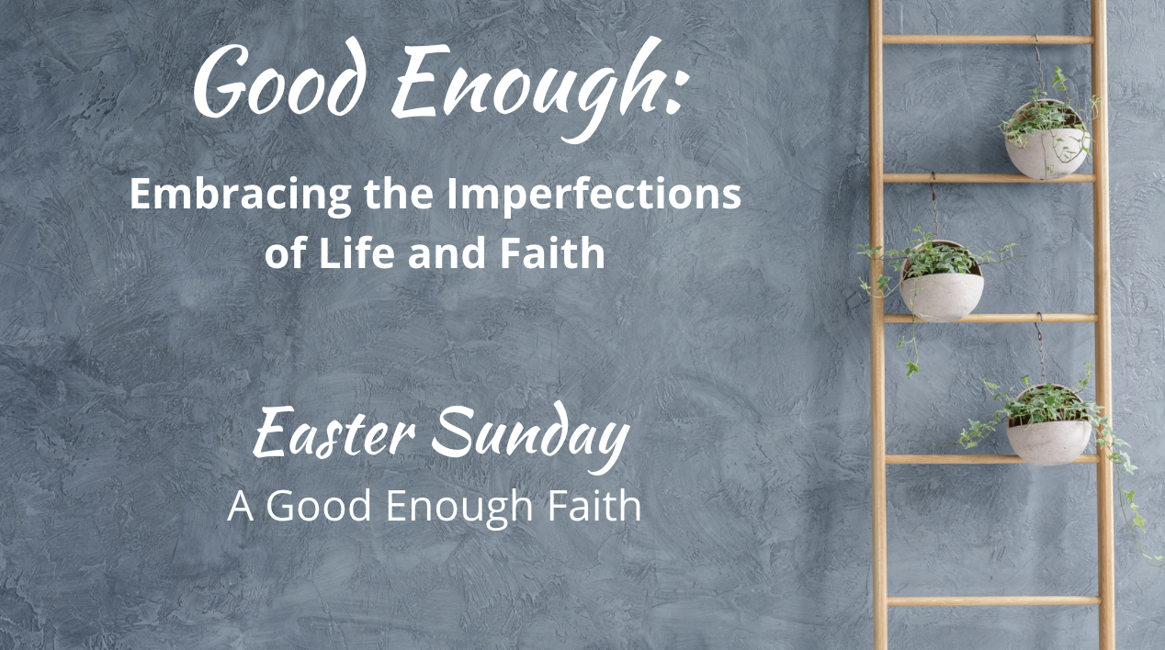

Easter Vigil/Easter Sunday
A Good Enough Faith

Easter is one of the days when our traditions are most important. I grew up in the First United Methodist Church, Adrian, Missouri. Every Easter we would have a sunrise service, then pancakes, then Easter service. We didn’t have a flowering cross, which I only heard of as an adult. But maybe yours does and you wouldn’t think of not doing that.

This document contains “pieces” of liturgy, visuals, and media ideas that fit the theme that you could choose to include (or not) in your Easter Sunday order of worship. We have gathered several ideas in our various worship arts categories, and then below that, scripted ideas that you can adapt. You might incorporate any of these into a late-night vigil, a sunrise service, or Easter Sunday worship, or a combination of those. As always, be sure to let us know what you are doing/did on the Worship Design Studio website and share your photos/stories in the Photos/Ideas Feed!

Visual Arts Ideas:
- Flowering cross: Even if your church has never done this before, it is a wonderful visual/ritual action to add to your service for this theme as an expression of the garden which has bloomed beyond its wildest imagining! You could incorporate the ladder you’ve been using as the anchoring stand for the cross, or move the ladder and its plants that have been on the chancel outside and replace it inside with the flowering cross. You’ll know what is right for your context AND allow this decision to be made during Holy Week so you can “feel” what’s right to do with the ladder and garden plants on Easter (I’m a big fan of allowing some symbolic ideas to unfold rather than always preconceive… because I’m often surprised by the way the Spirit moves when it comes to creativity). Here is an article about making smaller flowering crosses for home as well (and see “Dramatic Arts” below for a suggestion regarding children and flowering crosses).

- Lilies on the ladder: Another idea for the ladder would be to leave the “garden” you have created with the ladder plants during Holy Week in their separate place from the ladder and fill the ladder rungs with lilies! You could have the children process some of the lilies during a grand opening hymn, with adults ready to take them and place them in the “left open” spots.

- The Garden of Gethsemane: In the Holy Week scripts, I suggested that you create a Garden of Gethsemane in a part of the chancel or sanctuary. You could keep this in place for Easter and read the Gospel story of Mary mistaking Jesus as the gardener from that spot.

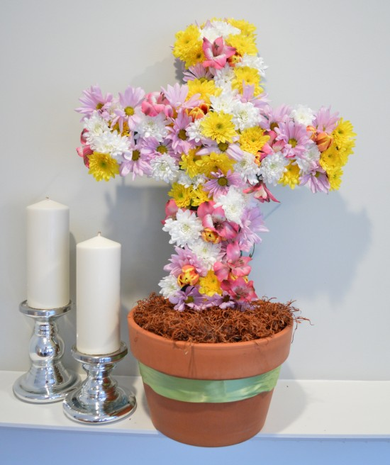

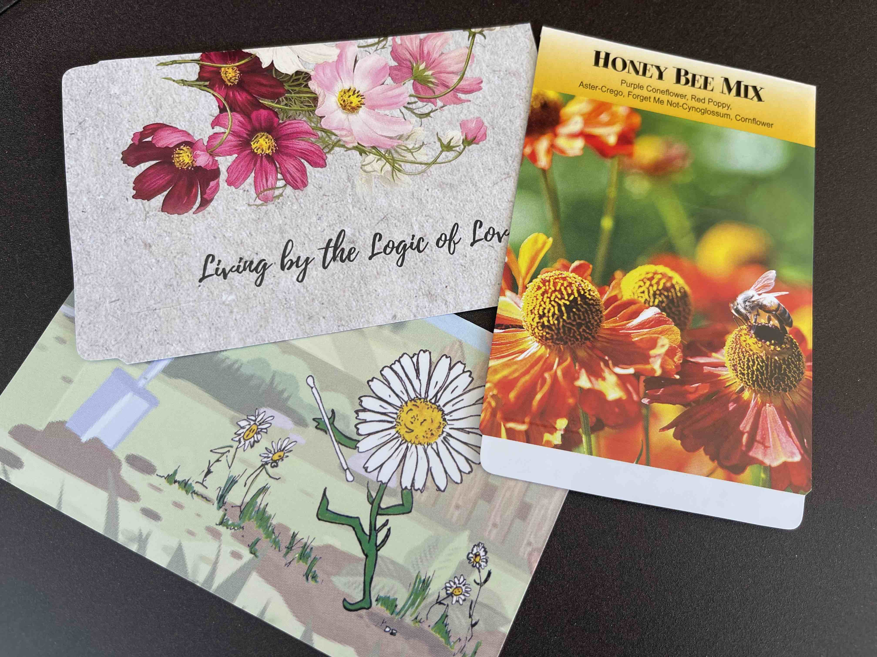

- Custom Seed Packets: Order custom seed packets with your church information printed on them to give to people as an Easter gift! I tried out three kinds from a company I’ve used before, 4Imprint.com, that will custom print your church’s message and information on the seed packets. There are many more to choose from depending on your church size and budget: check the choices out here. And here is another (unvetted) company who provides custom seed packets.


Media Arts Ideas:
- Start collecting photos of people’s gardens/flowers from home during the series. If you have a lot of social-media-savvy folx, you could even create a place on your church’s pages to upload photos. Then create a slideshow for Easter to play during the anthem or other time in the service.

- Use time-lapse videos of seeds sprouting and breaking through the dark earth. I love the collection here at “The Kids Should See This” website–run by a wonderful person that curates quality videos and amplifies underrepresented artists and voices. Here and here are some time-lapse flowers blooming (Pexels videos are free to download and use… keep searching the site for more).



- Ask your small groups of all sorts to take photos of their activities throughout Lent (including group photos–live or Zoom screenshot) and create a montage of these photos–what a great way to show visitors the vibrant community that you are “growing” at your church!

Music Arts Ideas:

You will have your favorites among your choirs and bands, but here are a couple of things to consider that highlight life and growth and possibilities:

- The “Hymn of Promise” classic by Natalie Sleeth perhaps never had a more appropriate worship series to shine with its “in the bulb there is a flower” lyric! Use it as a hymn choice and/or consider these versions as well:
For Handbells and optional Handchimes
For solo, duet, or trio
For orchestra and SATB



- “God’s Love is Alive in Us Today” is an anthem for multi-generational choirs and optional handbells. It is not an Easter anthem per se, but I love it for its message that WE are alive and so many possibilities await us because God’s love is in us. Originally written for a church’s 300th anniversary, you can get this in SATB (for mixed-age choir) or unison/two part as well as piano, organ, and handbell scores. So go as simple or complex as suits your context.
• “Love Rises” is another song from The Many for your bands to consider. The song says “today is the day” when stones are rolled away!
Dramatic Arts Ideas (including children):


- If you have some dramatic artists (i.e. good readers who love to read), consider writing or finding a poem or a reading about growing/gardening/seeds while a video of time-lapse seeds plays (see Media Arts Ideas above). It may be connected to people receiving seed packets (see Visual Arts Ideas above). Here is an example of a poem that could be good fodder for a time of reflection:
Garden of Your Mind
by Kerri Fantelli

What are you growing
in the garden of your mind –
what do you water
nourish, feed?
Do you plant seeds of forgiveness,
of love,
or do you fertilize weeds of anger
resentment, fear?
What are you growing
in the garden of your heart?
Do you allow sunshine to reach dark pain
in the corners of your heart –
Do you allow tears to wash it clean
and nourish it –
Or do you put up fences
to keep out the feelings?
Get on your knees
grow your own food
decide what it is you want in your soil.
Know what you are cultivating
what you are growing –
a lot can grow in the garden of your body
if you let it seed
nourish it
allow it
watch it grow.
- Think about how you might divide up “The Good Gardener” devotion from the Good Enough book between several readers to include in a sunrise or Easter service (the full text is included below in the Verbal Arts Ideas section). I would venture to say that if you include the preacher in the cast of readers, this could serve as a very powerful sermon, modeling proclamation as something we all do (in worship, and in our lives). It is also a perfect lead-in to giving people packets of seeds to take home and plant.

- The children’s book, The Flowering Cross, could be a good compliment in your children’s education time, combined with making smaller flowering crosses (or adding to your large flowering cross). Here is a video of a reading of it to check it out.

- Bring back your “dynamic duo” who have been doing the children’s time during Lent and do a “recap” for any visiting children about how they’ve learned to plant, fertilize (pee-uwww), water, and harvest (even the ugly produce) during the last few weeks. Then invite children to take home and tend some seeds that you have to offer them (see idea about custom seed packets in the Visual Arts Ideas above) or perhaps lily bulbs if you have lilies in the sanctuary and can get a bulb for each child to take with them. HOWEVER… remember that lilies are toxic to animals so while this is symbolically traditional and pretty cool, the consequences could be terrible and not at all about the message of life! (Perhaps this is a good reason to use other flowers on Easter??!)

Verbal Arts:

- As I mentioned above, “The Good Gardener” devotion at the end of Kate and Jessica’s book is stunningly simpatico with the culmination of this series. You could use this as sermon fodder, as a reading with one or several voices (including the preacher), for an Easter Vigil, sunrise, or main Easter service. You can find the complete text in the Good Enough book!

Liturgy Pieces
Here are some liturgy pieces to use/adapt/pull from for an Easter Vigil or an Easter Sunrise Ritual (consider gathering outside around a bonfire), or to incorporate into your Easter service (the ideas below are not a full service, just parts that extend the theme and thread elements from the Good Enough series):

Threshold
[accompaniment begins under the Leader’s words,
or use a guitar or sing a cappella if you are outside]

Leader: [adapt depending on what service you are using this for] During the season of Lent, and this last week in Holy Week, we focused on growing gardens, tending the life that is right in front of us, rather than constantly climbing ladders of what this world defines as success. We have been embracing “good enough” lives and “good enough” selves that are worthy of love, no matter what. We have been acknowledging the suffering that is a natural part of life, and we have practiced compassion as we deal with the realities and limitations that invite us to let go of perfectionism and the incessant drive toward something other than our own real, holy, and “blessed-regardless” lives. And now we encounter Easter. It is a day we proclaim that while death is a part of life–even little “deaths” along the way of dreams, of love, of the way we thought life would go–even though this is a part of life, we are part of a faith that invites us to consider that the Good Gardener is always tending us, abiding with us, beyond any kind of death that faces us.

“Good Enough”
[sung by a soloist]

What in our lives do we dream about for tomorrow, void of sorrow?
Time spent regretting decisions of our yesterdays, mistakes we made?
Sometimes we get what we get,
life disappoints us and yet,
God is still here and somehow, this faith is good enough.
[repeat with choir/congregation]

Calling on God
Based on Psalm 114

Leader: Let us pray together:

Holy One, You whose love endures forever,
you keep offering us new life and hope, no matter what.
We praise you, for you are our strength and our salvation.
We shall not die, but live, for you call us into the light–
encouraging us to reach for the sun, unfurl our full colors,
and know that we are held in the deep and rich soil of your garden–
this is more than good enough for us!
Amen.

Opening Hymn/Song
“The Hymn of Promise”
Chalice 638; GTG 250; NCH 433; UMH 707; VU 703; W&R 515

Honest Questions, Compassionate Response

Leader: Easter is tricky when it comes to faith. We come for the happy ending–the “and then they lived happily ever after.” The resurrection story proclaims hope over despair and life over death, yet we know that life continued, and continues for us, as a story of spiking heartbreak moments that are not forever fixed. The nature of being created for love is that we will always hunger for more, that there is never enough life and love to satisfy. And endings are often too soon. But perhaps a good enough faith is one that moves through the chronic nature of being incurably human with an eye for resurrection moments that assure us that this good enough life is worthy of our amazement. I invite you imagine in this silence the deep seed and shoot that is growing within you, yearning for light and life.

Silent Reflection

Leader: Hear this compassionate word from the prophet Isaiah: “I am about to create new heavens and a new earth; the former things shall not be remembered or come to mind. But be glad and rejoice forever in what I am creating; for I am about to create Jerusalem as a joy, and its people as a delight.”

Know that already, God is offering us freedom from
the fear of isolation and anguish at endings,
inviting us to community and creativity for birthing new life–
unexpected life, unending love.

And know, that despite our sometimes faltering steps,
in the name of Jesus Christ, you are being forgiven, even now.
In the name of Jesus Christ, you are forgiven.
Glory to God! Amen.

The Peace

[invite people to pass the peace in the manner to which you are accustomed, remembering to include the folx at home if you are live-streaming or recording]

WE PROCLAIM

First Reading
TBD per preacher

The Word in Music
[choral anthem; ensemble piece… see Music Arts Ideas above;
if you are using this as a Vigil or Sunrise service, this could be another easy hymn for people to sing with guitar or a cappella… perhaps “Amazing Grace” or, if you are gathered around a fire, something like “This Little Light of Mine”]

Gospel Reading
John 20: 1-18

Early on the first day of the week, while it was still dark, Mary Magdalene came to the tomb and saw that the stone had been removed from the tomb. So she ran and went to Simon Peter and the other disciple, the one whom Jesus loved, and said to them, “They have taken the Lord out of the tomb, and we do not know where they have laid him.”

Then Peter and the other disciple set out and went toward the tomb. The two were running together, but the other disciple outran Peter and reached the tomb first. He bent down to look in and saw the linen wrappings lying there, but he did not go in. Then Simon Peter came, following him, and went into the tomb. He saw the linen wrappings lying there, and the cloth that had been on Jesus’ head, not lying with the linen wrappings but rolled up in a place by itself. Then the other disciple, who reached the tomb first, also went in, and he saw and believed; for as yet they did not understand the scripture, that he must rise from the dead. Then the disciples returned to their homes.

But Mary stood weeping outside the tomb. As she wept, she bent over to look into the tomb; and she saw two angels in white, sitting where the body of Jesus had been lying, one at the head and the other at the feet. They said to her, “Woman, why are you weeping?” She said to them, “They have taken away my Lord, and I do not know where they have laid him.”

When she had said this, she turned around and saw Jesus standing there, but she did not know that it was Jesus. Jesus said to her, “Woman, why are you weeping? Whom are you looking for?” Supposing him to be the gardener, she said to him, “Sir, if you have carried him away, tell me where you have laid him, and I will take him away.” Jesus said to her, “Mary!” She turned and said to him in Hebrew, “Rabbouni!” (which means Teacher). Jesus said to her, “Do not hold on to me, because I have not yet ascended to the Father. But go to my brothers and say to them, ‘I am ascending to my Father and your Father, to my God and your God.’” Mary Magdalene went and announced to the disciples, “I have seen the Lord”; and she told them that he had said these things to her.

A Word of God that is still speaking,
Thanks be to God.

Thoughts about an Imperfect Life and Faith
“A Good Enough Faith”

[see Sermon Fodder document for prompts]

A possible ritual action for Easter Vigil or Sunrise service:

Leader: A bonfire is an ancient Easter Vigil tradition, signifying the return of light in the darkness, the opening of the tomb and the resurrection of Jesus. Our faith calls us to rekindle the fires of hope, and sometimes that means allowing some things to be transformed by a refining fire. We have focused this Lent on letting some things go: perfectionism being one, but also other things that rob us of the joy of living the reality of our lives, those things that pull us away from tending that which is the most important. So in this darkness, as we await the full light of resurrection on Easter morn, I invite you to a ritual of letting go. You have been given a piece of paper and writing utensil. Would you spend a moment writing words or phrases that represent what you would like to leave behind in the grave? [or if you used the cloth idea in the Good Friday service, this would be the time to have people use that to either write on or just imagine what that grave-cloth represents for their lives–be sure to have extras for people who were not at Good Friday or who did not bring their piece of cloth back for this service]

Time to write
[a song could be played here, an instrumental that continue through the placing of paper/cloths or simply silence kept]

In the lovely darkness of a womb and tomb,
God held us close, created hope, taking time to
fashion, craft, nurture, feed, and love us into liberation and new life.
God imbued our stories with eternal light in the story of the resurrected Jesus.
God has given us the light of day, the light of this world,
and invites us to let this light shine forth as disciples of Jesus,
aiding in the rekindling of the fire of the Spirit in all of creation.

And so, in an act of letting go into the light, we offer our
grief, concerns, worries, fears, prayers, and petitions to this fire.
Refine them, transform them,
just as you have transformed our ashes to the bright light of your love.
I invite you to come add your [paper/cloth] into the bonfire now.

[after this is done, light the Christ Candle from the bonfire and process it into the sanctuary and place it in the chancel… another tradition is to wait to prepare the sanctuary for Easter at this moment… and another tradition that I grew up with is to… HAVE PANCAKES!]

A possible ritual action for the Easter Service:

Leader: You have been given a packet of seeds. As we prepare to go out from this place, I invite you to hold that seed packet in your hands, placed between your palms as a prayer posture. And hear this blessing:

A Blessing for You Who Are Being Planted
[from Good Enough by Kate Bowler and Jessica Richie]

Blessed are you who are buried. You who feel stuck in the depths of grief and despair or who sit in the pit of unknowing. You who are learning to trust the timing of a tender Gardener.
Blessed are you who are growing, you who burst with new life, fresh creativity. Who understand the pain that sometimes comes with stretching and changing, pruning and being cut back.
And blessed are you in your season of fruitfulness. You who are learning to abide in the vine, and who taste the sweetness of God’s loving-kindness. The God who was there all along—planting, waiting, watering, pruning, delighting. The God who pays careful attention to God’s garden.
Benediction

And now, may the God who loves all of creation,
especially the gardens we call our lives,
and Jesus, our companion along this crooked path called life,
and the Holy Spirit, who loves to improvise in surprising ways,
go with you, dwell among you, and give you joy. Amen.

Choral Reprise
[sung slowly, in harmony]
God is still here and somehow, this faith is good enough.


