

Small Group or Individual
Study Ideas

Friends, there are so many ways to expand the study of “change” beyond the worship material. If you are using this series in the midst of preparing for change, in the midst of change, or recovering from change, it might be particularly important to encourage further study to help you solidify the lessons.

If you have a small group habit in your church already (or want to start one), that is wonderful! You can have folks meet together to study any of these suggested materials (there are resources for children and youth in our list as well). We highly recommend our original material that connects the worship scriptures with The Change Cycle–four sessions of video interviews with Rev. Lillie Brock, a pastor and change process facilitator, as a wonderful way to understand more deeply what to expect in the process of change. Eye-opening (great for leadership teams as well)! Preachers, see more about this in the Sermon Fodder.
If you don’t have small groups that meet together, consider inviting individuals to any of the suggestions on the following pages. The special interview series with Rev. Elder Lillie Brock on the “Change Cycle” can be done by individuals, couples, friends, and families with great prompts for talking about how we each navigate change. We’ve included some discussion/journal questions to go along with each of these four video segments to make them a self-sufficient study (you’ll find that study guide in a separate download). Enjoy!

Peace & Passion,
Dr. Marcia McFee

Interview Series on The Change Cycle with Rev. Lillie Brock
for small groups, leadership teams, couples, or individuals!

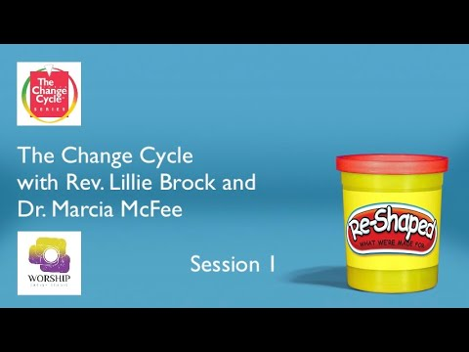
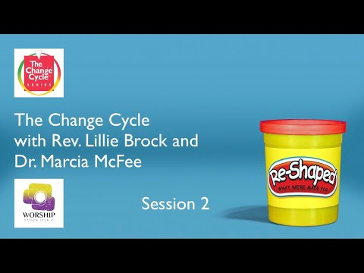
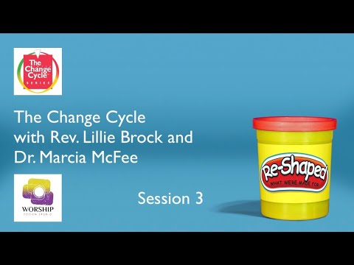
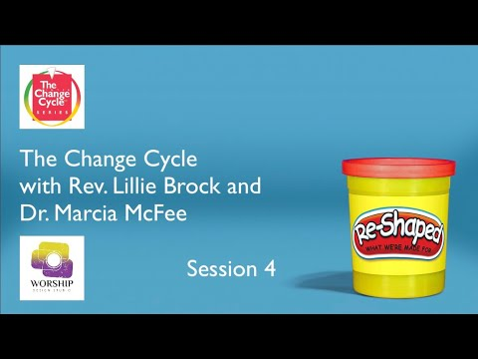

Click on the images below to preview the videos. Leader and study guide are available as another document in your downloads.
Wonderful introduction session to
how the brain deals with change
and overview of The Change Cycle
We are in the “Red Zone” of The Change Cycle in this session - what we do first with change - RESIST!
The “Yellow Zone” is the place of great danger AND great possibility. Just keep moving forward!
We’ve made it to the “Green Zone” in The Change Cycle and now we can move forward with deep understanding.
Find out more about The Change Cycle at www.ChangeCycle.com where you can order materials: a book, posters, and assessment tools!
Rev. Lillie Brock is available for keynotes, preaching, coaching, training sessions or facilitated conversations about the Change Cycle in person or online.
lilliebrock@changecycle.com

Book Studies for Adults



If you would like to offer your church a book study for small groups or individuals to explore outside of worship, here are two good book recommendations for adults that we discovered while researching options to accompany this series:

A Way Out of No Way: An Approach to Christian Innovation by Stephen Lewis and Kimberly R. Daniel — This book explores the topic of innovation or creative problem-solving from a Christian perspective. The authors examine the models of innovation that characterized Jesus’ ministry as well as the solutions that African American communities have developed to sustain, nourish, and empower themselves in a nation with deeply embedded systemic racism and hostile economic structures. Invite your community into critical conversations about working toward racial justice locally and globally, “making a way out of no way” and using your church’s resources for wise and creative work.

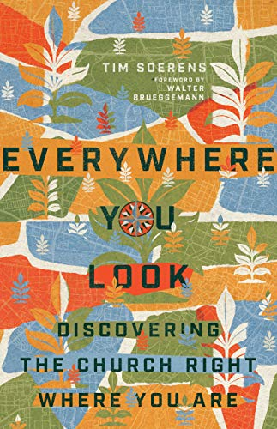


Everywhere You Look: Discovering the Church Right Where You Are by Tim Soerens — This book discusses the modern state of a declining population of traditional churchgoers and offers more expansive and inclusive ways of building community for new generations. This book could help your community approach conversations about change with fresh imagination and a deeper understanding of what it means to be the church in today’s world.

Books for Children and Youth

The following books are resources that could help spark conversations and reflections about being “re-shaped” with children and youth. Our list is arranged roughly in order of accessibility by age level. Several of the suggestions below are taken from a blog post titled “Children’s Books About Adapting to Change” by Children’s Library Lady. Many other suggestions on that page look like wonderful resources for children’s ministry!

The Dot by Peter H. Reynolds — Oh the many things a dot can be! This story emphasizes the power of re-shaping what we see to turn a simple dot into an unlimited number of visual illustrations.

Perfect Square by Michael Hall — A great visual illustration of the power of transformation and the possibilities that await when we view the world with creativity and and open mind.

Saturday by Oge Moya — A mother and her daughter wait all week to spend a special day together, only to encounter obstacles that spoil all their fun plans. This story highlights the value of time together anyway, even when things don’t go as planned.

The Garden of Hope by Isabel Otter — After her mother’s death, a young girl restores a neglected garden in a story of transformation and renewal.

After the Fall: How Humpty Dumpty Got Back Up Again by Dan Santat — This story picks up where an old nursery rhyme left off and explores what happened next to Humpty Dumpty. When we fall, we can get back up again and resume life with courage and grace.

Making a Difference: An Inspirational Book about Kids Changing the World! by Stacy C. Bauer, illustrated by Emanuela Ntamack — This book features a collection of vignettes about smart, passionate, and creative kids who have created change in the world.

It’s Your World! Get Informed, Get Inspired, & Get Going by Chelsea Clinton — Everyone can make a difference, including young people. This book presents practical ways that children and their families can talk about and address global issues like gender inequality, poverty, pollution, and more.

Be a Changemaker: How to Start Something That Matters by Laurie Ann Thompson — For older kids who are determined to make the world a better place and want to start now, this book provides suggestions for networking, developing community, fundraising, and other tools that kids need to build agency and work toward their goals.
Activities for Children

Each week of the series addresses a different aspect of change. We’ve selected animated films that provide a powerful illustration corresponding with each theme. If your church has a CVLI license or has the ability to purchase one for the duration of this season, you could host movie nights at the church once a week to give everyone a chance to view the films that you may later choose to reference as illustration points in your sermon.



Please refer to the Children’s Time document to see our ideas for engaging with the themes and stories presented in these films during your worship services and in children’s education or at home.

