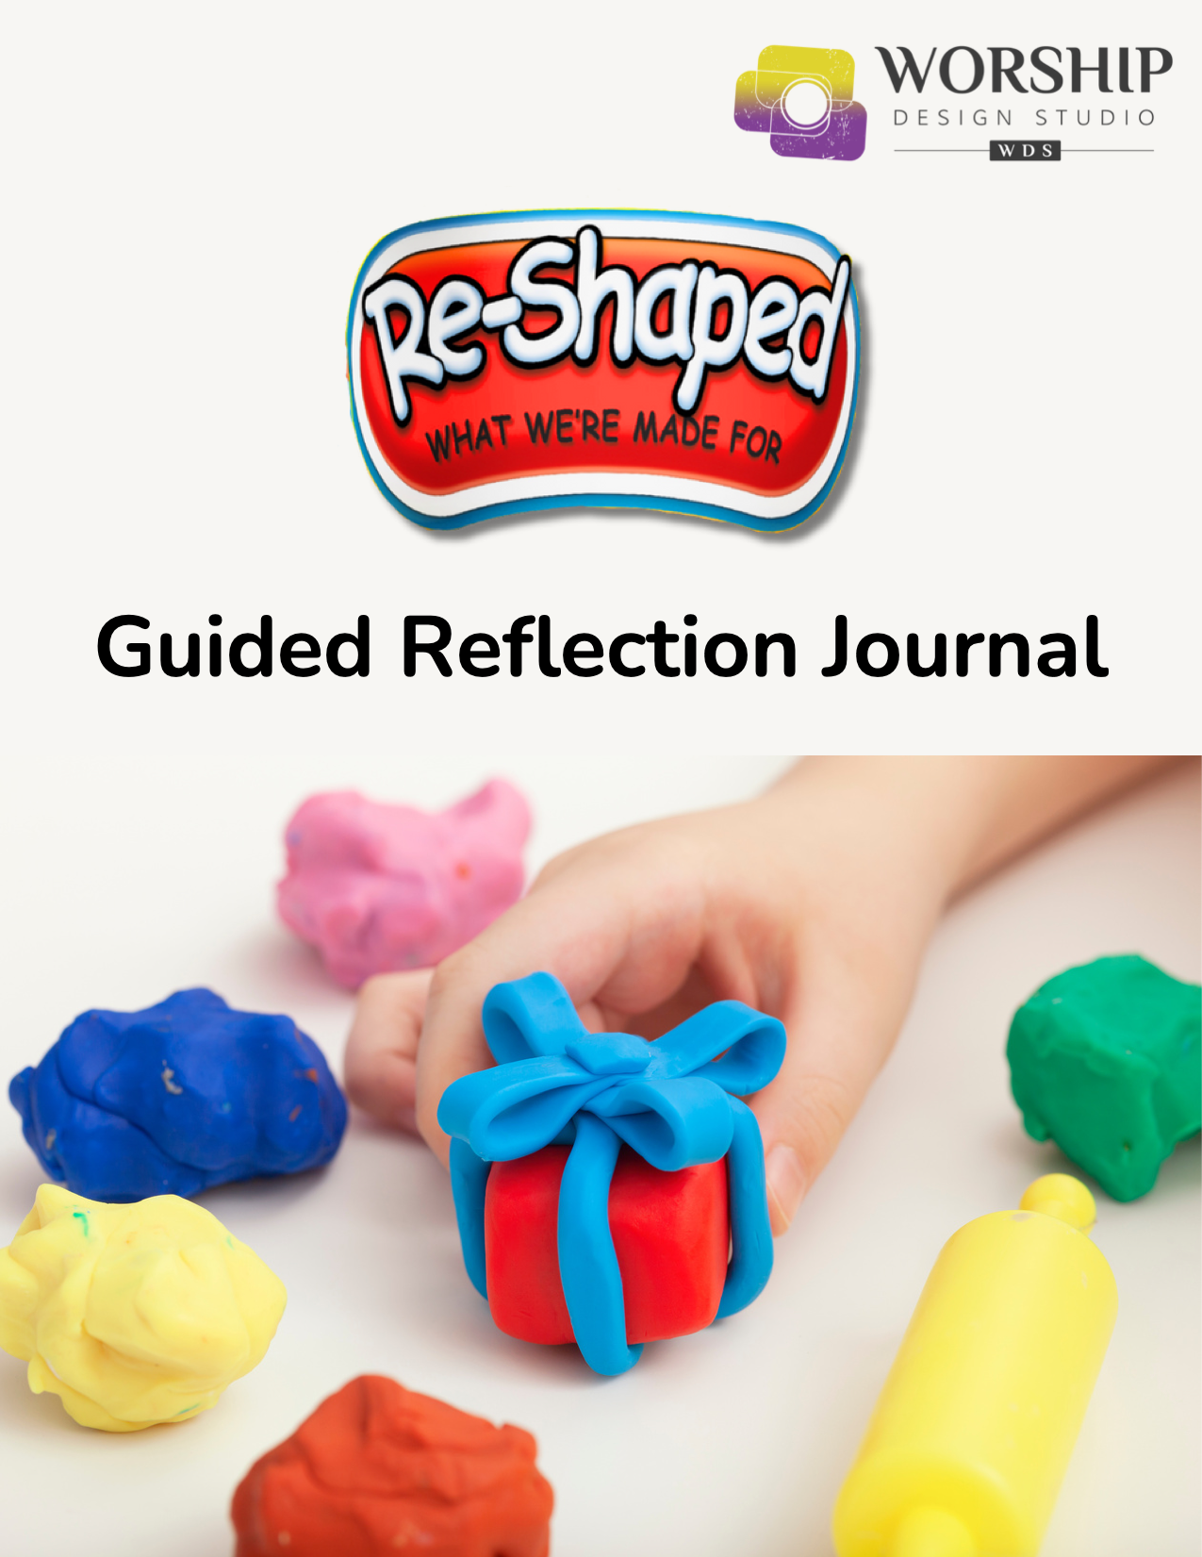
Table of Contents

Introduction page 3

Session One page 5

Session Two page 7

Session Three page 9

Session Four page 11

This journal is an accompaniment to the Worship Design Studio
Ordinary Time worship series, “Re-Shaped: What We’re Made For.”
worshipdesignstudio.com/reshaped

This journal can also be used independently from the worship series or any church gathering. It can be used privately or shared with a friend or in a small group setting.

May you be inspired to embrace change with curiosity and flexibility,
opening to new possibilities each and every day!

© 2024 Marcia McFee

Introduction

Welcome to our special interview series with Dr. Marcia McFee and Rev. Elder Lillie Brock on the “Change Cycle.” These four videos will introduce you to a way of looking at the process of change that is eye-opening – deepening our understanding about why we react to change and how we are “made for” and capable of change. This study can be done on your own, with your significant-other and family, or with a small group.

Each session starts with a time of centering our spirit by lighting a candle and saying a brief prayer. Then after you watch the video interview, you are invited to conversation. If you are doing this as an individual study, take some time to journal your thoughts and perhaps share an “aha” with someone else sometime during the week. The session closes with a blessing.

Change is so common and yet one of our most challenging human processes. Know that you are not alone no matter what changes you are going through. Many blessings on your journey.

– Dr. Marcia McFee
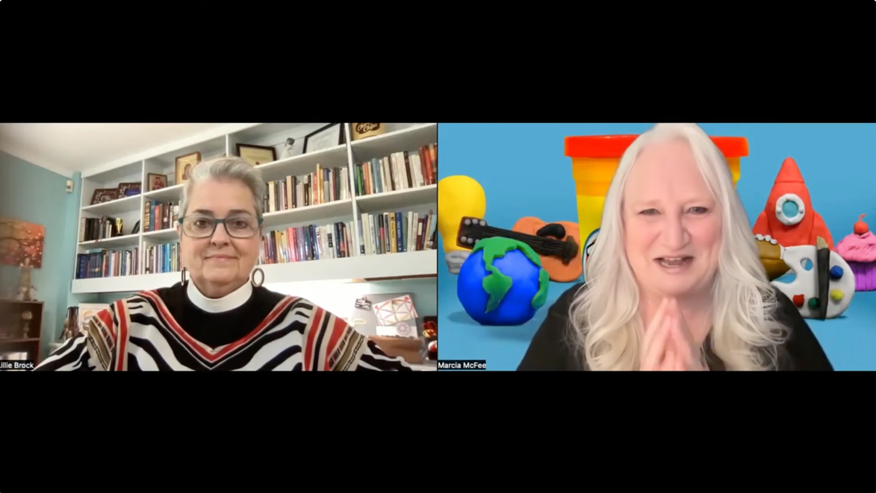

The Change Cycle™️ is a powerful tool used by all kinds of organizations and individuals to learn to navigate change with more ease. When you look at the model above, it's a circle, and it represents the true cyclical nature of each change we experience. In the outside ring are the six sequential and predictable stages of change. The names of the stages: Loss, Doubt, Discomfort, Discovery, Understanding, and Integration, indicate the primary experience of that stage. The inside pie pieces list the thoughts, feelings and behaviors most associated with the stage. The Change Cycle™️ uses the colors of a traffic light to signal that the stages mirror the actions we take at traffic lights. The Change Cycle™️ model is a map that depicts our human experience of each stage of change — in all changes, big or small, good or bad.

Learn more at www.changecycle.com.
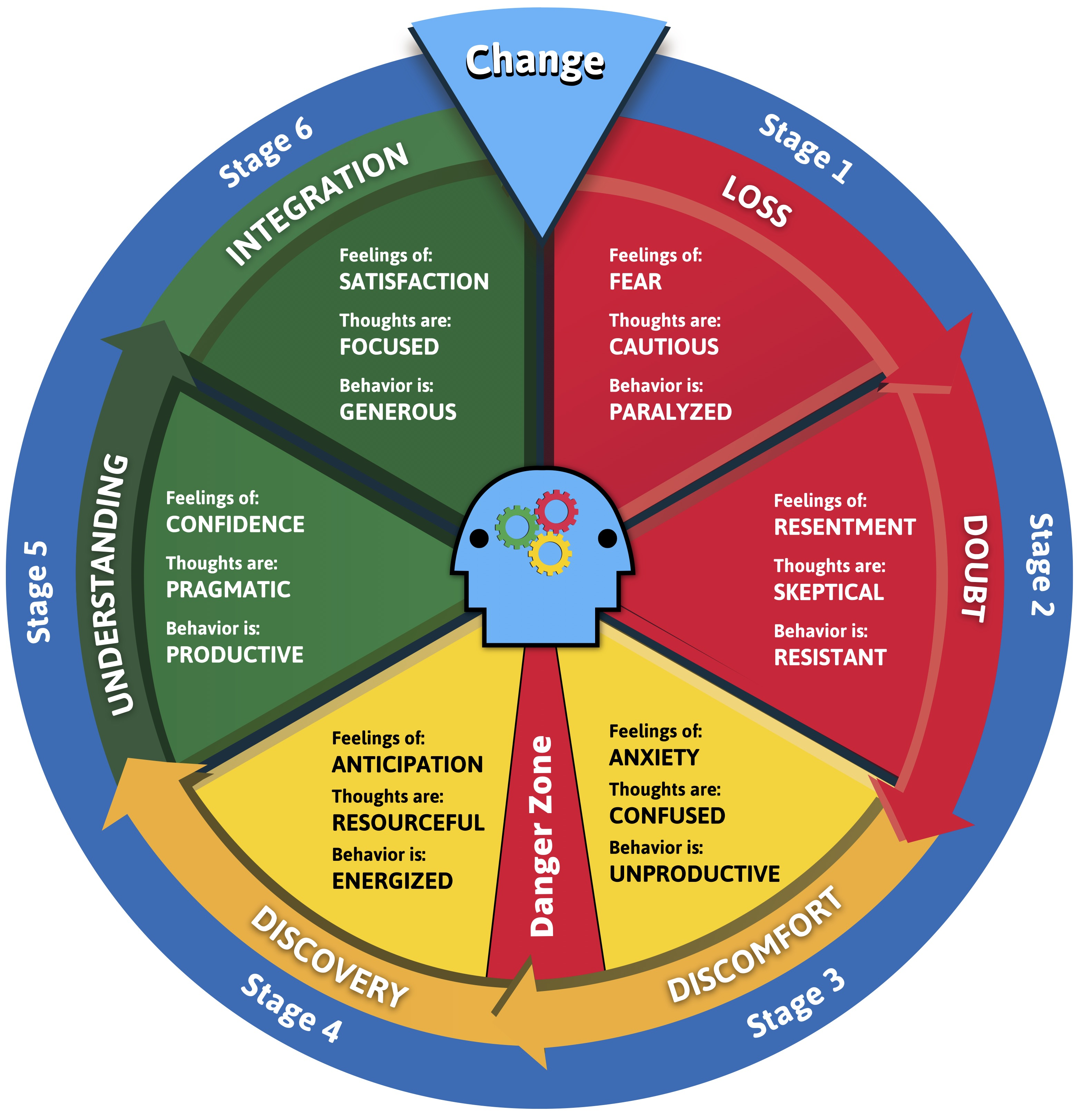
Session One
Introduction to the Change Cycle

We are on a reflective journey together about change. In our first session, we are reminded that change is inevitable and actually necessary for animating our spirits as we find renewed purpose throughout life. Here is an excerpt from scripture:

I went to the potter’s house, and sure enough, the potter was there, working away at his wheel. Whenever the pot the potter was working on turned out badly, as sometimes happens when you are working with clay, the potter would simply start over and use the same clay to make another pot. Then God’s Message came to me: “Can’t I do just as this potter does, people of Israel?” God’s Decree! “Watch this potter. In the same way that this potter works his clay, I work on you, people of Israel. — Jeremiah 18: 1-6 (The Message)


Let us light a candle, take a deep breath, and pray:
Creator God,
you sit at the Potter’s Wheel
and continue to fashion beautiful things.
Open us to your ongoing re-shaping of our lives
and help us believe that we are capable of change.
Calm our fears, and animate our spirits
for this time of discovery.
Amen.

Scan this QR code to go to the video.

Watch Session 1 of the interview series at https://youtu.be/Y3ZBO-EptS0

Notes
________________________________________________________________________________________________________________________________________________________________________________________________________________________________________________
____________________________________________________________ ________________________________________________________________________________________________________________________

[For groups]: In our conversation, everyone is invited to share, but sharing is not required. Please make room for all voices, keeping your contribution to a respectful time limit so everyone has a chance. Whatever is said here stays here – not because we are telling secrets but because we honor that what a person says here is their story to share.

I invite you to share something from the video that felt familiar or gave you an “aha” about your own process of change. What felt challenging? These are just suggestions... feel free to share whatever is bubbling up around this topic.

________________________________________________________________________________________________________________________________________________________________________________________________________________________________________________
____________________________________________________________ ________________________________________________________________________________________________________________________
________________________________________________________________________________________________________________________

Closing Prayer

From the Gospel According to Gumby,
“Blessed are the flexible for they shall bend but not break.”
Remember you were made to survive and thrive–
especially during times of change.
Go into the world knowing
that the Potter God is still shaping and reshaping you
as you were made to do;
that the Teacher Jesus is inviting you to a change of heart,
making it all so very possible;
and that the Adventurous Spirit is luring you to
more play and curiosity in your precious life.
Go in peace,
Stay in courage,
Amen!
Session Two
The Red Zone

We are on a reflective journey together about change. In our second session, we are reminded that transformation starts with a willingness within our own spirits to “lean into” the life path that is calling us. But that takes time. Here is an excerpt from scripture:

As John the Baptist preached he said, “The real action comes next: The star in this drama, to whom I’m a mere stagehand, will change your life. I’m baptizing you here in the river, turning your old life in for a kingdom life. His baptism—a holy baptism by the Holy Spirit—will change you from the inside out.” — Mark 1: 1-15 (The Message)

Let us light a candle, take a deep breath, and pray:
Life-giving God,
you refresh us from the inside out
with your water of life and spirit.
Open us to your presence within us
and help us see how you are
re-shaping our spirits each day.
Calm our fears, and animate our spirits
for this time of discovery.
Amen.


Scan this QR code to go to the video.

Watch Session 2 of the interview series at https://youtu.be/s0J-gJ5H2Jg

Notes
________________________________________________________________________________________________________________________________________________________________________________________________________________________________________________
____________________________________________________________ ________________________________________________________________________________________________________________________

[For groups]: In our conversation, everyone is invited to share, but sharing is not required. Please make room for all voices, keeping your contribution to a respectful time limit so everyone has a chance. Whatever is said here stays here – not because we are telling secrets but because we honor that what a person says here is their story to share.

I invite you to share something from the video that felt familiar or gave you an “aha” about your own process of change. What felt challenging? These are just suggestions... feel free to share whatever is bubbling up around this topic.

________________________________________________________________________________________________________________________________________________________________________________________________________________________________________________
____________________________________________________________ ________________________________________________________________________________________________________________________
____________________________________________________________________________________________________________________________________________________________________________________

Closing Prayer

From the Gospel According to Riley (from the movie Inside Out),
(with sadness) “We used to play tag and stuff.”
Remember that your spirit within is created to play with God’s Spirit.
Go into the world knowing
that the Potter God is still shaping and reshaping you
as you were made to do;
that the Teacher Jesus is inviting you to a change of heart,
making it all so very possible;
and that the Adventurous Spirit is luring you to
more play and curiosity in your precious life.
Go in peace,
Stay in courage,
Amen!
Session Three
The Yellow Zone

We are on a reflective journey together about change. In our third session, we are reminded that what feels like the chaos, or recklessness, of change is the breaking-open of possibility and the sprouting of new life. Here is an excerpt from scripture:

Unless a grain of wheat is buried in the ground, dead to the world, it is never any more than a grain of wheat. But if it is buried, it sprouts and reproduces itself many times over. In the same way, anyone who holds on to life just as it is destroys that life. But if you let it go, reckless in your love, you’ll have it forever, real and eternal. — John 12: 20-26 (The Message)

Let us light a candle, take a deep breath, and pray:

Breaking-Open God,
you call us to let the seeds of your love
be planted anew in us again and again.
Open us to letting go of how we think things are,
and allow us release as we are broken open into new life.
Calm our fears, and animate our spirits
for this time of discovery.
Amen.

Scan this QR code to go to the video.

Watch Session 3 of the interview series at https://youtu.be/KiEO7vT3ldQ

Notes
________________________________________________________________________________________________________________________________________________________________________________________________________________________________________________
____________________________________________________________ ________________________________________________________________________________________________________________________

[For groups]: In our conversation, everyone is invited to share, but sharing is not required. Please make room for all voices, keeping your contribution to a respectful time limit so everyone has a chance. Whatever is said here stays here – not because we are telling secrets but because we honor that what a person says here is their story to share.

I invite you to share something from the video that felt familiar or gave you an “aha” about your own process of change. What felt challenging? These are just suggestions... feel free to share whatever is bubbling up around this topic.

________________________________________________________________________________________________________________________________________________________________________________________________________________________________________________
____________________________________________________________ ________________________________________________________________________________________________________________________
________________________________________________________________________________________________________________________

Closing Prayer

From the Gospel According to Elsa (from Frozen),
"Let it go, let it go, when I'll rise like the break of dawn.”
Remember that perfection is not the point, but growth,
which needs both light and rain.
Go into the world knowing
that the Potter God is still shaping and reshaping
you as you were made to do;
that the Teacher Jesus is inviting you to a change of heart,
making it all so very possible;
and that the Adventurous Spirit is luring you to
more play and curiosity in your precious life.
Go in peace,
Stay in courage,
Amen!
Session Four
The Green Zone

We are on a reflective journey together about change. In our fourth session, we are reminded that, just like Peter, if we are going to change we have to take the first uncertain steps out of the boat onto the water and into the unknown. Here is an excerpt from scripture:

Jumping out of the boat, Peter walked on the water to Jesus. But when he looked down at the waves churning beneath his feet, he lost his nerve and started to sink. He cried, “Master, save me!” Jesus didn’t hesitate. He reached down and grabbed his hand. — Matthew 14: 22-31a (The Message)


Let us light a candle, take a deep breath, and pray:
Scan this QR code to go to the video.
Encouraging God,
we hear your invitation into the future
and we look to you for courage.
Open us to know your presence as we
embark together on new adventures.
Calm our fears, and animate our spirits
for ongoing discovery.
Amen.

Watch Session 4 of the interview series at https://youtu.be/MiewD-PSVTs

Notes
________________________________________________________________________________________________________________________________________________________________________________________________________________________________________________
____________________________________________________________ ________________________________________________________________________________________________________________________

[For groups]: In our conversation, everyone is invited to share, but sharing is not required. Please make room for all voices, keeping your contribution to a respectful time limit so everyone has a chance. Whatever is said here stays here – not because we are telling secrets but because we honor that what a person says here is their story to share.

I invite you to share something from the video that felt familiar or gave you an “aha” about your own process of change. What felt challenging? These are just suggestions... feel free to share whatever is bubbling up around this topic.

________________________________________________________________________________________________________________________________________________________________________________________________________________________________________________
____________________________________________________________ ________________________________________________________________________________________________________________________
____________________________________________________________

Closing Prayer

From the Gospel According to Elmo’s friends,
“Take the first step and soon you’ll see
just how brave your heart can be!”
Remember that you are never alone in the journey of change–
we’re all on it with Jesus who says, “Come on ahead!”
and then moves with us each step of the way.
Go into the world knowing
that the Potter God is still shaping and reshaping you
as you were made to do;
that the Teacher Jesus is inviting you to a change of heart,
making it all so very possible;
and that the Adventurous Spirit is luring you to
more play and curiosity in your precious life.
Go in peace,
Stay in courage,
Amen!


