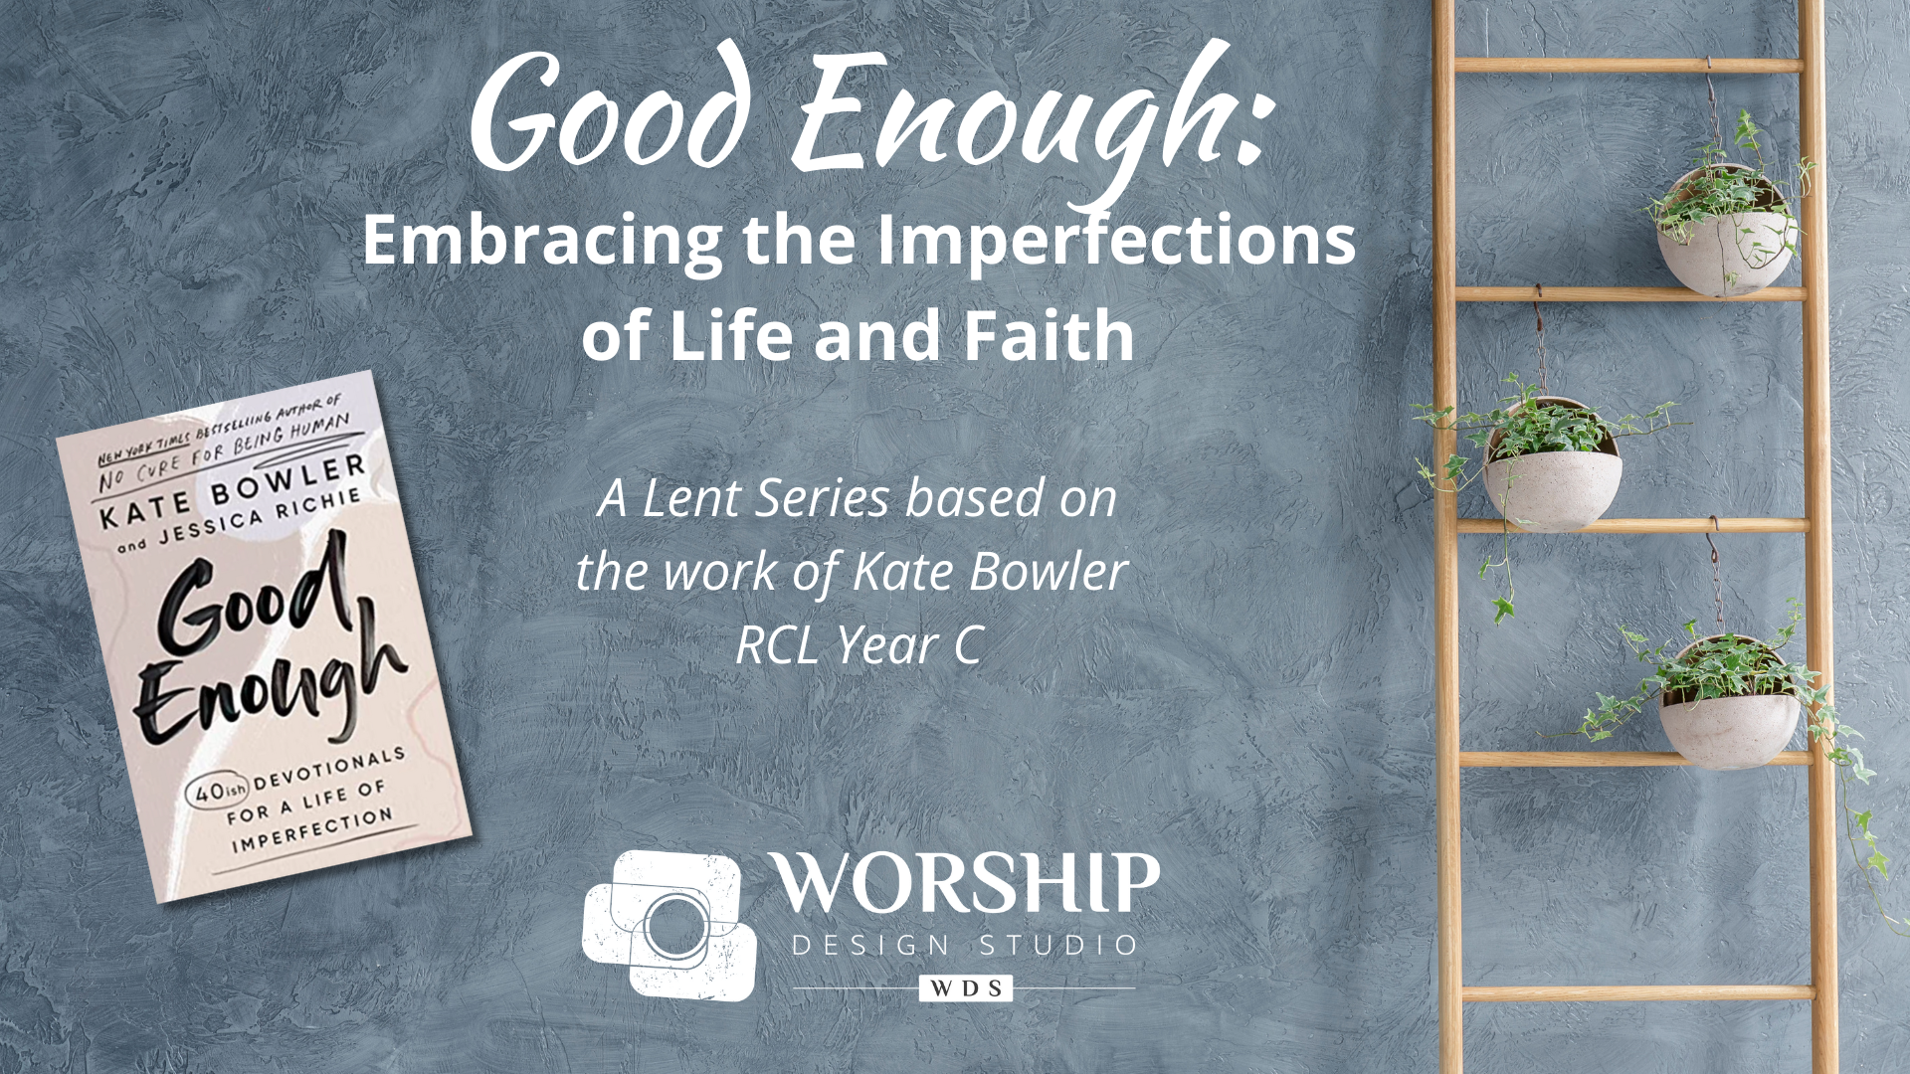

Communion Liturgy

The following prayer can be adapted to suit your particular tradition. If you commune once a month, place it in whatever week that falls in the year that you are doing this series. If you commune weekly, use this format but perhaps tweak the wording slightly to fit the theme each week. Using “Take, O Take Me as I Am” would be appropriate to use as the musical setting for the prayer every week.

Invitation to the Table
“Take, O Take Me as I Am”
[woven throughout communion liturgy;
you must have your own OneLicense or CCLI License for use of this song]
GTG 698; MV 85; VT 748; W&S 3119

Note: there is a Lenten Communion Rite version of this song
available for you to consider. The verses (which are not available in the above hymnal references) could be sung before the communion liturgy begins, omitting the “Lamb of God” if that is not part of your tradition.

Leader: Christ looks upon each one with love and says,
People: “you are welcome at my table.”
Christ looks upon each one with compassion and says,
“whatever troubles you, bring it here.”
Christ looks upon each one with grace and says,
“whatever you’d like to leave behind, do it here.”

Will you come?
Will you bring your troubles?
Will you shed all that is unnecessary in your life?

This is the place where you need not be perfect,
you need not be sure of yourself or your faith,
you need not feel whole and right with the world.

Jesus invited many to his tables
and in doing so, he assured them of their place
in the illogical reign of love and grace.
He just wanted them to be hungry for relationship–
hungry to look across a table into another’s eyes,
to break open their lives,
and lift a cup in the midst of the hard times and hear,
“this is for all,
and so this is for you, beloved.”

[All sing, a cappella if possible, slowly]
Take, O take me as I am;
summon out what I shall be;
set your seal upon my heart
and live in me.

[music may continue to sparingly underscore the following]

Great Thanksgiving

The Holy Living God be with you.
And also with you.
Lift up your hearts!
We lift them up to the Lord!
Let us give thanks to the Lord our God.
It is right to give our thanks and praise.

It is right, and a good and joyful thing,
anytime and everywhere to give thanks to you.
You created this world full of so much beauty and sorrow
and called it Good. And called it Enough.

Although we feel lost at times,
you are ever present.
We doubt, resist, turn away, and rage,
insistent on our own power to pull us through,
and yet sure that we are to blame,
making life seem like a confusing paradox.

But you are patient.
You are here to meet us–reside with us in strange and alienating times,
always faithful, always present
in this Body [gesture to the table]…
in this Body [gesture to the people].

And so,
together we proclaim the praise-filled truth of your glory
along with all the saints:

[to the tune of “Take, O Take Me as I Am”]
Holy, holy, God of Hosts!
Heav’n and earth sing out your name!
Blest are they who come today;
and take their place.

[music may continue to sparingly underscore the following]

Holy are you, and blessed is your Son Jesus Christ.
He proclaimed freedom for the bound,
justice for the oppressed,
grace for the lost,
love for the prodigal.

Through the life and ministry of Jesus,
we can imagine and live into a community
where all who struggle are taken into loving arms
and those who struggle to love are invited into greater compassion.

[underscoring concludes]

On the night in which he gave himself up for us,
he took bread, gave thanks to you, broke the bread,
gave it to his disciples, and said:

“Take, eat; this is my body which is given for you.
Do this in remembrance of me.”

When the supper was over, he took the cup,
gave thanks to you, gave it to his disciples, and said:

“Drink from this, all of you;
this is my blood of the new covenant,
poured out for you and for many
for the forgiveness of sins.
Do this, as often as you drink it,
in remembrance of me.”

And so,
We remember… [pause, piano enters]
We offer ourselves … [pause]
We proclaim God’s time…

[to the tune of “Take, O Take Me as I Am”]
Christ has died, yet Christ is ris’n;
Christ will come once again!
We remember and proclaim
redeeming love.

[piano underscoring continues, crescendo in energy from both piano and presider]

Pour out your Holy Spirit on us gathered here,
and on these gifts of bread and fruit of the vine.
Make them be for us sustenance for our days,
love for simple and ordinary lives,
fuel for justice in this world.

By your Spirit open us to each other.
Open us to the world,
making us one in you,
through Christ,
in the power of your amazing grace!

[All sing, soaring]
Take, O take me as I am;
summon out what I shall be;
set your seal upon my heart
and live in me.

Lord’s Prayer

Communion

