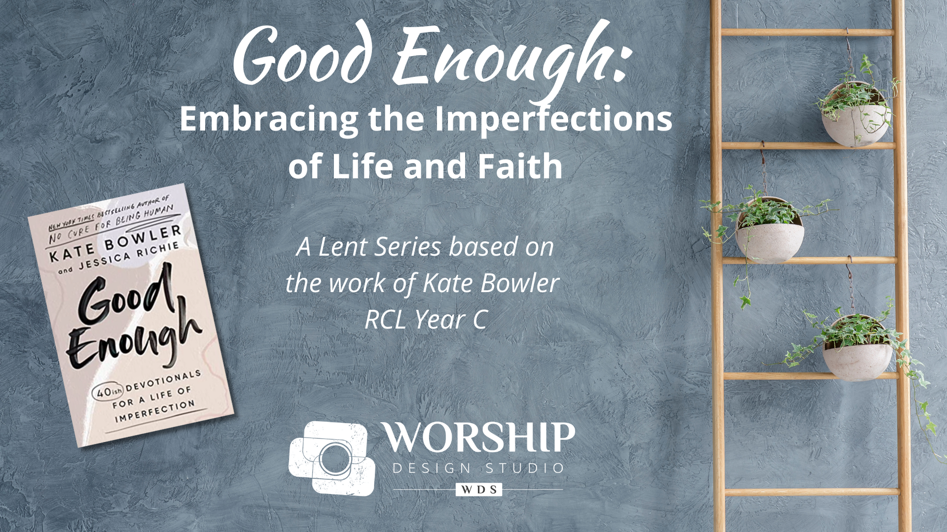

Small Group Suggestions


It has been a distinct delight to work with Kate Bowler’s team in creating this worship series. And it has been a personal journey for me as well. The devotions in this book have hit home for me time and again as I immersed myself in them while creating this series.

I love the wit and humor alongside truths that make me tear up with recognition of my own struggles with becoming fine with my “Good Enough” life and the overwhelming grace at not being perfect. As someone who is blessed-plagued with multiple creative ideas every day, to accept that “not everything is possible” is one of those gifts that starts with a bit of pain before turning to relief. Ah… I’m only human. In fact, as Kate says, I’m “incurably” human. And that’s good enough.

Kate and Jessica’s faith shine through in these pages. They allow us to see their own misgivings and imperfect spiritual practices and in doing so, invite us to deep honesty and compassion for ourselves and others. What a gift.

The hardest thing for me as I was working with their early and unpublished manuscript was not being able to talk about the book and share with others. You know a book is good if you really want to debrief it with others along the way! But now that the book is out, you won’t have that problem. In fact, I want to encourage you to use and share this book in three ways during the Lent season:

- Personal devotions. I’ve curated a list below of devotions that work especially well with the themes of each week of the worship series. Each devotion has “A Good Enough Step” that prompts a reflection or action, none of which are very hard or time-consuming. People will love incorporating these brief devotions and actions into their day as a Lent practice so I encourage you to invite folx to buy the book. If you are a church that has resources to provide the book, this will be well worth it.

- Small group discussion. Create small groups that will get together once-a-week, toward the end of the week, to share their thoughts and insights and favorite blessings from that week’s devotions. We’ve provided a format below for groups to use as a guide. They could do this in person or in an online format such as Zoom.

- Sermon fodder. Preachers–because the worship series is based on the concepts/theology in this book, reading the selections for the next week as you are working on your sermon can help you offer a perspective that will guide folx as they explore the concept further during the week. The sermon fodder document also has other material to inspire you related to the scriptures, but let the Good Enough book be one of your “exegetical” texts for the journey. I want to also highlight Kate’s book Blessed: A History of the American Prosperity Gospel as an important text for getting deeper into her research and work. See more about that book HERE.

If you want to read or find out more about all of Kate’s other best-selling books, these could make great preparation reading or serve as other books if groups want to expand their scope. See all Kate’s books HERE and listen to her podcasts (amazing!) HERE.

In this document you will find:

- Pages to adapt and send to the congregation before Lent begins that instruct them on how to purchase the Good Enough devotions and give them a guide to each week’s devotional selections.

- A small group facilitation guide to send to small group participants (can be led by anyone). The format is the same each week, but includes the specific scripture, synopses, opening prayer, and benediction from that week’s worship service.

A closing thought: I love that Kate and Jessica use the endearment, “My dears,” when speaking to us. I believe that we will hold each other and ourselves more “dearly” at the end of this series than before. My prayer is that this resource–both the worship series and the book–will be salve for our frustrated selves, inviting us to embrace the imperfections of life and faith, knowing that we are never alone.


Peace & Passion,
Watch a video trailer and
get your own copy
of the book HERE
Dr. Marcia McFee

Individual Devotions for Good Enough

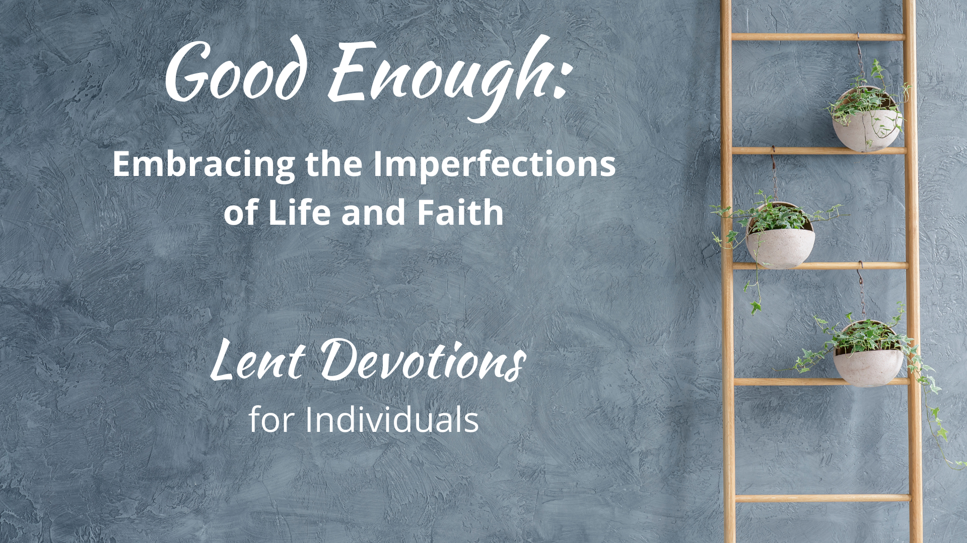
Dear Ones - We are so pleased to be utilizing the devotional book, Good Enough: 40’ish Devotionals for a Life of Imperfection, as the basis for our worship this Lent. Each week we will be focusing on a concept from the book, and we invite you to use it as a daily devotional, with the exception of Sundays (this is traditionally how the “40 days of Lent” are calculated… and at some point you’ll find the “40’ish-ness” where there is one more, which makes it perfectly imperfect). Within each week, you can read the listed devotions in any order, not just the order we have listed here. If a title catches your eye, trust that and go for it! There are check boxes to help you keep track of what you’ve read. Page numbers after each devotional title correspond to pages in the book.

Selections for the days after Ash Wednesday | “Perfectionism is impossible. Transformation isn’t.”

☐ Regula
☐ When Good Things Become Burdens
☐ Give Up Already

Selections for the days after Lent 1 | "Ordinary lives can be holy.”

☐ Shiny Things
☐ Building a Good Day
☐ Small Things, Great Love
☐ Happy Enough
☐ No Reason Whatsoever
☐ Mediocrity for the Win

Selections for the days after Lent 2 | “So much is out of our control."

☐ Asleep on the Job
☐ The Tragedy Olympics
☐ Being Honest about Disappointment
☐ Bottling Magic
☐ Gondola Prayers
☐ The In-Between
Selections for the days after Lent 3 | “Lots of things can be medicine.”

☐ Buoyed by the Absurd
☐ When You are Exhausted
☐ Hopping off the Treadmill
☐ Kindness Boomerags
☐ 2AM/2PM
☐ Too Few Sparrows

Selections for the days after Lent 4 | “We often believe we are the problem.”

☐ Needing Rules at All
☐ For the Exiles
☐ The Bad Thing
☐ Becoming Real
☐ To My Body
☐ Refuge

Selections for the days after Lent 5 | “We are fragile.”

☐ Right After It’s Over
☐ Hello, Goodbye
☐ Loving What Is
☐ The Burden of Love
☐ The Reality-Show Gospel
☐ Bright Hope

Selections for the days after Lent 6/Palm Sunday | “You are a group project.”

☐ The Foundation
☐ Say Potato
☐ The Cost of Caring
☐ When Words Fail

Selection especially for Maundy Thursday | “We are blessed, regardless.”

☐ #Blessed

Selection especially for Good Friday | “Even today, God is here and somehow, that is good enough.”

☐ Mourning a Future Self

Selection especially for Easter Sunday | “A Good Enough Faith"

- A Good Gardener

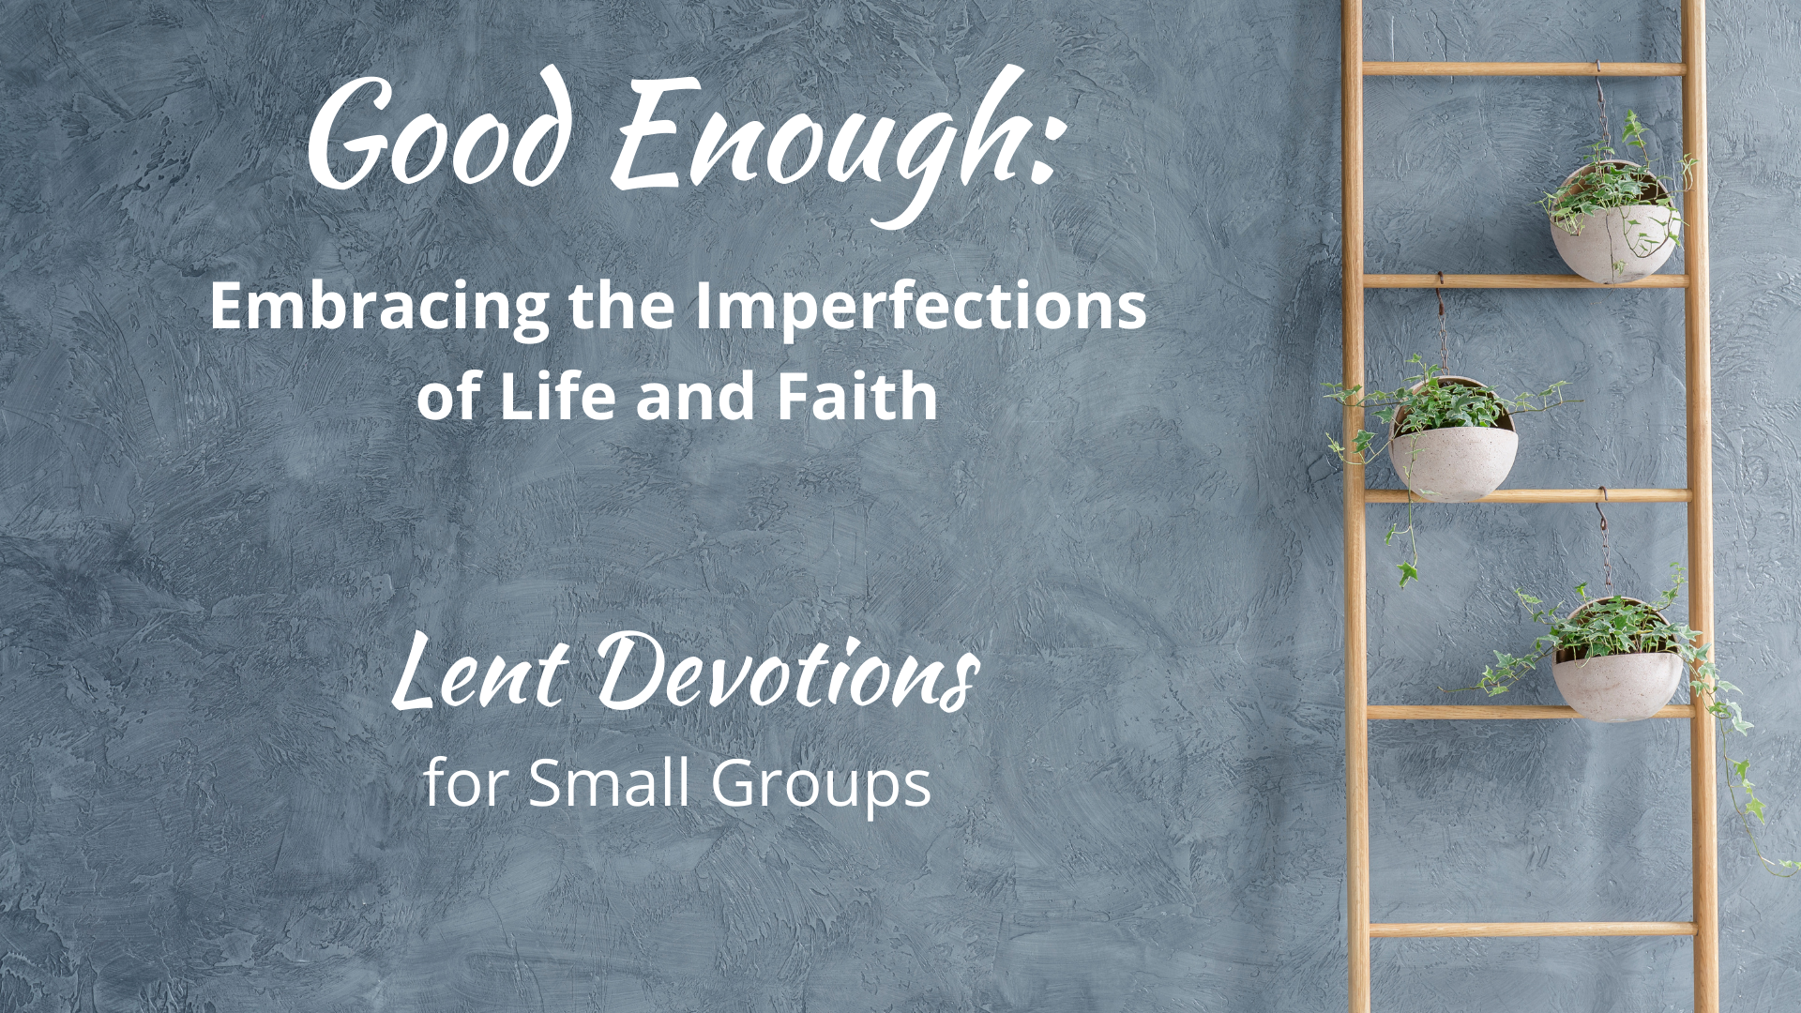

Small Group Sessions for Good Enough

Dear Ones - We are so pleased to be utilizing the devotional book, Good Enough: 40’ish Devotionals for a Life of Imperfection, as the basis for our worship this Lent. Each week, we will be focusing on a concept from the book in worship. The page called “Individual Devotions for Good Enough” gives you a road-map of devotions in the book to read each week that align most closely with that week’s theme.

Toward the end of each week, your small group will meet for a fun and meaningful time of debriefing on the topic and the devotionals. What follows in these pages is a simple format to help you organize your small group time. Anyone can be the “Leader” at any time. Assign one person to be the Leader each week or just go round-robin every week, changing voices each time the “Leader” part comes up.

One note about “setting the scene” for your small group time. The Danish have a term, hygge (hue-guh), to describe the creation of a “cozy” atmosphere that evokes warmth, friendship, wellness, and contentment. Whether you are meeting online or in person, find a special way for your group to create some hygge by lighting some candles, having something yummy to eat and/or drink, and have some good, soft, café music going when people arrive. You might even have some plants or flowers visible to remind you that we are called to be present and nurture what is living right in our midst. Breathe together, pray together, allow any emotions that might stir, and remember that “anything can be medicine”–including this time of gathering with each other. It’s all incredibly good enough. Many blessings on your journey.

Small Group Session: Week of Ash Wednesday
“Perfectionism is impossible. Transformation isn’t.”

Opening

Leader: We are beginning a reflective journey together during the Lent season with the book Good Enough: 40’ish Devotionals for a Life of Imperfection by Kate Bowler and Jessica Richie. In our Ash Wednesday worship, we were reminded that “Perfectionism is impossible. Transformation isn’t.” Here is an excerpt from the scripture:

"And whenever you fast, do not look dismal, like the hypocrites, for they disfigure their faces so as to show others that they are fasting. Truly I tell you, they have received their reward… but store up for yourselves treasures in heaven, where neither moth nor rust consumes and where thieves do not break in and steal. For where your treasure is, there your heart will be also.” - excerpt from Luke 19: 28-40

Jesus used the word “hypocrite” to describe those who put on airs in public to make people believe that they were holy, that their religious practice was… well… perfect. But their hearts were actually not in the practice, rather in the rewards that public approval could bring them–which is here today, often gone tomorrow. Sometimes it is life itself that robs us of the shiny, perfect life that we had planned for ourselves. A diagnosis. A broken heart. A lost opportunity. This Lent, rather than change for “the best,” we’ll seek to gain momentum one day at a time, as Kate Bowler and Jessica Richie say in the book, “to reach for a faith that is never perfect, but good enough.”

Let us light a candle, take a deep breath, and pray:

Holy One, Merciful God,
make yourself known to us,
Be present with us in this often troubled journey of life.
Create in us hearts that are open to transformation.
Give us the patience of practice in this Lent season–
ordering our days with time enough for you.
Amen.
Sharing

Leader: In our conversation, everyone is invited to share, but sharing is not required. Please make room for all voices, keeping your contribution to a respectful time limit so everyone has a chance. Whatever is said here stays here – not because we are telling secrets but because we honor that what a person says here is their story to share.

I invite you to share something from the devotions in the book you read so far that resonated with you, hit you as truth in your own life and faith, was funny or painful, or made you think about your own experience. Are you starting to notice when the phrase “good enough” can help you ease up on your own rigid expectations of yourself and others? These are just suggestions… feel free to share whatever is bubbling up around this topic.

Use this space to jot down your own notes:

[after all have shared who want to…]

Leader: A question for the group–what would you say about the difference between change or improving for the sake of perfectionism, and a more holistic change for the sake of our own needed transformation?

Closing

Choose one of the blessings from the devotions in the book to read as a closing.

Then read this benediction, taken from our weekly worship, together…

And now, may the God who loves all of creation, especially the imperfect bits,
and Jesus, our companion along this crooked path called life,
and the Holy Spirit, who loves to improvise in surprising ways,
go with you, dwell among you, and give you joy. Amen.

Small Group Session: Week of Lent 1
"Ordinary lives can be holy.”

Opening

Leader: We are on a reflective journey together during the Lent season with the book Good Enough: 40’ish Devotionals for a Life of Imperfection by Kate Bowler and Jessica Richie. In our Lent 1 worship, we were reminded that "ordinary lives can be holy.”
Here is an excerpt from the scripture:

Jesus, full of the Holy Spirit, returned from the Jordan and was led by the Spirit in the wilderness, where for forty days he was tempted by the devil. He ate nothing at all during those days, and when they were over, he was famished. The devil said to him, “If you are the Son of God, command this stone to become a loaf of bread.” Jesus answered him, “It is written, ‘One does not live by bread alone.’” - excerpt from Luke 4: 1-13

We find ourselves hungry for many things that we believe will bring us satisfaction. In today’s Gospel, the devil lays a bet that Jesus will jump at the chance for glory, fame, and the quick fix. Who wouldn’t? But Jesus keeps up the pithy one-liners long enough that the Tempster just has to slink away. What are the temptations that catch your ear, singing out promises that your life should be more special than it is? What if ordinary life is already holy–as is?

Let us light a candle, take a deep breath, and pray:

Holy One, Our Refuge and Shelter,
we call out to you,
sometimes in praise, sometimes in distress–as life goes.
Whether we perceive it or not, you are there.
Open us this day to your presence
in the smile of a friend, in the call of a bird–
in the simple and good enough moments that fill our days.
Amen.
Sharing

Leader: In our conversation, everyone is invited to share, but sharing is not required. Please make room for all voices, keeping your contribution to a respectful time limit so everyone has a chance. Whatever is said here stays here – not because we are telling secrets but because we honor that what a person says here is their story to share.

I invite you to share something from the devotions in the book you read so far that resonated with you, hit you as truth in your own life and faith, was funny or painful, or made you think about your own experience. What struck you this week as “good enough?” These are just suggestions… feel free to share whatever is bubbling up around this topic.
Use this space to jot down your own notes:

[after all have shared who want to…]

Leader: A question for the group–does it feel hard to accept mediocrity or the idea that our lives might not fit the popular definition of “extraordinary?” What influences try to convince you that you must work to be a kind of “exceptional” defined by society?

Closing

Choose one of the blessings from the devotions in the book to read as a closing.

Then read this benediction, taken from our weekly worship, together…

And now, may the God who loves all of creation, especially the ordinary bits,
and Jesus, our companion along this crooked path called life,
and the Holy Spirit, who loves to improvise in surprising ways,
go with you, dwell among you, and give you joy. Amen.

Small Group Session: Week of Lent 2
“So much is out of our control.”

Opening

Leader: We are on a reflective journey together during the Lent season with the book Good Enough: 40’ish Devotionals for a Life of Imperfection by Kate Bowler and Jessica Richie. In our Lent 2 worship, we were reminded that "so much is out of our control.”
Here is an excerpt from the scripture:

“Jerusalem, Jerusalem, the city that kills the prophets and stones those who are sent to it! How often have I desired to gather your children together as a hen gathers her brood under her wings, and you were not willing! See, your house is left to you. And I tell you, you will not see me until the time comes when you say, ‘Blessed is the one who comes in the name of the Lord.’” - excerpt from Luke 13: 31-35

Even Jesus got dang frustrated when folks didn’t behave as he would have liked. We probably aren’t receiving death threats from Herod as Jesus was, but our wellbeing could be threatened by the idea that if we just try hard enough, are nice enough, say just the right thing, life will always go our way. We run around in so many directions, trying to herd the chicks into some imagined semblance of perfect formation (have you ever tried to herd chicks?). What if we could let go of needing all things and all people to be “just so” and instead learn to dance with the unfolding of that which is not ours to control?

Let us light a candle, take a deep breath, and pray:

Holy One, Our Light and Salvation,
we call out to you,
sometimes afraid of the adversaries in life.
Shelter us in days of trouble, lead us on level paths.
Open us this day to your grace and peace,
transform our frustrations
into simple and good enough moments that fill our days.
Amen.
Sharing

Leader: In our conversation, everyone is invited to share, but sharing is not required. Please make room for all voices, keeping your contribution to a respectful time limit so everyone has a chance. Whatever is said here stays here – not because we are telling secrets but because we honor that what a person says here is their story to share.

I invite you to share something from the devotions in the book you read so far that resonated with you, hit you as truth in your own life and faith, was funny or painful, or made you think about your own experience. What struck you this week as “good enough?” These are just suggestions… feel free to share whatever is bubbling up around this topic.
Use this space to jot down your own notes:

[after all have shared who want to…]

Leader: A question for the group–why do you think we so often try to control things that are uncontrollable? What do you do or say to yourself when you notice that you are getting frustrated that life is not the way YOU want it to be?

Closing

Choose one of the blessings from the devotions in the book to read as a closing.

Then read this benediction, taken from our weekly worship, together…

And now, may the God who loves all of creation, especially when it’s painful,
and Jesus, our companion along this crooked path called life,
and the Holy Spirit, who loves to improvise in surprising ways,
go with you, dwell among you, and give you joy. Amen.

Small Group Session: Week of Lent 3
"Lots of things can be medicine.”

Opening

Leader: In our Lent 3 worship, we were reminded that "lots of things can be medicine.”
Here is an excerpt from the scripture:

Then he told this parable: “A man had a fig tree planted in his vineyard; and he came looking for fruit on it and found none. So he said to the gardener, ‘See here! For three years I have come looking for fruit on this fig tree, and still I find none. Cut it down! Why should it be wasting the soil?’ He replied, ‘Sir, let it alone for one more year, until I dig around it and put manure on it. If it bears fruit next year, well and good; but if not, you can cut it down.’” - excerpt from Luke 13: 1-9

Oh, the shame of being the unproductive fig tree! Cut it down! Make room for a more dedicated and hard-working fig tree! Who among us is living up to our fullest potential? The productivity experts these days can diagnose what’s wrong and sell us the antidote in 3 amazing sessions for a low-low price that is guaranteed to turn our lives around. But the gardener offers an alternative medicine–nurture it slowly, letting it soak in the manure all around until it can get the good stuff out of it. Lying fallow and getting fertilized with laughter and tears at the crappy stuff of life can help heal what ails us. Is this not sometimes productive enough?

Let us light a candle, take a deep breath, and pray:

Holy One, Our Balm, Our Feast,
we lift our hands and call your name,
in need of healing–thirsting and hungry.
Your steadfast love is better than life.
Open us this day to your nourishment
in the songs of the land, in the beauty of the sky–
in the simple and good enough moments that fill our days.
Amen.

Sharing

Leader: In our conversation, everyone is invited to share, but sharing is not required. Please make room for all voices, keeping your contribution to a respectful time limit so everyone has a chance. Whatever is said here stays here – not because we are telling secrets but because we honor that what a person says here is their story to share.

I invite you to share something from the devotions in the book you read so far that resonated with you, hit you as truth in your own life and faith, was funny or painful, or made you think about your own experience. What struck you this week as “good enough?” These are just suggestions… feel free to share whatever is bubbling up around this topic.
Use this space to jot down your own notes:

[after all have shared who want to…]

Leader: A question for the group–What productivity expectations exist in our lives? How do they hold us captive? And what damage do you think this does to our sense of worth?

Closing

Choose one of the blessings from the devotions in the book to read as a closing.

Then read this benediction, taken from our weekly worship, together…

And now, may the God who loves all of creation, and you–without price,
and Jesus, our companion along this crooked path called life,
and the Holy Spirit, who loves to improvise in surprising ways,
go with you, dwell among you, and give you joy. Amen.

Small Group Session: Week of Lent 4
“We often believe we are the problem.”

Opening

Leader: In our Lent 4 worship, we were reminded that “we often believe we are the problem.” Here is an excerpt from the scripture:

“While he was still far off, his father saw him and was filled with compassion; he ran and put his arms around him and kissed him. Then the son said to him, ‘Father, I have sinned against heaven and before you; I am no longer worthy to be called your son.’ But the father said to his slaves, ‘Quickly, bring out a robe--the best one--and put it on him; put a ring on his finger and sandals on his feet. And get the fatted calf and kill it, and let us eat and celebrate; for this son of mine was dead and is alive again; he was lost and is found!’ And they began to celebrate.” - excerpt from Luke 15: 11b-32

To his surprise, the Prodigal Son’s extravagant failure is met with extravagant love and grace. We can be pretty hard on ourselves when things don’t go as planned. Guilt, shame, and fear of being seen as a failure can leave us wallowing in the pig pen. Our delusions of a perfectible life keep us disappointed in ourselves. Truth is, life is a big ole risk every single day and facing whatever each day holds is not only good enough, but worthy of love and grace. Do you find yourself being unrealistically hard on yourself?

Let us light a candle, take a deep breath, and pray:

Holy One, God of Forgiveness,
we call out to you and and you surround us with deliverance.
You love us infinitely more than we love ourselves or others.
Open us this day to your counsel,
helping us be more merciful, more grace-filled,
so that we might rejoice in simple and good enough moments that fill our days. Amen.

Sharing

Leader: In our conversation, everyone is invited to share, but sharing is not required. Please make room for all voices, keeping your contribution to a respectful time limit so everyone has a chance. Whatever is said here stays here – not because we are telling secrets but because we honor that what a person says here is their story to share.

I invite you to share something from the devotions in the book you read so far that resonated with you, hit you as truth in your own life and faith, was funny or painful, or made you think about your own experience. What struck you this week as “good enough?” These are just suggestions… feel free to share whatever is bubbling up around this topic.
Use this space to jot down your own notes:

[after all have shared who want to…]

Leader: A question for the group–what are your expectations of “a perfect day?” When the list gets done (does it ever)? When there are accomplishments to celebrate? When you’ve done everything right? What other definitions of a perfect day could take the place of these?

Closing

Choose one of the blessings from the devotions in the book to read as a closing.

Then read this benediction, taken from our weekly worship, together…

And now, may the God who loves all of creation, especially the broken bits,
and Jesus, our companion along this crooked path called life,
and the Holy Spirit, who loves to improvise in surprising ways,
go with you, dwell among you, and give you joy. Amen.

Small Group Session: Week of Lent 5
“We are fragile.”

Opening

Leader: In our Lent 5 worship, we were reminded that “we are fragile.” Here is an excerpt from the scripture:

“Mary took a pound of costly perfume made of pure nard, anointed Jesus' feet, and wiped them with her hair. The house was filled with the fragrance of the perfume. But Judas Iscariot, one of his disciples (the one who was about to betray him), said, ‘Why was this perfume not sold for three hundred denarii and the money given to the poor?’
Jesus said, ‘Leave her alone. She bought it so that she might keep it for the day of my burial. You always have the poor with you, but you do not always have me.’"
- excerpt from John 12: 1-8

Jesus speaks the words no one wanted to admit: he was not always going to be around. “Oh, don’t say that,” so many of us have said to a loved one who speaks the truth about the fragility of life. Perhaps we get uncomfortable because it reveals the precious nature of the present moment, laying bare the beauty and horror of it all. The indescribable pain we know we will one day face invades our senses like a pervasive perfume, inescapable. What if we stopped denying the limited nature of our lives and breathed in deeply the fragrance of vulnerability?

Let us light a candle, take a deep breath, and pray:

Holy One, Lover of Souls,
we call out to you.
You know our tears and sorrows,
and you bear the seeds of grief with us.
Open us this day to your comfort
that nurtures these seeds into sheaves of joy–
the simple and good enough moments that fill our days. Amen.


Sharing
You might make plans to attend Maundy Thursday or Good Friday service together as a group, as a beautiful way to end your Lent journey together.

Leader: In our conversation, everyone is invited to share, but sharing is not required. Please make room for all voices, keeping your contribution to a respectful time limit so everyone has a chance. Whatever is said here stays here – not because we are telling secrets but because we honor that what a person says here is their story to share.

I invite you to share something from the devotions in the book you read so far that resonated with you, hit you as truth in your own life and faith, was funny or painful, or made you think about your own experience. What struck you this week as “good enough?” These are just suggestions… feel free to share whatever is bubbling up around this topic.
Use this space to jot down your own notes:

[after all have shared who want to…]

Leader: A question for the group–how open are you to talking about death and grief? Can you name where this comfort or discomfort comes from in your family and community? What are the advantages to being open to talking about, and perhaps just sitting with, the sorrows of life and not just reciting nifty platitudes that sweep it under the rug?

Closing

Choose one of the blessings from the devotions in the book to read as a closing.

Then read this benediction, taken from our weekly worship, together…

And now, may the God who loves all of creation,
especially the grief-stricken parts,
and Jesus, our companion along this crooked path called life,
and the Holy Spirit, who loves to improvise in surprising ways,
go with you, dwell among you, and give you joy. Amen.

Small Group Session: Week of Lent 6 (Holy Week)
“You are a group project.”

Opening

Leader: In our Lent 6 Palm Sunday worship, we were reminded that “you are a group project.” Here is an excerpt from the scripture:

Then they brought [the colt] to Jesus; and after throwing their cloaks on the colt, they set Jesus on it. As he rode along, people kept spreading their cloaks on the road. As he was now approaching the path down from the Mount of Olives, the whole multitude of the disciples began to praise God joyfully with a loud voice for all the deeds of power that they had seen, saying, “Blessed is the king who comes in the name of the Lord! Peace in heaven, and glory in the highest heaven!” Some of the Pharisees in the crowd said to him, “Teacher, order your disciples to stop.” He answered, “I tell you, if these were silent, the stones would shout out.” - excerpt from Luke 19: 28-40

Jesus orchestrated a low-budget parade into a city where he knew his days were numbered. “Get me a colt,” he said. And folks gathered and his friends started some liturgical shouting that ticked off the local priests. Life is hard and we all need friends and sometimes big, loud, praying that will not be messed with. We are created for interdependence. So all our hiding and pretending that we are “perfectly fine” all on our own just won’t work. Get on the donkey when you need to and let people lay down their cloaks for you and make some noise for you. ‘Cause you know you’ll do it for them too when the chips are down. What keeps you from connectedness with others?

Let us light a candle, take a deep breath, and pray:

Holy One, God of Goodness,
we long to be in your house in the presence of beloveds,
binding the festal procession with branches.
Open us this day to your love
in and through the webs of our relationships–
and in the simple and good enough moments that fill our days. Amen.

Sharing

Leader: In our conversation, everyone is invited to share, but sharing is not required. Please make room for all voices, keeping your contribution to a respectful time limit so everyone has a chance. Whatever is said here stays here – not because we are telling secrets but because we honor that what a person says here is their story to share.

I invite you to share something from the devotions in the book you read so far that resonated with you, hit you as truth in your own life and faith, was funny or painful, or made you think about your own experience. What struck you this week as “good enough?” These are just suggestions… feel free to share whatever is bubbling up around this topic.
Use this space to jot down your own notes:
[after all have shared who want to…]

Leader: A question for the group–In the holy days when we commemorate the end of Jesus’ life, we often focus on our personal relationship with Jesus. But what if we saw the whole story like we are one of Jesus’ family, friends, and disciples (which we are)? Can you see your relationship with others as important as the one you would have had with Jesus if you had been there? How does this change your experience of the story?

Closing

Choose one of the blessings from the devotions in the book to read as a closing.

Then read this benediction, taken from our weekly worship, together…

And now, may the God who loves all of creation, especially the lonely bits,
and Jesus, our companion along this crooked path called life,
and the Holy Spirit, who loves to improvise in surprising ways,
go with you, dwell among you, and give you joy. Amen.

