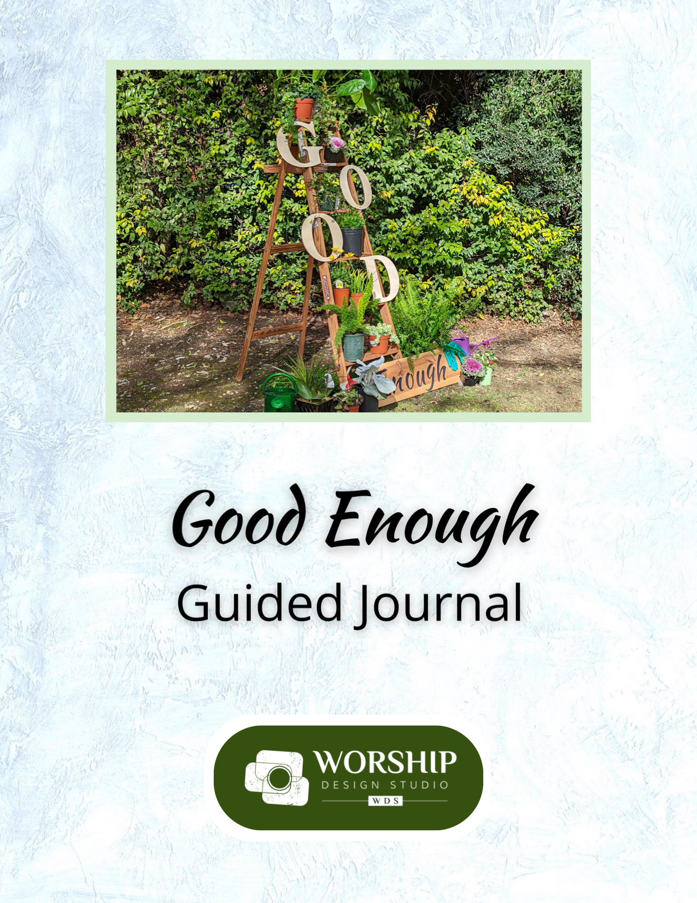

Table of Contents

Introduction page 4

Ash Wednesday page 5

Lent One page 7

Lent Two page 9

Lent Three page 11

Lent Four page 13

Lent Five page 15

Lent Six (Palm Sunday) page 17

Maundy Thursday page 19

Good Friday page 21

Easter Sunday page 23

This journal is an accompaniment to the Worship Design Studio
worship series, “Good Enough,” based on the book of the same name
by Kate Bowler. https://worshipdesignstudio.com/goodenough

This journal can also be used independently from the worship series or any church gathering. It can be used privately or shared with a friend or in a small group setting.

May the content in this journal inspire you to embrace your
“good enough” life and bloom right where you are planted!

Journal © 2025 Marcia McFee with thanks to Kate Bowler and team
Introduction

We live in a culture bent on definitions of a good life as continuous upward mobility–climbing ladders of prosperity with increasingly fabulous experiences that we can post to ever-more-likable social media accounts. We may comb the shelves of the self-help section in search of just the right formula to gain success. Perhaps we even gravitate towards spiritual leaders who promise great rewards if we only do “the right thing.” But life happens, right? Most times we are not moving upward but trying to repair the rung we’ve just slipped from. So what if we stopped climbing ladders of success and started fertilizing, watering, and blooming right where we find ourselves? Welcome to a Lent of affirming a faith in which we are blessed, regardless, and where we can lean into embracing our “good enough” lives.

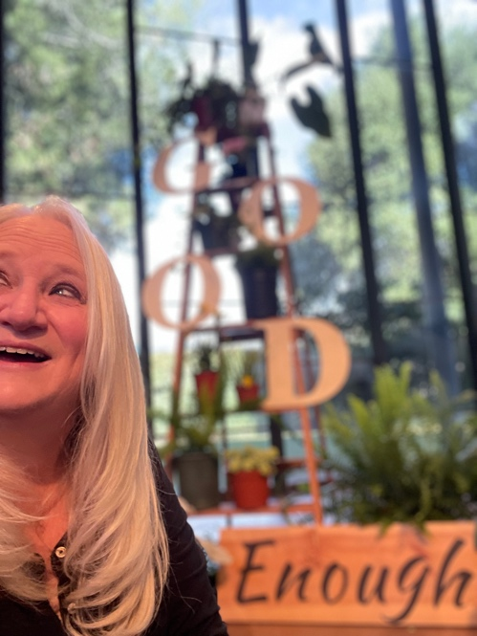
Friends, I suffer from a generational handing-off of good ole perfectionism. My mom, her mom, her mom, and on it goes likely for the generations I didn’t get to meet. Something in those farm women and then professional women starting with my mom, expected that they would “do all and be all.” Some of you, no matter your gender, may have a similar experience. Or it may be that you grew up in such chaos that trying to control life was a tactic for survival. And then there is our culture, as I wrote in the description above. We give big points to people who “succeed” in the ways that 21st century society defines success.

I hope you will meet this invitation with a sigh of relief as well as recognition. And I hope that you will resist that voice inside that says “What?! ‘Good enough’ is only for slackers!” If you are hearing that, dig a little bit and find out where it is coming from. Because I don’t think it is coming from the Creator who made a lot of things–including the “imperfect” stuff–and called it all good. You are enough to be beloved. And that’s very, very good.

Peace & Passion,
Dr. Marcia McFee
Ash Wednesday
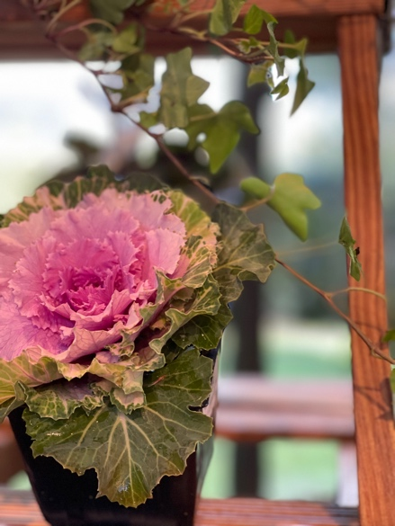
Perfectionism is impossible. Transformation isn’t.


Jesus used the word “hypocrite” to describe those who put on airs in public to make people believe that they were holy, that their religious practice was… well… perfect. But their hearts were actually not in the practice, rather in the rewards that public approval could bring them–which is here today, often gone tomorrow. Sometimes it is life itself that robs us of the shiny, perfect life that we had planned for ourselves. A diagnosis. A broken heart. A lost opportunity. This Lent, rather than change for “the best,” we’ll seek to gain momentum one day at a time, “to reach for a faith that is never perfect, but good enough” (Bowler/Richie).

"And whenever you fast, do not look dismal, like the hypocrites, for they disfigure their faces so as to show others that they are fasting. Truly I tell you, they have received their reward… but store up for yourselves treasures in heaven, where neither moth nor rust consumes and where thieves do not break in and steal. For where your treasure is, there your heart will be also.”

– Matthew 6: 1-6, 16-21

One imperfect thing in my life that bothered me recently was…

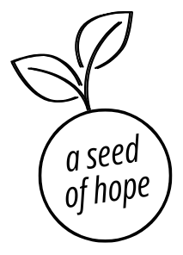
____________________________________________________________________________________________________________________________________________________________________________________
Know that already, God is offering us freedom from the bonds of perfectionism, inviting us to break the yoke of what “should be” so that we might discover what “might be” when we honor the small steps that are actually possible, in this moment, for this one day.
What would you say about the difference between change or improving for the sake of perfectionism, and a more holistic change for the sake of our own needed transformation?

________________________________________________________________________________________________________________________________________________________________________________________________________________________________________________
____________________________________________________________ ________________________________________________________________________________________________________________________
________________________________________________________________________________________________________________________________________________________________________________________________________________________________________________

Holy One, Merciful God,
make yourself known to us.
Be present with us in this often troubled journey of life.
Create in us hearts that are open to transformation.
Give us the patience of practice in this Lent season–
ordering our days with time enough for you.
Amen.

If you are reading the book “Good Enough” by Kate Bowler and Jessica Richie, here are some suggestions for further reading this week:

☐ Regula
☐ When Good Things Become Burdens
☐ Give Up Already
Scan the QR code to listen to an episode
from the “Everything Happens” podcast:
“Toxic Positivity” with Susan David.
Lent One
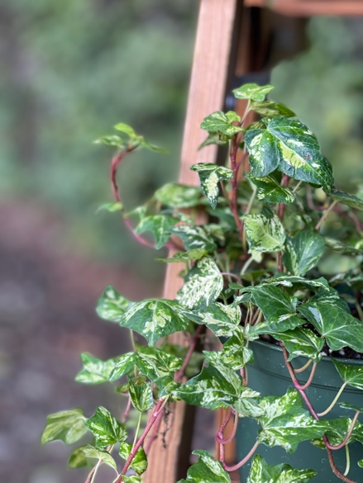
Ordinary lives can be holy.

We find ourselves hungry for many things that we believe will bring us satisfaction. The devil lays a bet that Jesus will jump at the chance for glory, fame, and the quick fix. Who wouldn’t? But Jesus keeps up the pithy one-liners long enough that the Temptster just has to slink away. What are the temptations that catch your ear, singing out promises that your life should be more special than it is? What if ordinary life is already holy–as is?

Jesus, full of the Holy Spirit, returned from the Jordan and was led by the Spirit in the wilderness, where for forty days he was tempted by the devil. He ate nothing at all during those days, and when they were over, he was famished. The devil said to him, "If you are the Son of God, command this stone to become a loaf of bread.” Jesus answered him, "It is written, 'One does not live by bread alone.’"
Know that already, God is offering us freedom from the temptations of the “not enough-ness” of our time, inviting us to love and revere the seeming ordinariness of the day-to-day so that we might recognize its true beauty.

– Luke 4: 1-13

Something “ordinary” that I often take for granted
that actually makes my life quite amazing:

____________________________________________________________________________________________________________________________________________________________________________________
Does it feel hard to accept mediocrity or the idea that our lives might not fit the popular definition of “extraordinary?” What influences try to convince you that you must work to be a kind of “exceptional” defined by society?

________________________________________________________________________________________________________________________________________________________________________________________________________________________________________________
____________________________________________________________ ________________________________________________________________________________________________________________________
________________________________________________________________________________________________________________________________________________________________________________________________________________________________________________

Holy One, Our Refuge and Shelter,
we call out to you,
sometimes in praise, sometimes in distress–as life goes.
Whether we perceive it or not, you are there.
Open us this day to your presence
in the smile of a friend, in the call of a bird–
in the simple and good enough moments that fill our days.
Amen.


If you are reading the book “Good Enough” by Kate Bowler and Jessica Richie, here are some suggestions for further reading this week:

☐ Shiny Things
☐ Building a Good Day
☐ Small Things, Great Love
☐ Happy Enough
☐ No Reason Whatsoever
☐ Mediocrity for the Win
Scan the QR code to listen to an episode
from the “Everything Happens” podcast:
“Ordinary Miracles” with Sarah Bessey.
Lent Two
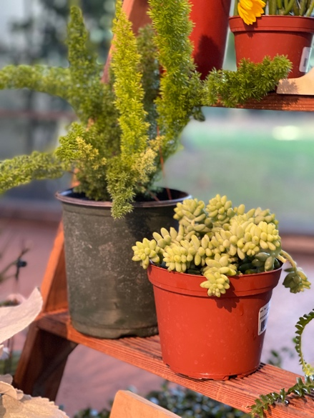
So much is out of our control.

Even Jesus got dang frustrated when folks didn’t behave as he would have liked. We probably aren’t receiving death threats from Herod as Jesus was, but our wellbeing could be threatened by the idea that if we just try hard enough, are nice enough, say just the right thing, life will always go our way. We run around in so many directions, trying to herd the chicks into some imagined semblance of perfect formation (have you ever tried to herd chicks?). What if we could let go of needing all things and all people to be “just so” and instead learn to dance with the unfolding of that which is not ours to control?

“Jerusalem, Jerusalem, the city that kills the prophets and stones those who are sent to it! How often have I desired to gather your children together as a hen gathers her brood under her wings, and you were not willing! See, your house is left to you. And I tell you, you will not see me until the time comes when you say, 'Blessed is the one who comes in the name of the Lord.’”
Know that already, God is offering us freedom from feeling alone in fixing what feels oh so wrong with this world, inviting us to let go of the need to be God, so that we might recognize that God is with us, offering courage in difficulty.

– Luke 13: 31-35

This feels out of my control today,
and I wish I could just push a button in my brain to let it go:

____________________________________________________________________________________________________________________________________________________________________________________
Why do you think we so often try to control things that are uncontrollable? What do you do or say to yourself when you notice that you are getting frustrated that life is not the way YOU want it to be?

________________________________________________________________________________________________________________________________________________________________________________________________________________________________________________
____________________________________________________________ ________________________________________________________________________________________________________________________
________________________________________________________________________________________________________________________________________________________________________________________________________________________________________________

Holy One, Our Light and Salvation,
we call out to you,
sometimes afraid of the adversaries in life.
Shelter us in days of trouble, lead us on level paths.
Open us this day to your grace and peace,
transform our frustrations
into simple and good enough moments that fill our days.
Amen.
Scan the QR code to listen to an episode
from the “Everything Happens” podcast:
“There’s No Good Card for That”
with Emily McDowell.

If you are reading the book “Good Enough” by Kate Bowler and Jessica Richie, here are some suggestions for further reading this week:

☐ Asleep on the Job
☐ The Tragedy Olympics
☐ Being Honest about Disappointment
☐ Bottling Magic
☐ Gondola Prayers
☐ The In-Between
Lent Three
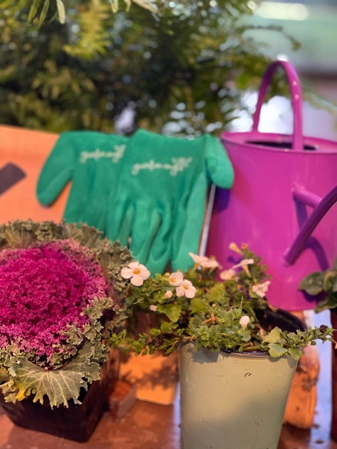
Lots of things can be medicine.

Oh, the shame of the unproductive fig tree. Cut it down! Make room for a more dedicated and hard-working fig tree! Who among us is living up to our fullest potential? The productivity experts these days can diagnose what’s wrong and sell us the antidote in 3 amazing sessions for a low-low price that is guaranteed to turn our lives around. But the gardener offers an alternative medicine–nurture it slowly, letting it soak in the manure all around until it can get the good stuff out of it. Lying fallow and getting fertilized with laughter and tears at the crappy stuff of life can help heal what ails us and that is sometimes productive enough.

Then [Jesus] told this parable: "A man had a fig tree planted in his vineyard; and he came looking for fruit on it and found none. So he said to the gardener, 'See here! For three years I have come looking for fruit on this fig tree, and still I find none. Cut it down! Why should it be wasting the soil?’ He replied, 'Sir, let it alone for one more year, until I dig around it and put manure on it. If it bears fruit next year, well and good; but if not, you can cut it down.’”
Know that already, God is offering us love enough, no matter how much we attain or achieve. We are invited to release oppressive expectations of ourselves and others so that we might recognize true worth afforded to all.

– Luke 13: 1-9

My favorite thing to do to raise my spirits
when I’m feeling down in the dumps:

____________________________________________________________________________________________________________________________________________________________________________________
What productivity expectations exist in our lives? How do they hold us captive? And what damage do you think this does to our sense of worth?

________________________________________________________________________________________________________________________________________________________________________________________________________________________________________________
____________________________________________________________ ________________________________________________________________________________________________________________________
________________________________________________________________________________________________________________________________________________________________________________________________________________________________________________

Holy One, Our Balm, Our Feast
we lift our hands and call your name,
in need of healing–thirsting and hungry.
Your steadfast love is better than life.
Open us this day to your nourishment
in the songs of the land, in the beauty of the sky–
in the simple and good enough moments that fill our days.
Amen.
Scan the QR code to listen to an episode
from the “Everything Happens” podcast:
“The Art of the Absurd” with Jenny Lawson.

If you are reading the book “Good Enough” by Kate Bowler and Jessica Richie, here are some suggestions for further reading this week:

☐ Buoyed by the Absurd
☐ When You are Exhausted
☐ Hopping off the Treadmill
☐ Kindness Boomerags
☐ 2AM/2PM
☐ Too Few Sparrows
Lent Four
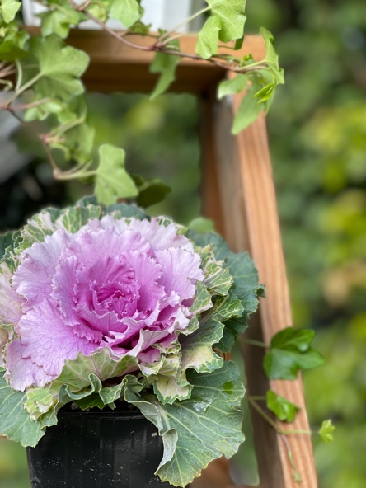
We often believe we are the problem.

The Prodigal Son lives high on the hog and then famine strikes in the land of his dream vacation. And so he heads home, tail between his legs, expecting that he has lost it all. To his surprise, his extravagant failure is met with extravagant love and grace. We can be pretty hard on ourselves when things don’t go as planned. Guilt, shame, and fear of being seen as a failure can leave us wallowing in the pig pen. Our delusions of a perfectible life keep us disappointed in ourselves. Truth is, life is a big ole risk every single day and facing whatever each day holds is not only good enough, but worthy of love and grace.

“I will get up and go to my father, and I will say to him, ‘Father, I have sinned against heaven and before you; I am no longer worthy to be called your son; treat me like one of your hired hands.’” So he set off and went to his father. But while he was still far off, his father saw him and was filled with compassion; he ran and put his arms around him and kissed him.
Know that already, God is offering us freedom from the guilt and shame of our past failings and our present unrealistic expectations. We are invited to rejoice that each day is a new beginning, so that we might enjoy, and not dread, the life before us.

– Luke 15: 1-3, 11b-32

I am often way too hard on myself about ___________________.
I could give myself a little more grace by…

____________________________________________________________________________________________________________________________________________________________________________________
What are your expectations of “a perfect day?” When the list gets done (does it ever)? When there are accomplishments to celebrate? When you’ve done everything right? What other definitions of a perfect day could take the place of these?

________________________________________________________________________________________________________________________________________________________________________________________________________________________________________________
____________________________________________________________ ________________________________________________________________________________________________________________________
________________________________________________________________________________________________________________________________________________________________________________________________________________________________________________
Holy One, God of Forgiveness,
we call out to you and
and you surround us with deliverance.
You love us infinitely more than we love ourselves or others.
Open us this day to your counsel,
helping us be more merciful, more grace-filled,
so that we might rejoice in simple and good enough moments that fill our days.

Amen.
If you are reading the book “Good Enough” by Kate Bowler and Jessica Richie, here are some suggestions for further reading this week:

☐ Needing Rules at All
☐ For the Exiles
☐ The Bad Thing
☐ Becoming Real
☐ To My Body
☐ Refuge
Scan the QR code to listen to an episode
from the “Everything Happens” podcast:
“Bless This Body” with Susan Burton.
Lent Five
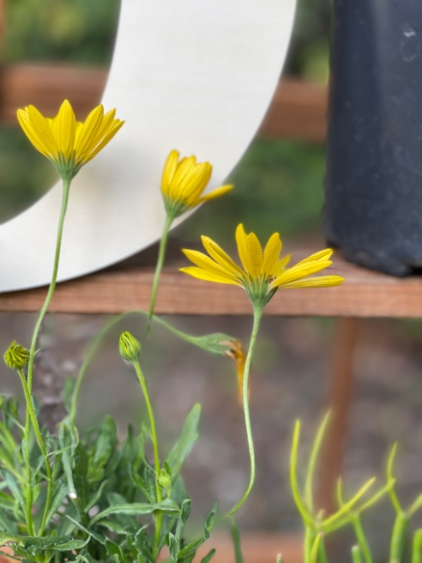
We are fragile.

Jesus speaks the words no one wanted to admit: he was not always going to be around. “Oh, don’t say that,” so many of us have said to a loved one who speaks the truth about the fragility of life. Perhaps we get uncomfortable because it reveals the precious nature of the present moment, laying bare the beauty and horror of it all. The indescribable pain we know we will one day face invades our senses like a pervasive perfume, inescapable. What if we stopped denying the limited nature of our lives and breathed in deeply the fragrance of vulnerability?

Mary took a pound of costly perfume made of pure nard, anointed Jesus' feet, and wiped them with her hair. The house was filled with the fragrance of the perfume… Jesus said, "Leave her alone. She bought it so that she might keep it for the day of my burial. You always have the poor with you, but you do not always have me.”
Know that already, God is offering us freedom from the need to avoid suffering at the cost of denying the fullness of life. We are invited into the knowledge that Christ’s vulnerability in life, death, and resurrection shows us the sacred nature of the heights and depths of sorrow and joy in our own saga.

– John 12: 1-8

Someone I can always count on to stay with me in the truth
and not mince words when I’m really going through it:

____________________________________________________________________________________________________________________________________________________________________________________
How open are you to talking about death and grief? Can you name where this comfort or discomfort comes from in your family and community? What are the advantages to being open to talking about, and perhaps just sitting with, the sorrows of life and not just reciting nifty platitudes that sweep it under the rug?

________________________________________________________________________________________________________________________________________________________________________________________________________________________________________________
____________________________________________________________ ________________________________________________________________________________________________________________________
____________________________________________________________________________________________________________________________________________________________________________________

Holy One, Lover of Souls,
we call out to you.
You know our tears and sorrows,
and you bear the seeds of grief with us.
Open us this day to your comfort
that nurtures these seeds into sheaves of joy–
the simple and good enough moments that fill our days.

Amen.
Scan the QR code to listen to an episode
from the “Everything Happens” podcast:
“The Language of Grief” with Jayson Greene.
If you are reading the book “Good Enough” by Kate Bowler and Jessica Richie, here are some suggestions for further reading this week:

☐ Right After It’s Over
☐ Hello, Goodbye
☐ Loving What Is
☐ The Burden of Love
☐ The Reality-Show Gospel
☐ Bright Hope
Lent Six (Palm Sunday)
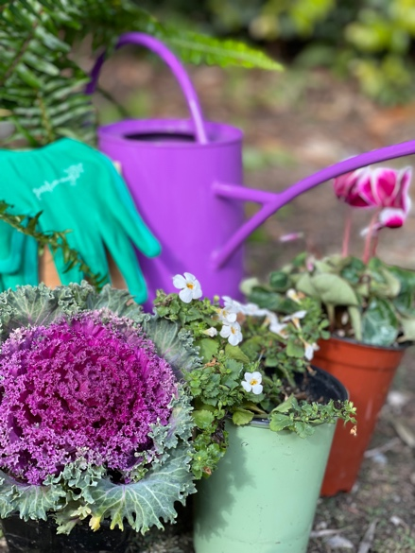
You are a group project.

Jesus orchestrated a low-budget parade into a city where he knew his days were numbered. “Get me a colt,” he said. Not a steed. Not a float. A young, green donkey (not the color, that’s horse-speak for not-ridden-a-lot-yet). And folks gathered and his friends started some liturgical shouting that ticked off the local priests. Life is hard and we all need friends and sometimes big, loud, praying that will not be messed with. We are created for interdependence. So all our hiding and pretending that we are “perfectly fine” all on our own just won’t work. Get on the donkey when you need to and let people lay down their cloaks for you and make some noise for you. ‘Cause you know you’ll do it for them too when the chips are down.
Know that already, God is offering us freedom from isolation as we are called into the kind of community Christ had in mind for all. We are invited to the audacity of interdependence so that we might recognize love in its giving and receiving.

As he rode along… the whole multitude of the disciples began to praise God joyfully with a loud voice for all the deeds of power that they had seen, saying, "Blessed is the one who comes in the name of the Lord! Peace in heaven, and glory in the highest heaven!” Some of the Pharisees in the crowd said to him, "Teacher, order your disciples to stop.” He answered, "I tell you, if these were silent, the stones would shout out.”

– Luke 19: 28-40

The last time I rallied around a loved one to show support was…

____________________________________________________________________________________________________________________________________________________________________________________
In the holy days when we commemorate the end of Jesus’ life, we often focus on our personal relationship with Jesus. But what if we saw the whole story like we are one of Jesus’ family, friends, and disciples (which we are)? Can you see your relationship with others as important as the one you would have had with Jesus if you had been there? How does this change your experience of the story?

________________________________________________________________________________________________________________________________________________________________________________________________________________________________________________
____________________________________________________________ ________________________________________________________________________________________________________________________
____________________________________________________________________________________________________________________________________________________________________________________

Holy One, God of Goodness,
we call out to you at the Gates of Righteousness,
sometimes in praise, sometimes in distress–sometimes both at once.
We long to be in your house in the presence of beloveds,
binding the festal procession with branches.
Open us this day to your love
in and through the webs of our relationships–
and in the simple and good enough moments that fill our days.
If you are reading the book “Good Enough” by Kate Bowler and Jessica Richie, here are some suggestions for further reading this week:

☐ The Foundation
☐ Say Potato
☐ The Cost of Caring
☐ When Words Fail

Amen.
Scan the QR code to listen to an episode
from the “Everything Happens” podcast:
“Belonging” with Willie Jennings.
Maundy Thursday
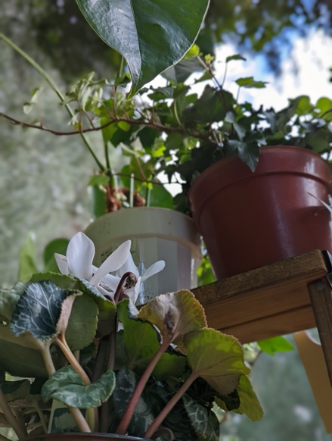
We are blessed, regardless.

The mid-20th century brought a particular shift as televangelists began to speak of blessing as a “pact” with God in which our good works (mostly our good wallets) would multiply the prosperity in our lives. But for Jesus, this moment in the Upper Room was full of trouble, danger, deception, and uncertainty. Surely Jesus, Son of God, had enough blessing capital to out-maneuver this set of circumstances! In the midst of the pain of his moment, Jesus defines the real blessing pact–washing feet, breaking the bread, lifting the cup, sharing even with those who are about to betray him. Love that cannot be quantified reminds us that each and every person is blessed, always, regardless of who we are, how we’ve failed, or what we’ve accomplished.
Know that already, God is offering us freedom from never feeling good enough for all the blessings of life and faith, inviting us to love and to bless in the same way–indiscriminately, extravagantly.

“Little children, I am with you only a little longer. You will look for me; and as I said to the Jews so now I say to you, 'Where I am going, you cannot come.’ I give you a new commandment, that you love one another. Just as I have loved you, you also should love one another. By this everyone will know that you are my disciples, if you have love for one another.”

– John 13: 1-17, 31b-35

A blessing for future me to remember
the next time I need a reminder:

____________________________________________________________________________________________________________________________________________________________________________________
Were you ever presented with the philosophy that blessings are earned from God in proportion to our own behavior? How do you interpret #blessed culture in a world where bad things can and often do happen to “good people”?

________________________________________________________________________________________________________________________________________________________________________________________________________________________________________________
____________________________________________________________ ________________________________________________________________________________________________________________________
________________________________________________________________________________________________________________________________________________________________________________________________________________________________________________

Holy One, You who lay a table of blessing before us,
you have heard us and have come to us.
We lift up the cup of salvation in praise,
we break open and share our love.
Open us this night to your presence
in our gardens of delight and sorrow–
in the simple and good enough moments that fill our days.

Amen.
If you are reading the book “Good Enough” by Kate Bowler and Jessica Richie, here is a suggestion for further reading this week:

☐ #Blessed
Scan the QR code to listen to an episode
from the “Everything Happens” podcast:
“Life After Dark” with Barbara Brown Taylor.
Good Friday
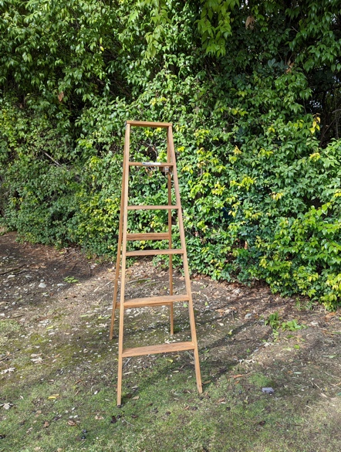
Even today, God is here,
and somehow that is good enough.

Some days are just lousy and that doesn’t even begin to cover it. The first recorded use of "guode friday” was in the South English Legendary, a text from 1290. Calling a day “good” was a way to denote a time of holy observance, not judge it as a pretty solid “8” on the scale of fabulousness. What if even our lousiest days could be experienced as a holy observance of the reality that this is life? Perhaps the “good news” in the midst of the devastation is that God is buried with us in our deepest pain, wrapping us, holding us until we can move through that birth canal once again into renewed life.
God hears you, and God can handle anything.

They took the body of Jesus and wrapped it with the spices in linen cloths, according to the burial custom of the Jews. Now there was a garden in the place where he was crucified, and in the garden there was a new tomb in which no one had ever been laid. And so, because it was the Jewish day of Preparation, and the tomb was nearby, they laid Jesus there.

– John 18: 1-19; 42

Something I want to lay in the tomb and give over to God:

____________________________________________________________________________________________________________________________________________________________________________________
Whenever things go wrong in our lives, there is a natural impulse to find solutions quickly, to change whatever we must in order to find our way back to equilibrium. But sometimes, we have to stay in the painful interstitial world of “not quite right”-ness. Where do you see God in the story of Good Friday?

________________________________________________________________________________________________________________________________________________________________________________________________________________________________________________
____________________________________________________________ ________________________________________________________________________________________________________________________
________________________________________________________________________________________________________________________________________________________________________________________________________________________________________________

Holy One, Trusted Guide of our ancestors,
at times we feel forsaken.
You took us from the womb
and laid us in the safety of loving arms,
and yet life has thrown us again and again
into the loss of connection.
Gardens of joy grow silent with grief.
Be with us this night as we mourn what cannot be.

Amen.
Scan the QR code to listen to an episode
from the “Everything Happens” podcast:
“Learning to Hold On, Learning to Let Go”
with Richard Rohr.
If you are reading the book “Good Enough” by Kate Bowler and Jessica Richie, here is a suggestion for further reading this week:

☐ Mourning a Future Self
Easter Sunday
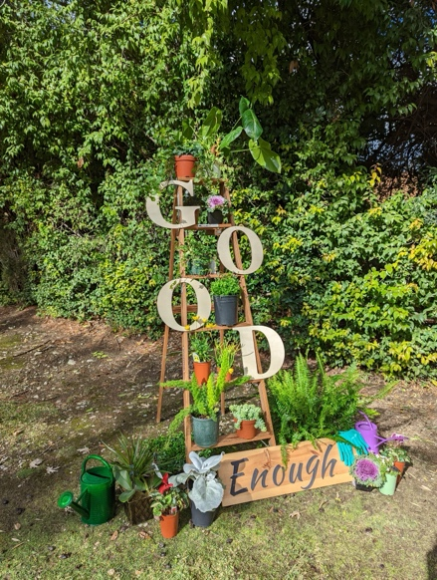
A Good Enough Faith

Easter is tricky when it comes to faith. We come for the happy ending–the “and then they lived happily ever after.” The resurrection story proclaims hope over despair and life over death, yet we know that life continued, and continues for us, as a story of spiking heartbreak moments that are not forever fixed. The nature of being created for love is that we will always hunger for more, that there is never enough life and love to satisfy. And endings are often too soon. But perhaps a good enough faith is one that moves through the chronic nature of being incurably human with an eye for resurrection moments that assure us that this good enough life is worthy of our amazement.

They said to her, "Woman, why are you weeping?" She said to them, "They have taken away my Lord, and I do not know where they have laid him.” When she had said this, she turned around and saw Jesus standing there, but she did not know that it was Jesus. Jesus said to her, "Woman, why are you weeping? Whom are you looking for?" Supposing him to be the gardener, she said to him, "Sir, if you have carried him away, tell me where you have laid him, and I will take him away.” Jesus said to her, "Mary!" She turned and said to him in Hebrew, "Rabbouni!" (which means Teacher).
Know that already, God is offering us freedom from the fear of isolation and anguish at endings, inviting us to community and creativity for birthing new life–unexpected life, unending love.

– John 20: 1-18

A resurrection moment that gave me new life during this season:

____________________________________________________________________________________________________________________________________________________________________________________
On the day of resurrection, Jesus meets Mary in the garden, the fertile place where all manner of life is planted, nurtured, and brought into being. What new life is being cultivated in you as a result of this journey?

________________________________________________________________________________________________________________________________________________________________________________________________________________________________________________
____________________________________________________________ ________________________________________________________________________________________________________________________
________________________________________________________________________________________________________________________________________________________________________________________________________________________________________________

Holy One, You whose love endures forever,
you keep offering us new life and hope, no matter what.
We praise you, for you are our strength and our salvation.
We shall not die, but live, for you call us into the light–
encouraging us to reach for the sun, unfurl our full colors,
and know that we are held in the deep and rich soil of your garden–
this is more than good enough for us!
Amen.

Scan the QR code to listen to an episode
from the “Everything Happens” podcast:
“Be Where You Are” with Heather Havrilesky.
If you are reading the book “Good Enough” by Kate Bowler and Jessica Richie, here is a suggestion for further reading this week:

☐ A Good Gardener


